ARCserveIT NT ELO Troubleshooting Tips

Cannot see your Fibre Channel attached devices in TLO Setup / ARCserveIT Device Manager

- Make sure that your Fibre Channel equipment is in the supported device list on CA web site, http://support.cai.com/techbases/asnt/elont66.html.
- If your Fibre Channel hardware is supported by CA, please go to NT “\Control Panel\SCSI Adapters”, and then expand the tree of your Fibre Channel adapter. Can you see ALL of your Fibre Channel device(s)?
- If YES, please check ARCserveIT Activity log to see if your have the proper licenses installed.
- If you don’t have any license problem, please go to ARCserveIT Server Admin, to enable Tape Engine debug log. Restart Tape Engine, and then send arcserve.log and tape.log (located in \ARCserveIT\log directory) from the Primary Server and problem Distributed Server to CA ARCserveIT Tech Support for help.
- If your NT cannot see all of your Fibre Channel devices, please use HyperTerminal as an assistant to monitor your Fibre Channel Bridge/Router to check your Fibre Channel connections. Instructions about how to use HyperTerminal to monitor Bridge/Router are in the user manual of the Bridge/Router.

Cannot see your ELO installed servers in ELO Configuration Utility

- Go to a DOS box to ping your ELO server(s), which cannot be seen in ELO configuration.
- If you are unable to ping your ELO server, please check your Ethernet settings /connections.
- If you are able to ping your ELO servers, please go to a DOS box, and cd to your ARCserveIT directory.
- Type “dsconfig”, and then ENTER. You will see a GUI interface showed up as below.

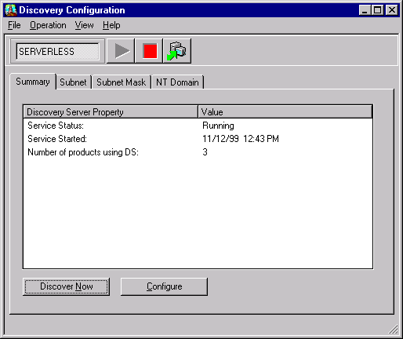

- Click on the RED button to stop ARCserveIT Discovery Service, and then restart it by clicking on the green triangle button (As shown below).

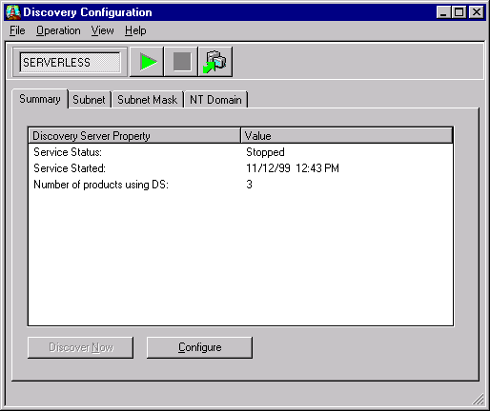

- Check your ELO Configuration Utility to see if you can see all of your ELO installed servers.
- If YES, you can close this Discovery Configuration utility now.
- If NOT, please click on “Subnet” tab and check if your subnets, in which your ELO servers are connected, are listed there (As shown below).

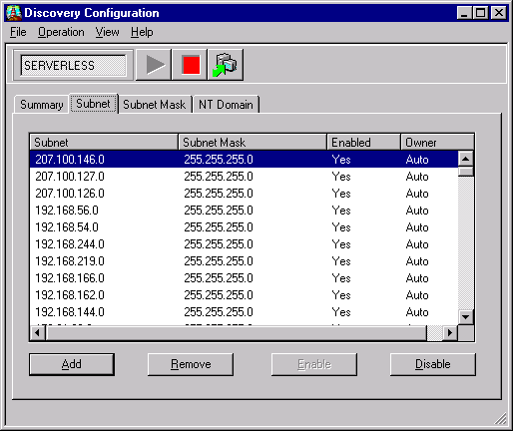

- If your subnet does not show up in the list, please click on “Add” button to add in your Subnet & Subnet Mask manually.
- Click on “Subnet Mask” tab to see if you have correct subnet mask there. If NOT, please click on “Add” button to add in your subnet mask.
- Repeat steps 5, 6, and 7.
- If you still cannot see all of your ELO installed servers in ELO configuration utility, please click on “NT Domain” tab (As shown below).

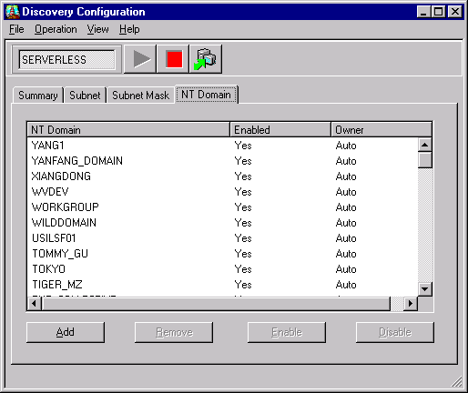

- Click on “Add” button to add in your ARCserveIT Server Name, which is not displayed in ELO configuration utility, and then click on “OK” button (As shown below).

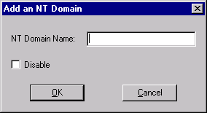

- Click on “Summary” tab (As shown below).

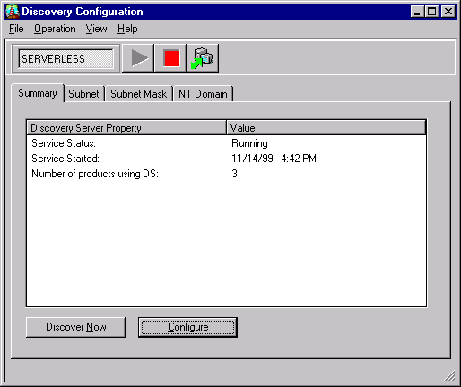

- Click on “Configure” button to bring up Configuration window (As shown below).

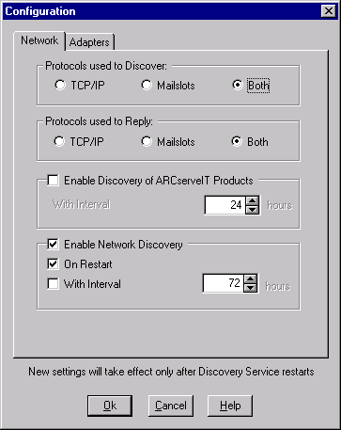

- Select “Both” in “Protocols used to Discover” section, and “Both” in “Protocols used to Reply” section, and then click on “OK” button.
- If you have a dual-channel NIC or more then one NIC installed and active, please click on “Adapters” tab (As shown below) to select a right IP address, which is connected to the public LAN, and then click on OK button. You can ignore this step, if you don’t have more than one IP address for this server.

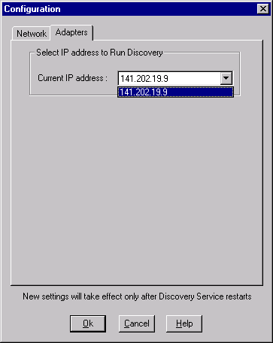

- Repeat steps 5, 6, and 7.
- You should be able to see all of your ELO installed server(s) in ELO Configuration Utility now.

Note:
Due to the network traffic, we highly recommend you to disable all of your unnecessary NT Domain(s) (as shown below) after you change your Protocol setting in Step #15.
You can highlight all of your NT Domains and disable them in one shot.

