Use this document during review meetings to identify any customizations required to the Microsoft CRM Account entity.

Contents
Account Entity 1
Account List 2
Account Form 2
General Tab 2
Details Tab 3
Administration Tab 4
Notes Tab 5
New Tabs Needed 5
Attributes 5
Existing Attributes Not Used By Default 5
New Attributes Needed 7
Preview Form 7
Views 7
Account Advanced Find View 7
Account Associated View 7
Account Lookup View 7
Accounts: No Campaign Activities in Last 3 Months 8
Accounts: No Orders in Last 6 Months 8
Accounts: Responded to Campaigns in Last 6 Months 8
Active Accounts 8
Inactive Accounts 8
My Active Accounts (default) 9
Quick Find Active Accounts 9
New Views Needed 9
Reports that Use the Account Entity 9
New Reports Needed 9
Relationships and Mapping 10
Relationships Needed with New Entities 10
New Mappings Needed 10

Account Entity

Changes:
Change needed
Rename entity
Rename messages for entity
Description

Account List
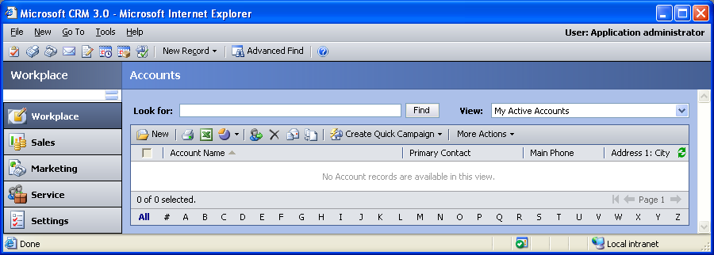

Changes:
Change needed
Default view: My Active Accounts

Account Form

General Tab
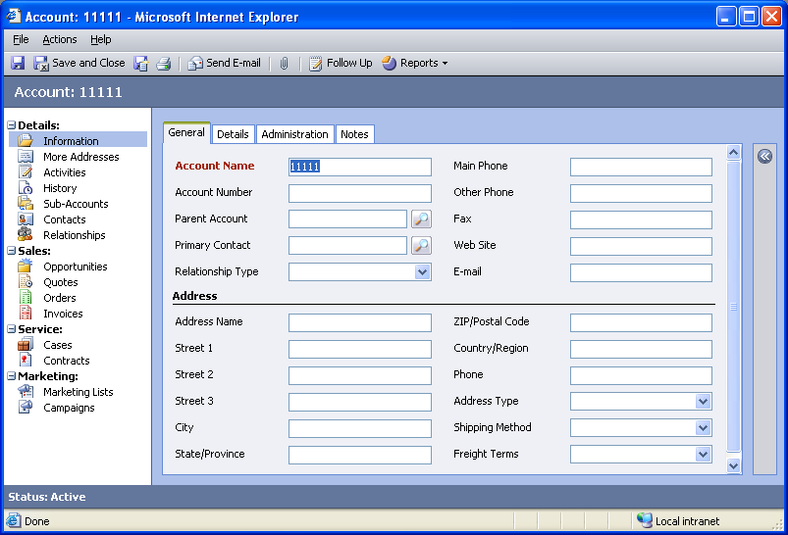

Changes:
Area | Change needed | Report change needed
Display additional fields
Change labels

Details Tab
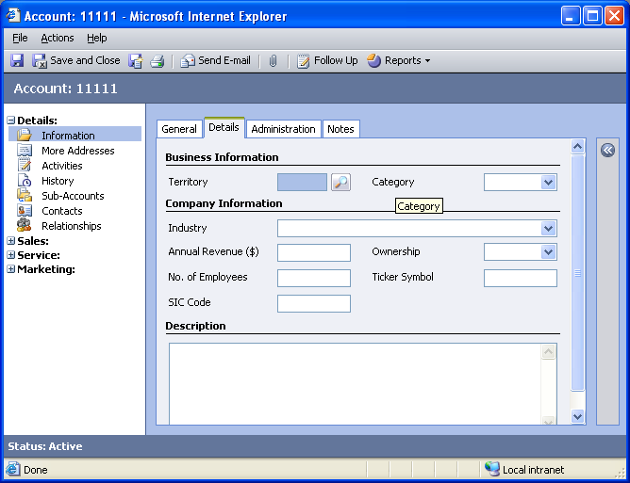

Changes:
Area | Change needed | Report change needed
Display additional fields
Remove or reorder fields
Change labels

Administration Tab
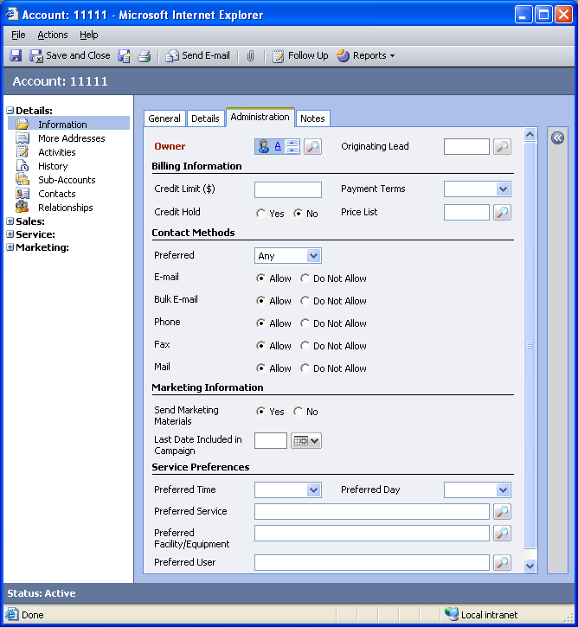

Changes:
Area | Change needed | Report change needed
Display additional fields
Remove or reorder fields
Change labels

Notes Tab
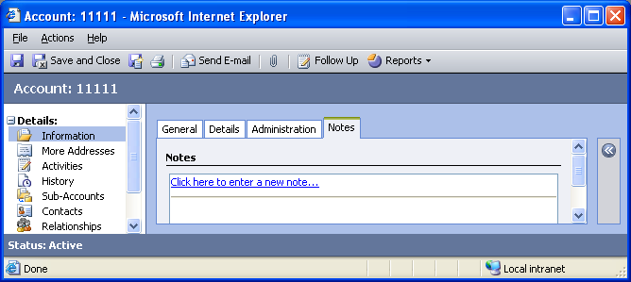

Changes:
Area | Change needed | Report change needed
Display additional fields
Remove or reorder fields
Change labels

New Tabs Needed
New Tab | Fields

Attributes

Existing Attributes Not Used By Default
Display name | Schema name | Type
Account Rating | accountratingcode | picklist
Address 1: County | address1_county | text
Address 1: Fax | address1_fax | text
Address 1: Latitude | address1_latitude | float
Address 1: Longitude | address1_longitude | float
Address 1: Post Office Box | address1_postofficebox | text
Address 1: Primary Contact Name | address1_primarycontactname | text
Address 1: Telephone 2 | address1_telephone2 | text
Address 1: Telephone 3 | address1_telephone3 | text
Address 1: UPS Zone | address1_upszone | text
Address 1: UTC Offset | address1_utcoffset | integer
Address 2: Address Type | address2_addresstypecode | picklist
Address 2: City | address2_city | text
Address 2: Country/Region | address2_country | text
Address 2: County | address2_county | text
Address 2: Fax | address2_fax | text
Address 2: Freight Terms | address2_freighttermscode | picklist
Address 2: Latitude | address2_latitude | float
Address 2: Longitude | address2_longitude | float
Address 2: Name | address2_name | text
Address 2: Post Office Box | address2_postofficebox | text
Address 2: Primary Contact Name | address2_primarycontactname | text
Address 2: Shipping Method | address2_shippingmethodcode | picklist
Address 2: State/Province | address2_stateorprovince | text
Address 2: Street 1 | address2_line1 | text
Address 2: Street 2 | address2_line2 | text
Address 2: Street 3 | address2_line3 | text
Address 2: Telephone 1 | address2_telephone1 | text
Address 2: Telephone 2 | address2_telephone2 | text
Address 2: Telephone 3 | address2_telephone3 | text
Address 2: UPS Zone | address2_upszone | text
Address 2: UTC Offset | address2_utcoffset | integer
Aging 30 | aging30 | money
Aging 60 | aging60 | money
Aging 90 | aging90 | money
Business Type | businesstypecode | picklist
Classification | accountclassificationcode | picklist
Created By | createdby | lookup
Created On | createdon | datetime
Customer Size | customersizecode | picklist
Do not allow Bulk Mails | donotbulkpostalmail | boolean
E-mail Address 2 | emailaddress2 | text
E-mail Address 3 | emailaddress3 | text
FTP Site | ftpsiteurl | text
Modified By | modifiedby | lookup
Modified On | modifiedon | datetime
Shares Outstanding | sharesoutstanding | integer
Shipping Method | shippingmethodcode | picklist
Status | statecode | state
Status Reason | statuscode | status
Stock Exchange | stockexchange | text
Telephone 3 | telephone3 | text
Territory Code | territorycode | picklist

New Attributes Needed
Display name | Schema name | Type

Preview Form
Changes needed
Fields:
Street 1
Street 2
City
ZIP/Postal Code
Other Phone
Fax
State/Province

Views

Account Advanced Find View
Changes needed
Fields:
Account Name
Primary Contact
Main Phone
Sorting: Account Name, ascending

Account Associated View
Changes needed
Fields:
Account Name
Primary Contact
Main Phone
Sorting: Account Name, ascending

Account Lookup View
Changes needed
Display Fields:
Account Name
Primary Contact
Address 1: City
Main Phone
E-mail
Find Fields:
Account Name
Account Number
E-mail
Sorting: Account Name, ascending

Accounts: No Campaign Activities in Last 3 Months
Changes needed
Fields:
Account Name
Last Date Included in Campaign
Main Phone
Address 1: City
Sorting: Account Name, ascending

Accounts: No Orders in Last 6 Months
Changes needed
Fields:
Account Name
Primary Contact
Main Phone
Address 1: City
Sorting: Account Name, ascending

Accounts: Responded to Campaigns in Last 6 Months
Changes needed
Fields:
Account Name
Main Phone
Address 1: City
Sorting: Account Name, ascending

Active Accounts
Changes needed
Fields:
Account Name
Primary Contact
Main Phone
Address 1: City
Sorting: Account Name, ascending

Inactive Accounts
Changes needed
Fields:
Account Name
Primary Contact
Main Phone
Sorting: Account Name, ascending

My Active Accounts (default)
Changes needed
Fields:
Account Name
Primary Contact
Main Phone
Sorting: Account Name, ascending

Quick Find Active Accounts
Changes needed
Display Fields:
Account Name
Account Number
Primary Contact
Address 1: City
Main Phone
E-mail
Find Fields:
Account Name
Category
Relationship Type
Sorting: Account Name, ascending

New Views Needed
New View | Fields and Sorting

Reports that Use the Account Entity
Report | Changes needed to labels | Other changes needed
Account Distribution
Account Distribution Detail
Account Overview
Account Overview Sub-Report
Account Summary
Neglected Accounts
Neglected Accounts Detail
Products by Account
Products by Account Detail
Sales History
Sales History Detail
Sales Pipeline
Sales Pipeline Detail

New Reports Needed
New Report | Business need

Relationships and Mapping

Relationships Needed with New Entities
Entity | Attribute | Type of relationship

New Mappings Needed
Entity | Attribute | Type of mapping

