Use this document during review meetings to identify any customizations required to the Microsoft CRM Campaign Activity entity.

Contents
Campaign Activity Entity 1
Campaign Activity List 1
Campaign Activity Form 2
Campaign Activity Tab 2
Notes Tab 3
New Tabs Needed 3
Attributes 3
Existing Attributes Not Used By Default 3
New Attributes Needed 4
Preview Form 4
Views 4
All Campaign Activities 4
Campaign Activity Advanced Find View 4
Campaign Activity Associated View 4
Campaign Activity Lookup View 4
In Progress Campaign Activities 5
My Campaign Activities (default) 5
Quick Find Active Campaign Activities 5
New Views Needed 5
Reports that Use the Campaign Activity Entity 5
New Reports Needed 5
Relationships and Mapping 5
Relationships Needed with New Entities 5
New Mappings Needed 6

Campaign Activity Entity

Changes:
Change needed
Rename entity
Rename messages for entity
Description

Campaign Activity List
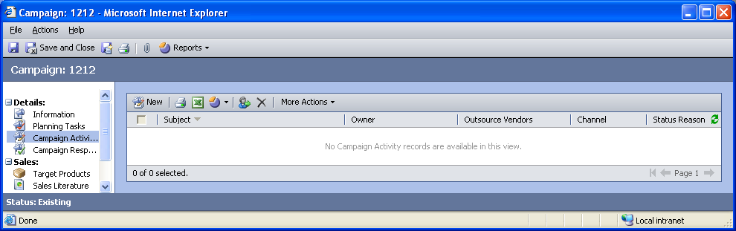

Changes:
Change needed
Default view: My Campaign Activities

Campaign Activity Form

Campaign Activity Tab
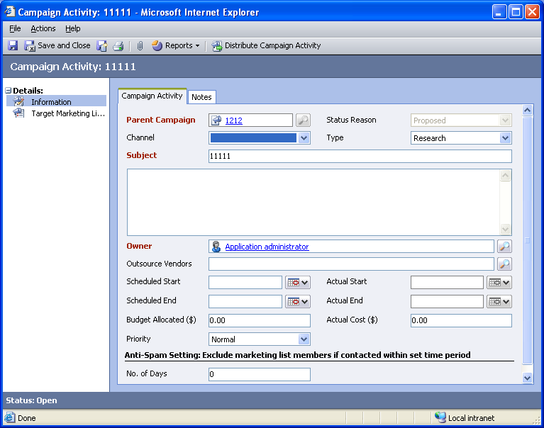

Changes:
Area | Change needed | Report change needed
Display additional fields
Remove or reorder fields
Change labels

Notes Tab
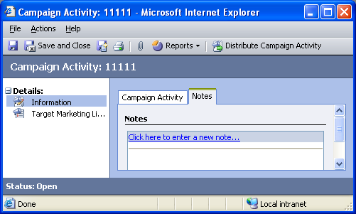

Changes:
Area | Change needed | Report change needed
Display additional fields
Remove or reorder fields
Change labels

New Tabs Needed
New Tab | Fields

Attributes

Existing Attributes Not Used By Default
Display name | Schema name | Type
Actual Duration | actualdurationminutes | integer
Category | category | text
Created By | createdby | lookup
Created On | createdon | datetime
Exclude Members Who Opt Out | donotsendonoptout | boolean
From | from | partylist
Ignore Inactive Marketing List Members | ignoreinactivelistmembers | boolean
Modified By | modifiedby | lookup
Modified On | modifiedon | datetime
Status | statecode | state
Sub-Category | subcategory | text

New Attributes Needed
Display name | Schema name | Type

Preview Form
Changes needed
Fields:
Budget Allocated
Actual Start
Priority
Scheduled End

Views

All Campaign Activities
Changes needed
Fields:
Subject
Parent Campaign
Priority
Sorting: Subject, ascending

Campaign Activity Advanced Find View
Changes needed
Fields:
Subject
Parent Campaign
Sorting: Subject, ascending

Campaign Activity Associated View
Changes needed
Fields:
Subject
Owner
Outsource Vendors
Channel
Status Reason
Sorting: Subject, descending

Campaign Activity Lookup View
Changes needed
Display Fields:
Subject
Parent Campaign
Find Fields:
Subject
Sorting: Subject, ascending

In Progress Campaign Activities
Changes needed
Fields:
Subject
Parent Campaign
Priority
Sorting: Subject, ascending

My Campaign Activities (default)
Changes needed
Fields:
Subject
Parent Campaign
Priority
Sorting: Subject, ascending

Quick Find Active Campaign Activities
Changes needed
Display Fields:
Subject
Parent Campaign
Find Fields:
Subject
Sorting: Subject, ascending

New Views Needed
New View | Fields and Sorting

Reports that Use the Campaign Activity Entity
Report | Changes needed to labels | Other changes needed
Campaign Activity Status
Campaign Activity Status Sub-Report
Campaign Comparison
Campaign Performance Sub-Report

New Reports Needed
New Report | Business need

Relationships and Mapping

Relationships Needed with New Entities
Entity | Attribute | Type of relationship

New Mappings Needed
Entity | Attribute | Type of mapping

