Use this document during review meetings to identify any customizations required to the Microsoft CRM Campaign Response entity.

Contents
Campaign Response Entity 1
Campaign Response List 1
Campaign Response Form 2
Campaign Response Tab 2
Notes Tab 3
New Tabs Needed 3
Attributes 3
Existing Attributes Not Used By Default 3
New Attributes Needed 4
Preview Form 4
Views 4
All Campaign Responses 4
Campaign Response Advanced Find View 4
Campaign Response Associated View 4
My Campaign Responses (default) 5
Open Campaign Responses 5
Quick Find Campaign Responses 5
New Views Needed 5
Reports that Use the Campaign Response Entity 5
New Reports Needed 5
Relationships and Mapping 5
Relationships Needed with New Entities 5
New Mappings Needed 6

Campaign Response Entity

Changes:
Change needed
Rename entity
Rename messages for entity
Description

Campaign Response List
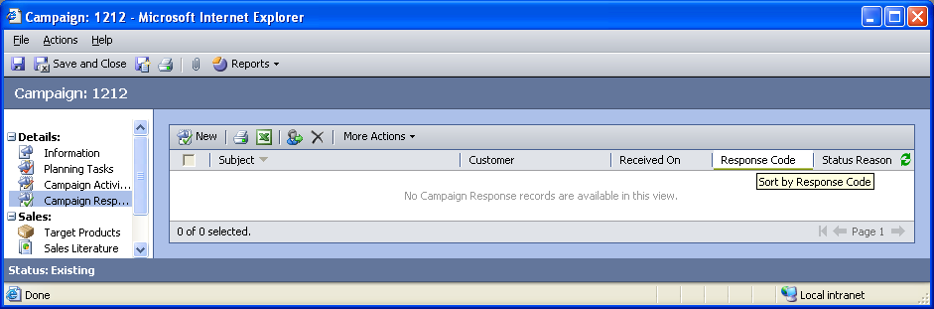

Changes:
Change needed
Default view: My Campaign Responses

Campaign Response Form

Campaign Response Tab
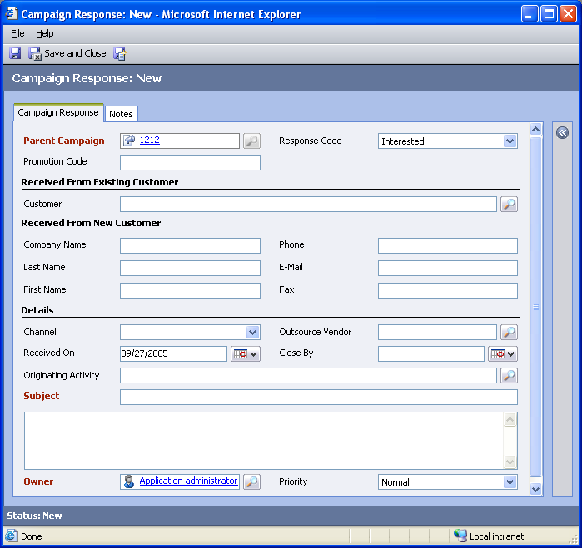

Changes:
Area | Change needed | Report change needed
Display additional fields
Remove or reorder fields
Change labels

Notes Tab
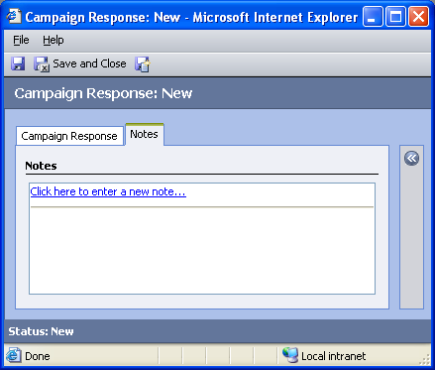

Changes:
Area | Change needed | Report change needed
Display additional fields
Remove or reorder fields
Change labels

New Tabs Needed
New Tab | Fields

Attributes

Existing Attributes Not Used By Default
Display name | Schema name | Type
Actual Duration | actualdurationminutes | integer
Actual End | actualend | datetime
Actual Start | actualstart | datetime
Category | category | text
Created By | createdby | lookup
Created On | createdon | datetime
From | from | partylist
Modified By | modifiedby | lookup
Modified On | modifiedon | datetime
Scheduled Start | scheduledstart | datetime
Status | statecode | state
Status Reason | statuscode | status
Sub-Category | subcategory | text

New Attributes Needed
Display name | Schema name | Type

Preview Form
Changes needed
Fields:
Company Name
Actual Start
Priority
Close By

Views

All Campaign Responses
Changes needed
Fields:
Subject
Parent Campaign
Response Code
Priority
Sorting: Subject, ascending

Campaign Response Advanced Find View
Changes needed
Fields:
Subject
Parent Campaign
Response Code
Sorting: Subject, ascending

Campaign Response Associated View
Changes needed
Fields:
Subject
Customer
Received On
Response Code
Status Reason
Sorting: Subject, descending

My Campaign Responses (default)
Changes needed
Fields:
Subject
Parent Campaign
Response Code
Priority
Sorting: Subject, ascending

Open Campaign Responses
Changes needed
Fields:
Subject
Parent Campaign
Response Code
Priority
Sorting: Subject, ascending

Quick Find Campaign Responses
Changes needed
Display Fields:
Subject
Parent Campaign
Response Code
Find Fields:
Subject
Sorting: Subject, ascending

New Views Needed
New View | Fields and Sorting

Reports that Use the Campaign Response Entity
Report | Changes needed to labels | Other changes needed
Campaign Comparison
Campaign Performance
Campaign Performance Detail

New Reports Needed
New Report | Business need

Relationships and Mapping

Relationships Needed with New Entities
Entity | Attribute | Type of relationship

New Mappings Needed
Entity | Attribute | Type of mapping

