Use this document during review meetings to identify any customizations required to the Microsoft CRM Campaign entity.

Contents
Campaign Entity 1
Campaign List 2
Campaign Form 3
General Tab 3
Financials Tab 4
Administration Tab 4
Notes Tab 5
New Tabs Needed 5
Attributes 5
Existing Attributes Not Used By Default 5
New Attributes Needed 6
Preview Form 6
Views 6
All Campaigns and Campaign Templates 6
Campaign Advanced Find View 6
Campaign Associated View 6
Campaign Lookup View 6
Campaign Templates 7
Launched Campaigns 7
My Campaigns (default) 7
Quick Find Active Campaigns 7
New Views Needed 7
Reports that Use the Campaign Entity 7
New Reports Needed 8
Relationships and Mapping 8
Relationships Needed with New Entities 8
New Mappings Needed 8

Campaign Entity

Changes:
Change needed
Rename entity
Rename messages for entity
Description

Campaign List
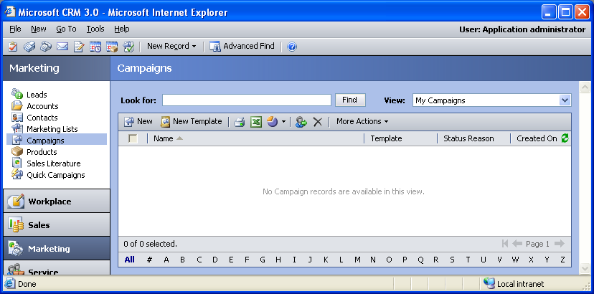

Changes:
Change needed
Default view: My Campaigns

Campaign Form

General Tab
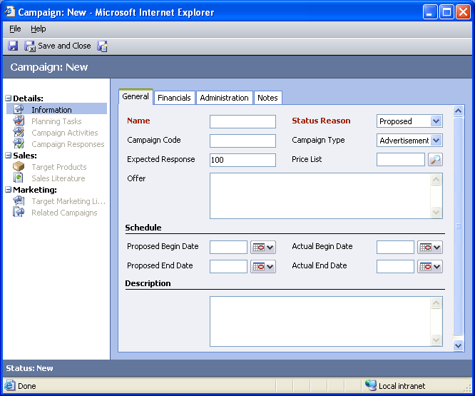

Changes:
Area | Change needed | Report change needed
Display additional fields
Remove or reorder fields
Change labels

Financials Tab
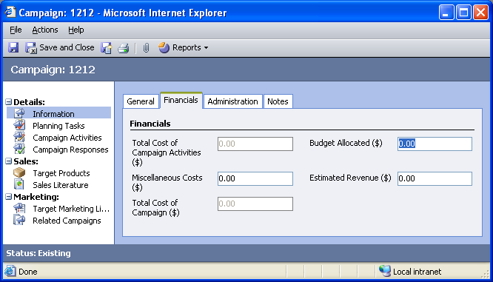

Changes:
Area | Change needed | Report change needed
Display additional fields
Remove or reorder fields
Change labels

Administration Tab
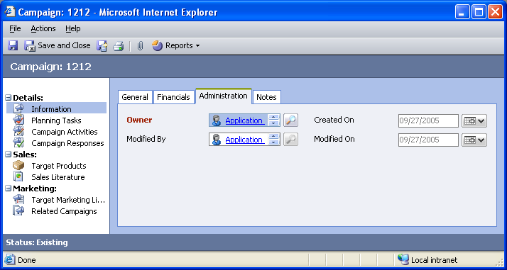

Changes:
Area | Change needed | Report change needed
Display additional fields
Remove or reorder fields
Change labels

Notes Tab
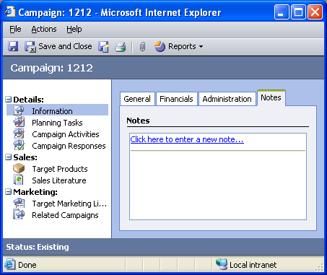

Changes:
Area | Change needed | Report change needed
Display additional fields
Remove or reorder fields
Change labels

New Tabs Needed
New Tab | Fields

Attributes

Existing Attributes Not Used By Default
Display name | Schema name | Type
Created By | createdby | lookup
Message | message | text
Promotion Code | promotioncodename | text
Status | statecode | state
Template | istemplate | boolean

New Attributes Needed
Display name | Schema name | Type

Preview Form
Changes needed
Fields:
Actual Start Date
Expected Response Percentage
Campaign Type
Proposed End Date
Estimated Revenue
Budget Allocated

Views

All Campaigns and Campaign Templates
Changes needed
Fields:
Name
Template
Status Reason
Created On
Sorting: Name, ascending

Campaign Advanced Find View
Changes needed
Fields:
Name
Template
Status Reason
Created On
Sorting: Name, ascending

Campaign Associated View
Changes needed
Fields:
Name
Template
Status Reason
Created On
Sorting: Name, ascending

Campaign Lookup View
Changes needed
Display Fields:
Name
Find Fields:
Name
Sorting: Name, ascending

Campaign Templates
Changes needed
Fields:
Name
Status Reason
Created On
Sorting: Name, ascending

Launched Campaigns
Changes needed
Fields:
Name
Status Reason
Created On
Sorting: Name, ascending

My Campaigns (default)
Changes needed
Fields:
Name
Template
Status Reason
Created On
Sorting: Name, ascending

Quick Find Active Campaigns
Changes needed
Display Fields:
Name
Template
Status Reason
Created On
Find Fields:
Campaign Code
Name
Sorting: Name, ascending

New Views Needed
New View | Fields and Sorting

Reports that Use the Campaign Entity
Report | Changes needed to labels | Other changes needed
Campaign Activity Status
Campaign Activity Status Sub-Report
Campaign Comparison
Campaign Performance
Campaign Performance Sub-Report

New Reports Needed
New Report | Business need

Relationships and Mapping

Relationships Needed with New Entities
Entity | Attribute | Type of relationship

New Mappings Needed
Entity | Attribute | Type of mapping

