Use this document during review meetings to identify any customizations required to the Microsoft CRM Case entity.

Contents
Case Entity 1
Case List 1
Case Form 2
General Tab 2
Notes and Article Tab 3
Attributes 3
Existing Attributes Not Used By Default 3
New Attributes Needed 4
Preview Form 4
Views 4
Active Cases 4
All Cases 4
Case Advanced Find View 4
Case Associated View 5
Case Lookup View 5
My Active Cases (default) 5
My Resolved Cases 5
Quick Find Active Cases 5
Resolved Cases 5
New Views Needed 6
Reports that Use the Case Entity 6
New Reports Needed 6
Relationships and Mapping 6
Relationships Needed with New Entities 6
New Mappings Needed 6

Case Entity

Changes:
Change needed
Rename entity
Rename messages for entity
Description

Case List
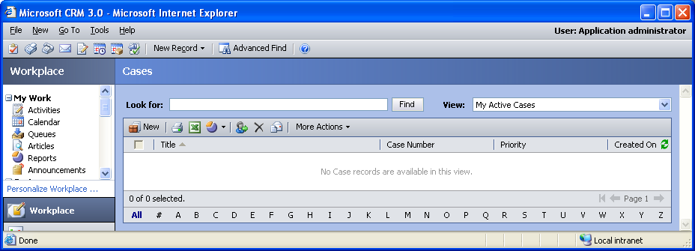

Changes:
Change needed
Default view: My Active Cases

Case Form

General Tab
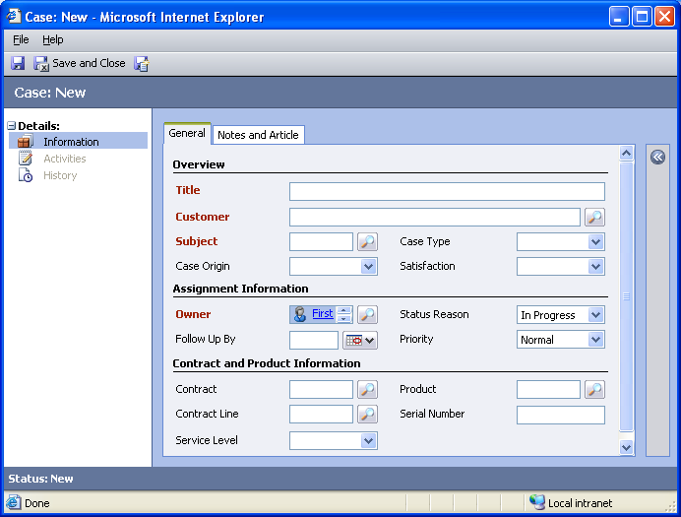

Changes:
Area | Change needed | Report change needed
Display additional fields
Remove or reorder fields
Change labels

Notes and Article Tab
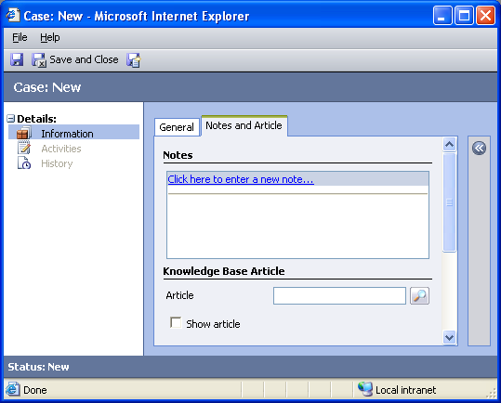

Changes:
Area | Change needed | Report change needed
Display additional fields
Remove or reorder fields
Change labels

Attributes

Existing Attributes Not Used By Default
Display name | Schema name | Type
Actual Service Units | actualserviceunits | integer
Billed Service Units | billedserviceunits | integer
Case Number | ticketnumber | text
Case Stage | incidentstagecode | picklist
Created By | createdby | lookup
Created On | createdon | datetime
Decrementing | isdecrementing | boolean
Description | description | memo
Modified By | modifiedby | lookup
Modified On | modifiedon | datetime
Responsible Contact | responsiblecontactid | lookup
Severity | severitycode | picklist
Status | statecode | state

New Attributes Needed
Display name | Schema name | Type

Preview Form
Changes needed
Fields:
Owner
Customer
Service Level
Description

Views

Active Cases
Changes needed
Fields:
Title
Case Number
Priority
Sorting: Title, ascending

All Cases
Changes needed
Fields:
Title
Status
Case Number
Priority
Created On
Sorting: Title, ascending

Case Advanced Find View
Changes needed
Fields:
Title
Case Number
Created On
Sorting: Title, ascending

Case Associated View
Changes needed
Fields:
Title
Status
Case Number
Created On
Sorting: Title, ascending

Case Lookup View
Changes needed
Display Fields:
Title
Customer
Find Fields:
Title
Case Number
Sorting: Title, ascending

My Active Cases (default)
Changes needed
Fields:
Title
Case Number
Priority
Created On
Sorting: Title, ascending

My Resolved Cases
Changes needed
Fields:
Title
Case Number
Priority
Created On
Sorting: Title, ascending

Quick Find Active Cases
Changes needed
Display Fields:
Title
Case Number
Priority
Created On
Find Fields:
Case Number
Title
Sorting: Title, ascending

Resolved Cases
Changes needed
Fields:
Title
Case Number
Priority
Created On
Sorting: Title, ascending

New Views Needed
New View | Fields and Sorting

Reports that Use the Case Entity
Report | Changes needed to labels | Other changes needed
Account Overview Sub-Report
Case Summary Table
Case Summary Table Detail
Neglected Cases
Neglected Cases Detail
Top Knowledge Base Articles
Top Knowledge Base Articles Detail

New Reports Needed
New Report | Business need

Relationships and Mapping

Relationships Needed with New Entities
Entity | Attribute | Type of relationship

New Mappings Needed
Entity | Attribute | Type of mapping

