Use this document during review meetings to identify any customizations required to the Microsoft CRM Competitor entity.

Contents
Competitor Entity 1
Competitor List 2
Competitor Form 2
General Tab 2
Analysis Tab 3
Notes Tab 4
New Tabs Needed 4
Attributes 4
Existing Attributes Not Used By Default 4
New Attributes Needed 5
Preview Form 6
Views 6
All Competitors (default) 6
Competitor Advanced Find View 6
Competitor Associated View 6
Competitor Lookup View 6
Quick Find Active Competitors 6
New Views Needed 6
Reports that Use the Competitor Entity 7
New Reports Needed 7
Relationships and Mapping 7
Relationships Needed with New Entities 7
New Mappings Needed 7

Competitor Entity

Changes:
Change needed
Rename entity
Rename messages for entity
Description

Competitor List
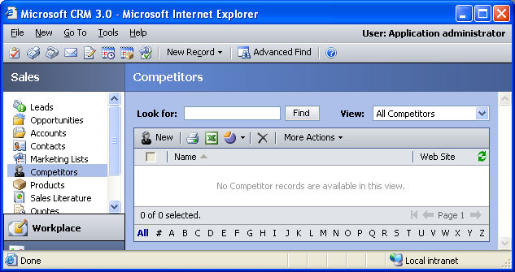

Changes:
Change needed
Default view: All Competitors

Competitor Form

General Tab
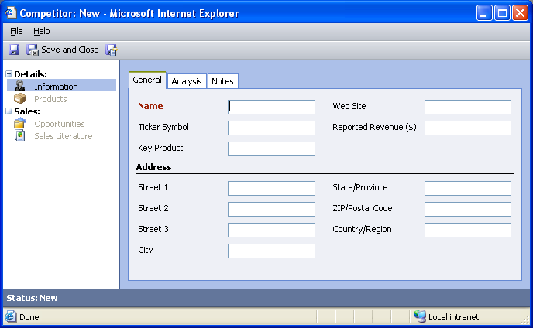

Changes:
Area | Change needed | Report change needed
Display additional fields
Remove or reorder fields
Change labels

Analysis Tab
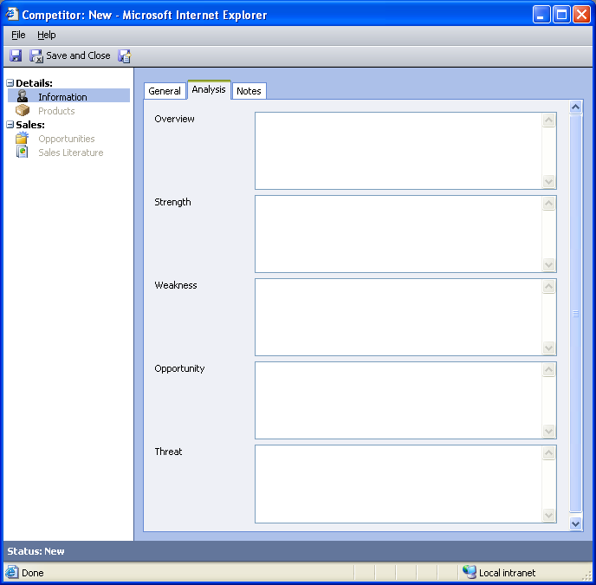

Changes:
Area | Change needed | Report change needed
Display additional fields
Remove or reorder fields
Change labels

Notes Tab
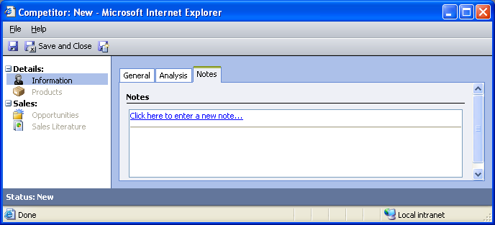

Changes:
Area | Change needed | Report change needed
Display additional fields
Remove or reorder fields
Change labels

New Tabs Needed
New Tab | Fields

Attributes

Existing Attributes Not Used By Default
Display name | Schema name | Type
Address 1: Address Type | address1_addressstypecode | picklist
Address 1: County | address1_county | text
Address 1: Fax | address1_fax | text
Address 1: Latitude | address1_latitude | float
Address 1: Longitude | address1_longitude | float
Address 1: Name | address1_name | text
Address 1: Post Office Box | address1_postofficebox | text
Address 1: Shipping Method | address1_shippingmethodcode | picklist
Address 1: Telephone 1 | address1_telephone1 | text
Address 1: Telephone 2 | address1_telephone2 | text
Address 1: Telephone 3 | address1_telephone3 | text
Address 1: UPS Zone | address1_upszone | text
Address 1: UTC Offset | address1_utcoffset | integer
Address 2: Address Type | address2_addresstypecode | picklist
Address 2: City | address2_city | text
Address 2: Country/Region | address2_country | text
Address 2: County | address2_county | text
Address 2: Fax | address2_fax | text
Address 2: Latitude | address2_latitude | float
Address 2: Longitude | address2_longitude | float
Address 2: Name | address2_name | text
Address 2: Post Office Box | address2_postofficebox | text
Address 2: Shipping Method | address2_shippingmethodcode | picklist
Address 2: State/Province | address2_stateorprovince | text
Address 2: Street 1 | address2_line1 | text
Address 2: Street 2 | address2_line2 | text
Address 2: Street 3 | address2_line3 | text
Address 2: Telephone 1 | address2_telephone1 | text
Address 2: Telephone 2 | address2_telephone2 | text
Address 2: Telephone 3 | address2_telephone3 | text
Address 2: UPS Zone | address2_upszone | text
Address 2: UTC Offset | address2_utcoffset | text
Address 2: ZIP/Postal Code | address2_postalcode | text
Created By | createdby | lookup
Created On | createdon | datetime
Modified By | modifiedby | lookup
Modified On | modifiedon | datetime
Reference Info URL | referenceinfourl | text
Reporting Quarter | reportingquarter | integer
Reporting Year | reportingyear | integer
Ticker Symbol | tickersymbol | text
Win Percentage | winpercentage | float

New Attributes Needed
Display name | Schema name | Type

Preview Form
Changes needed
Fields:
Key Product
Reported Revenue

Views

All Competitors (default)
Changes needed
Fields:
Name
Web Site
Sorting: Name, ascending

Competitor Advanced Find View
Changes needed
Fields:
Name
Web Site
Sorting: Name, ascending

Competitor Associated View
Changes needed
Fields:
Name
Web Site
Sorting: Name, ascending

Competitor Lookup View
Changes needed
Display Fields:
Name
Find Fields:
Name
Sorting: Name, ascending

Quick Find Active Competitors
Changes needed
Display Fields:
Name
Web Site
Find Fields:
Name
Sorting: Name, ascending

New Views Needed
New View | Fields and Sorting

Reports that Use the Competitor Entity
Report | Changes needed to labels | Other changes needed
Competitor Win Loss
Competitor Win Loss Detail

New Reports Needed
New Report | Business need

Relationships and Mapping

Relationships Needed with New Entities
Entity | Attribute | Type of relationship

New Mappings Needed
Entity | Attribute | Type of mapping

