Use this document during review meetings to identify any customizations required to the Microsoft CRM Contract Template entity.

Contents
Contract Template Entity 1
Contract Template List 1
Contract Template Form: Not Customizable 2
General Tab 2
Attributes 2
Views 2
Contract Templates (default) 2
Contract Templates Advanced Find View 3
Contract Template Lookup View 3
Reports that Use the Contract Template Entity 3
New Reports Needed 3
Relationships and Mapping 3

Contract Template Entity

Changes:
Change needed
Rename entity
Rename messages for entity
Description

Contract Template List
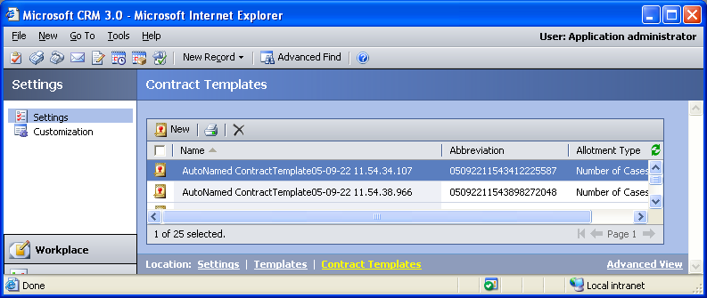

Contract Template Form: Not Customizable

General Tab
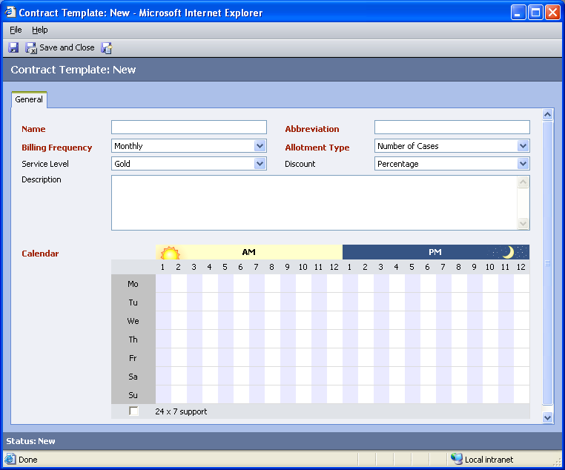

Attributes
No new attributes can be added for the Contract Template entity.

Views
No new views can be added for the Contract Template entity.

Contract Templates (default)
Changes needed
Fields:
Name
Abbreviation
Allotment Type
Billing Frequency
Contract Service Level
Created By
Created On
Description
Modified By
Modified On
Use Discount as Percentage
Sorting: Name, ascending

Contract Templates Advanced Find View
Changes needed
Fields:
Name
Abbreviation
Allotment Type
Billing Frequency
Contract Service Level
Created By
Created On
Description
Modified By
Modified On
Use Discount as Percentage
Sorting: Name, ascending

Contract Template Lookup View
Changes needed
Display Fields:
Name
Abbreviation
Allotment Type
Billing Frequency
Contract Service Level
Created By
Created On
Description
Modified By
Modified On
Use Discount as Percentage
Find Fields:
Name
Sorting: Name, ascending

Reports that Use the Contract Template Entity
No default reports use the Contract Template entity.

New Reports Needed
New Report | Business need

Relationships and Mapping
No relationships or mappings can be added.

