Use this document during review meetings to identify any customizations required to the Microsoft CRM E-mail Template entity.

Contents
E-mail Template Entity 1
E-mail Template List: 1
E-mail Template Form: Not Customizable 2
Details Tab 2
Attributes 2
Views 2
All E-mail Templates 2
E-mail Template Advanced Find View 2
E-mail Template Lookup View 3
My E-mail Templates 3
Personal E-mail Templates (default) 3
Quick Find All E-mail Template 3
New Views Needed 3
Reports that Use the E-mail Template Entity 3
New Reports Needed 3
Relationships and Mapping 3

E-mail Template Entity

Changes:
Change needed
Rename entity
Rename messages for entity
Description

E-mail Template List:
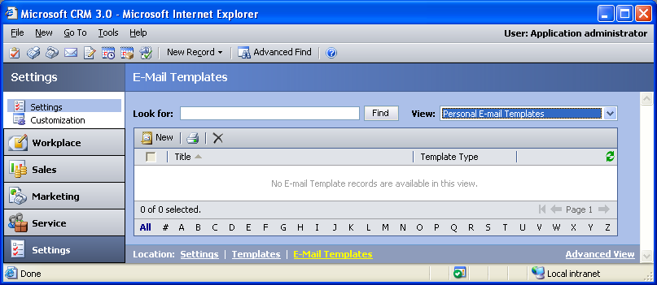

Changes:
Change needed
Default view: Personal E-mail Templates

E-mail Template Form: Not Customizable

Details Tab
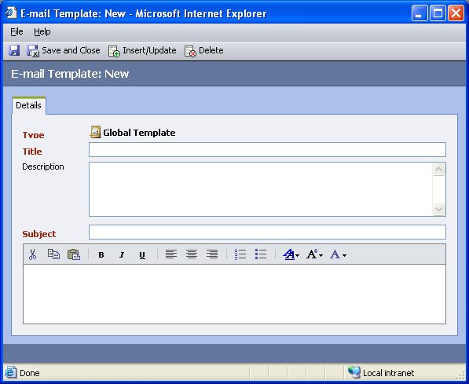

Attributes
No attributes can be added for the E-mail Template entity.

Views
No views can be added for the E-mail Template entity.

All E-mail Templates
Changes needed
Fields:
Title
Template Type
Viewable By
Sorting: Title, ascending

E-mail Template Advanced Find View
Changes needed
Fields:
Title
Template Type
Viewable By
Sorting: Title, ascending

E-mail Template Lookup View
Changes needed
Display Fields:
Title
Find Fields:
Title
Sorting: Title, ascending

My E-mail Templates
Changes needed
Fields:
Title
Template Type
Sorting: Title, ascending

Personal E-mail Templates (default)
Changes needed
Fields:
Title
Template Type
Sorting: Title, ascending

Quick Find All E-mail Template
Changes needed
Display Fields:
Title
Template Type
Viewable By
Find Fields:
Title
Sorting: Title, ascending

New Views Needed
New View | Fields and Sorting

Reports that Use the E-mail Template Entity
No default reports use the E-mail Template entity.

New Reports Needed
New Report | Business need

Relationships and Mapping
No relationships or mapping can be added.

