Use this document during review meetings to identify any customizations required to the Microsoft CRM E-mail entity.

Contents
E-mail Entity 1
E-mail Form 2
E-mail Tab 2
Attachments Tab 3
New Tabs Needed 3
Attributes 3
Existing Attributes Not Used By Default 3
New Attributes Needed 4
Preview Form 4
Views 4
All E-mails 4
E-mail Advanced Find View 4
E-mail Lookup View 4
My Draft E-mails 5
My Received E-mails (default) 5
My Sent E-mails 5
Quick Find All E-mail 5
New Views Needed 5
Reports that Use the E-mail Entity 6
New Reports Needed 6
Relationships and Mapping 6

E-mail Entity

Changes:
Change needed
Rename entity
Rename messages for entity
Description
Default view: My Received E-mails

E-mail Form

E-mail Tab
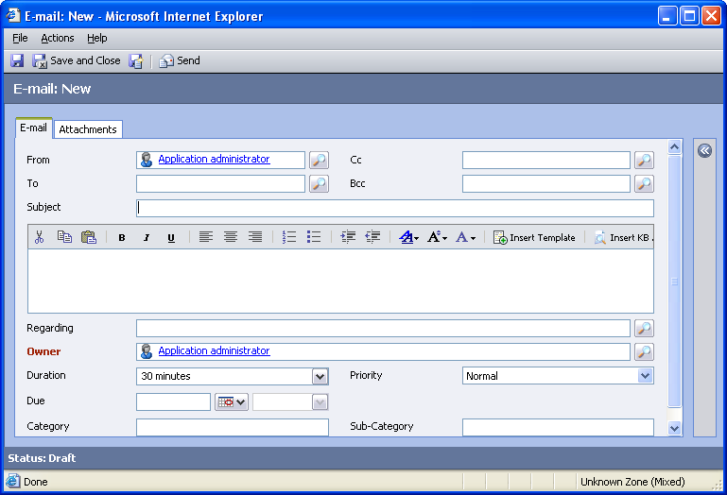

Changes:
Area | Change needed | Report change needed
Display additional fields
Remove or reorder fields
Change labels

Attachments Tab
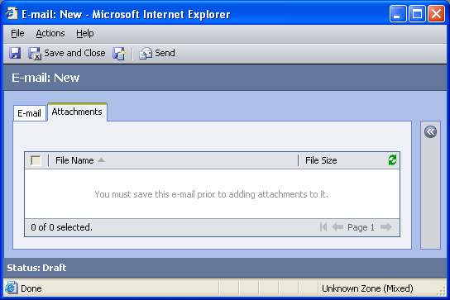

Changes:
Area | Change needed | Report change needed
Display additional fields
Remove or reorder fields
Change labels

New Tabs Needed
New Tab | Fields

Attributes

Existing Attributes Not Used By Default
Display name | Schema name | Type
Activity Status | statecode | state
Actual End | actualend | datetime
Actual Start | actualstart | datetime
Created By | createdby | lookup
Created On | createdon | datetime
Direction | directioncode | boolean
Modified By | modifiedby | lookup
Modified On | modifiedon | datetime
Start Date | scheduledstart | datetime
Status Reason | statuscode | status
Submitted By | submittedby | text
Tracking Token | trackingtoken | text

New Attributes Needed
Display name | Schema name | Type

Preview Form
Changes needed
Fields:
Priority
Created By
Due
Created On

Views

All E-mails
Changes needed
Fields:
Subject
From
To
Regarding
Priority
Status Reason
Modified On
Sorting: Subject, ascending

E-mail Advanced Find View
Changes needed
Fields:
Subject
From
To
Regarding
Priority
Status Reason
Modified On
Sorting: Subject, ascending

E-mail Lookup View
Changes needed
Display Fields:
Subject
Regarding
Modified On
Find Fields:
Subject
Sorting: Subject, ascending

My Draft E-mails
Changes needed
Fields:
Subject
Regarding
Modified On
To
Priority
Due Date
Sorting: Modified On, ascending

My Received E-mails (default)
Changes needed
Fields:
Subject
Regarding
Priority
Actual End
Sorting: Actual End, ascending

My Sent E-mails
Changes needed
Fields:
To
Subject
Regarding
Priority
Actual End
Sorting: Actual End, ascending

Quick Find All E-mail
Changes needed
Display Fields:
Subject
Regarding
Status Reason
To
From
Modified On
Find Fields:
Subject
Sorting: Subject, ascending

New Views Needed
New View | Fields and Sorting

Reports that Use the E-mail Entity
Report | Changes needed to labels | Other changes needed

New Reports Needed
New Report | Business need

Relationships and Mapping
No relationships or mappings can be added.

