Use this document during review meetings to identify any customizations required to the Microsoft CRM Fax entity.

Contents
Fax Entity 1
Fax Form 2
Fax Tab 2
Notes Tab 3
New Tabs Needed 3
Attributes 3
Existing Attributes Not Used By Default 3
New Attributes Needed 4
Preview Form 4
Views 4
All Faxes 4
Fax Advanced Find View 4
Fax Lookup View 4
My Faxes (default) 5
Quick Find All Faxes 5
New Views Needed 5
Reports that Use the Fax Entity 5
New Reports Needed 5
Relationships and Mapping 5
Relationships Needed with New Entities 5
New Mappings Needed 6

Fax Entity

Changes:
Change needed
Rename entity
Rename messages for entity
Description
Default view: My Faxes

Fax Form

Fax Tab
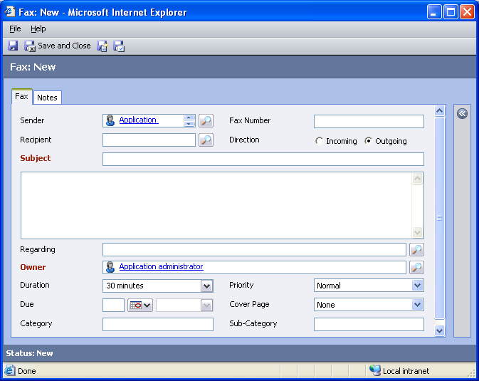

Changes:
Area | Change needed | Report change needed
Display additional fields
Remove or reorder fields
Change labels

Notes Tab
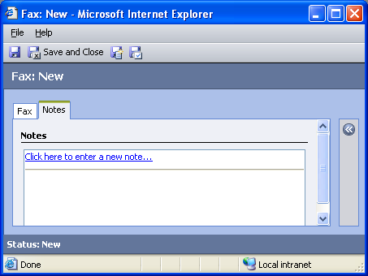

Changes:
Area | Change needed | Report change needed
Display additional fields
Remove or reorder fields
Change labels

New Tabs Needed
New Tab | Fields

Attributes

Existing Attributes Not Used By Default
Display name | Schema name | Type
Activity Status | statecode | state
Actual End | actualend | datetime
Actual Start | actualstart | datetime
Billing Code | billingcode | text
Created By | createdby | lookup
Created On | createdon | datetime
Modified By | modifiedby | lookup
Modified On | modifiedon | datetime
Number of Pages | numberofpagees | integer
Start Date | scheduledstart | datetime
Status Reason | statuscode | status
Transmit. Station id | tsid | text

New Attributes Needed
Display name | Schema name | Type

Preview Form
Changes needed
Fields:
Priority
Created By
Due
Created On

Views

All Faxes
Changes needed
Fields:
Subject
Sender
Recipient
Regarding
Direction
Fax Number
Priority
Due Date
Activity Status
Owner
Sorting: Subject, ascending

Fax Advanced Find View
Changes needed
Fields:
Subject
Activity Status
Priority
Due Date
Created By
Regarding
Sorting: Subject, ascending

Fax Lookup View
Changes needed
Display Fields:
Subject
Due Date
Activity Status
Find Fields:
Subject
Sorting: Subject, ascending

My Faxes (default)
Changes needed
Fields:
Subject
Sender
Recipient
Regarding
Activity Status
Created On
Sorting: Created On, descending

Quick Find All Faxes
Changes needed
Display Fields:
Subject
Activity Status
Priority
Due Date
Created By
Regarding
Find Fields:
Subject
Sorting: Subject, ascending

New Views Needed
New View | Fields and Sorting

Reports that Use the Fax Entity
Report | Changes needed to labels | Other changes needed

New Reports Needed
New Report | Business need

Relationships and Mapping

Relationships Needed with New Entities
Entity | Attribute | Type of relationship

New Mappings Needed
Entity | Attribute | Type of mapping

