Use this document during review meetings to identify any customizations required to the Microsoft CRM Invoice entity.

Contents
Invoice Entity 1
Invoice List 2
Invoice Form 2
General Tab 2
Shipping Tab 3
Addresses Tab 4
Administration Tab 4
Notes Tab 5
New Tabs Needed 5
Attributes 5
Existing Attributes Not Used By Default 5
New Attributes Needed 6
Preview Form 6
Views 6
All Invoices 6
Closed Invoices 6
Invoice Advanced Find View 6
Invoice Associated View 6
Invoice Lookup View 7
Invoices: No Campaign Activities in Last 3 Months 7
My Invoices (default) 7
Quick Find Active Invoices 7
New Views Needed 7
Reports that Use the Invoice Entity 7
New Reports Needed 8
Relationships and Mapping 8
Relationships Needed with New Entities 8
New Mappings Needed 8

Invoice Entity

Changes:
Change needed
Rename entity
Rename messages for entity
Description

Invoice List
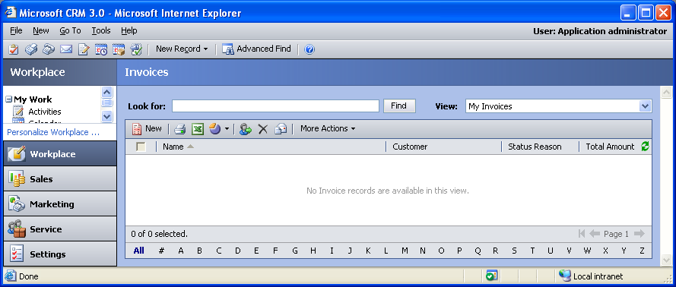

Changes:
Change needed
Default view: My Invoices

Invoice Form

General Tab
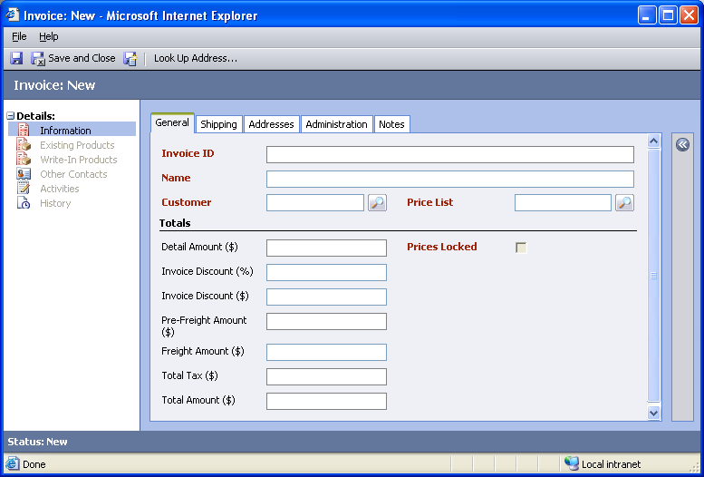

Changes:
Area | Change needed | Report change needed
Display additional fields
Remove or reorder fields
Change labels

Shipping Tab
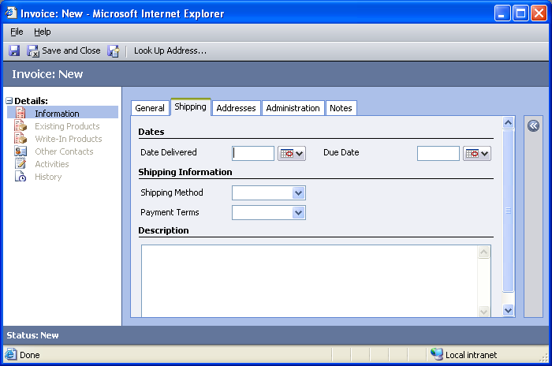

Changes:
Area | Change needed | Report change needed
Display additional fields
Remove or reorder fields
Change labels

Addresses Tab
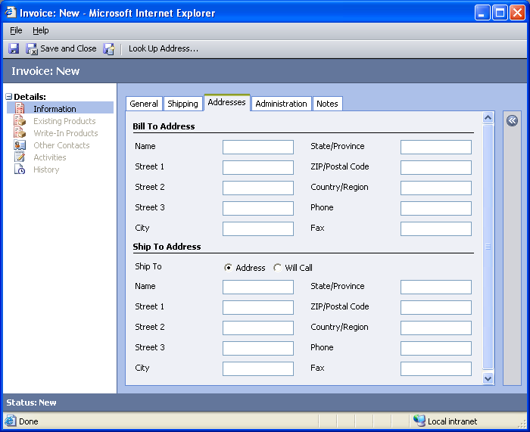

Changes:
Area | Change needed | Report change needed
Display additional fields
Remove or reorder fields
Change labels

Administration Tab
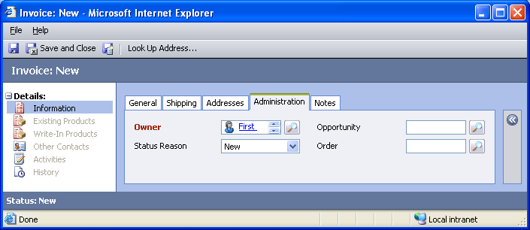

Changes:
Area | Change needed | Report change needed
Display additional fields
Remove or reorder fields
Change labels

Notes Tab
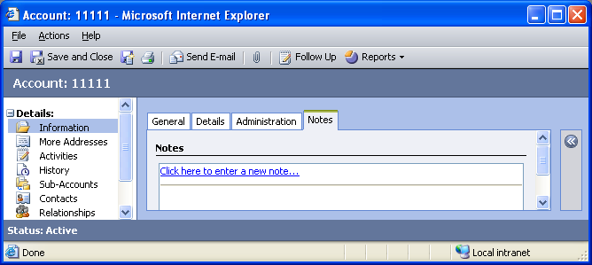

Changes:
Area | Change needed | Report change needed
Display additional fields
Remove or reorder fields
Change labels

New Tabs Needed
New Tab | Fields

Attributes

Existing Attributes Not Used By Default
Display name | Schema name | Type
Created By | createdby | lookup
Created On | createdon | datetime
Last Submitted to Backoffice | lastbackofficesubmit | datetime
Modified By | modifiedby | lookup
Modified On | modifiedon | datetime
Priority | prioritycode | picklist
Ship to Freight Terms | shipto_freighttermscode | picklist
Status | statecode | state
Total Discount Amount | totaldiscountamount | money
Total Line Item Discount Amount | totallineitemdiscountamount | money

New Attributes Needed
Display name | Schema name | Type

Preview Form
Changes needed
Fields:
Status Reason
Date Delivered
Due Date
Owner

Views

All Invoices
Changes needed
Fields:
Name
Customer
Status Reason
Total Amount
Sorting: Name, ascending

Closed Invoices
Changes needed
Fields:
Name
Customer
Status Reason
Total Amount
Sorting: Name, ascending

Invoice Advanced Find View
Changes needed
Fields:
Invoice Name
Primary Contact
Main Phone
Sorting: Invoice Name, ascending

Invoice Associated View
Changes needed
Fields:
Name
Customer
Status Reason
Total Amount
Sorting: Name, ascending

Invoice Lookup View
Changes needed
Display Fields:
Name
Customer
Find Fields:
Name
Sorting: Name, ascending

Invoices: No Campaign Activities in Last 3 Months
Changes needed
Fields:
Invoice Name
Last Date Included in Campaign
Main Phone
Address 1: City
Sorting: Invoice Name, ascending

My Invoices (default)
Changes needed
Fields:
Name
Customer
Status Reason
Total Amount
Sorting: Name, ascending

Quick Find Active Invoices
Changes needed
Display Fields:
Name
Customer
Status Reason
Total Amount
Find Fields:
Name
Sorting: Name, ascending

New Views Needed
New View | Fields and Sorting

Reports that Use the Invoice Entity
Report | Changes needed to labels | Other changes needed
Invoice Status
Invoice Status Detail

New Reports Needed
New Report | Business need

Relationships and Mapping

Relationships Needed with New Entities
Entity | Attribute | Type of relationship

New Mappings Needed
Entity | Attribute | Type of mapping

