Use this document during review meetings to identify any customizations required to the Microsoft CRM Lead entity.

Contents
Lead Entity 1
Lead List 2
Lead Form 2
General Tab 2
Details Tab 3
Administration Tab 4
Notes Tab 5
New Tabs Needed 5
Attributes 5
Existing Attributes Not Used By Default 5
New Attributes Needed 7
Preview Form 7
Views 7
Closed Leads 7
Lead Advanced Find View 7
Lead Associated View 7
Lead Lookup View 8
Leads Opened Last Week 8
Leads Opened This Week 8
Leads: No Campaign Activities Sent 8
Leads: Older Than 6 Months 8
Active Leads 9
My Open Leads (default) 9
Open Leads 9
Quick Find All Leads 9
New Views Needed 9
Reports that Use the Lead Entity 9
New Reports Needed 10
Relationships and Mapping 10
Relationships Needed with New Entities 10
New Mappings Needed 10

Lead Entity

Changes:
Change needed
Rename entity
Rename messages for entity
Description

Lead List
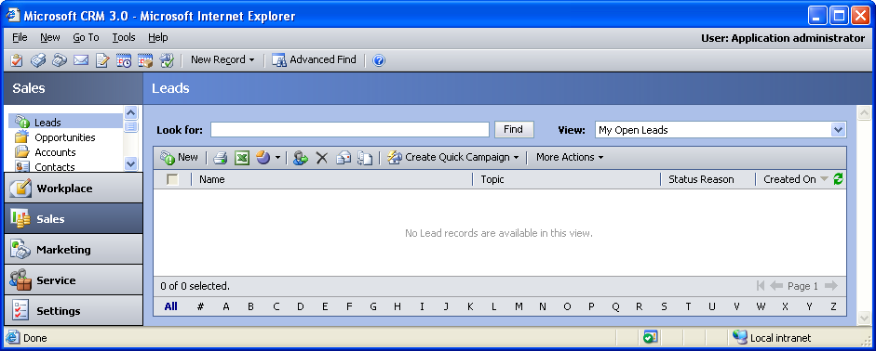

Changes:
Change needed
Default view: My Open Leads

Lead Form

General Tab
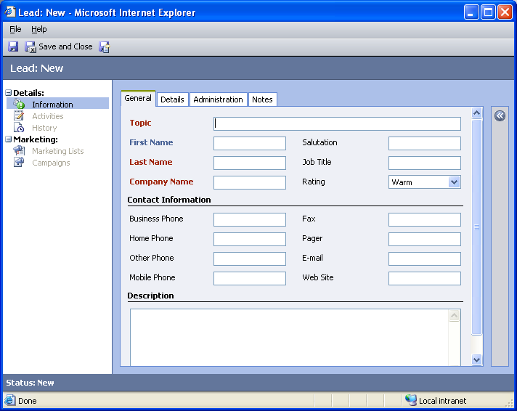

Changes:
Area | Change needed | Report Change needed
Display additional fields
Change labels

Details Tab
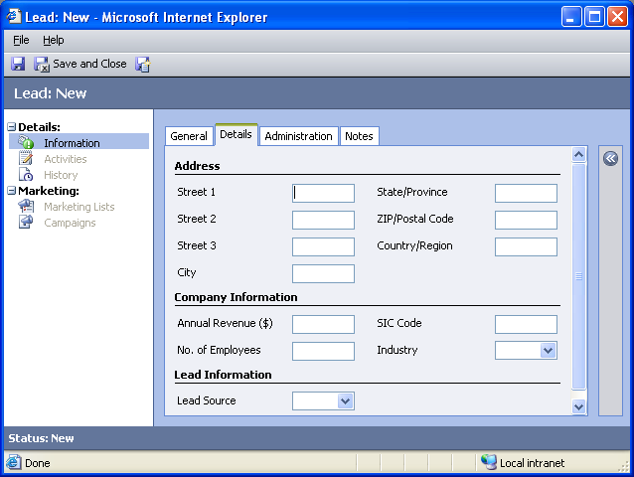

Changes:
Area | Change needed | Report Change needed
Display additional fields
Remove or reorder fields
Change labels

Administration Tab
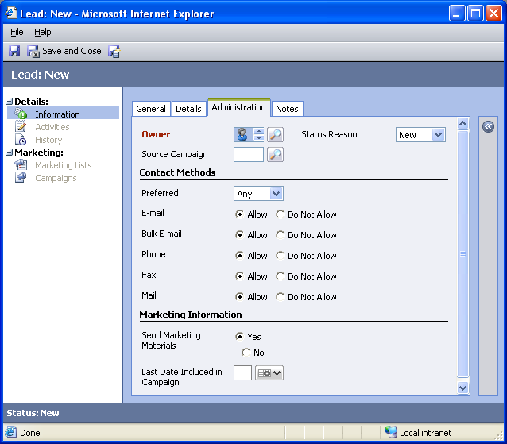

Changes:
Area | Change needed | Report Change needed
Display additional fields
Remove or reorder fields
Change labels

Notes Tab
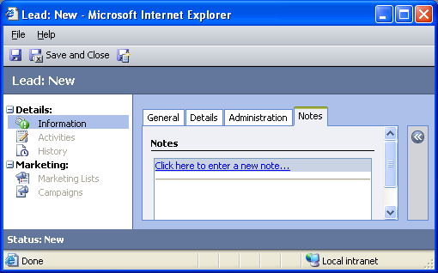

Changes:
Area | Change needed | Report Change needed
Display additional fields
Remove or reorder fields
Change labels

New Tabs Needed
New Tab | Fields

Attributes

Existing Attributes Not Used By Default
Display name | Schema name | Type
Address 1: Address Type | address1_addresstypecope | picklist
Address 1: County | address1_county | text
Address 1: Fax | address1_fax | text
Address 1: Latitude | address1_latitude | float
Address 1: Longitude | address1_longitude | float
Address 1: Name | address1_name | text
Address 1: Post Office Box | address1_postofficebox | text
Address 1: Shipping Method | address1_shippingmethodcode | picklist
Address 1: Telephone 1 | address1_telephone1 | text
Address 1: Telephone 2 | address1_telephone2 | text
Address 1: Telephone 3 | address1_telephone3 | text
Address 1: UPS Zone | address1_upszone | text
Address 1: UTC Offset | address1_utcoffset | integer
Address 2: Address Type | address2_addresstypecode | picklist
Address 2: City | address2_city | text
Address 2: Country/Region | address2_country | text
Address 2: County | address2_county | text
Address 2: Fax | address2_fax | text
Address 2: Latitude | address2_latitude | float
Address 2: Longitude | address2_longitude | float
Address 2: Name | address2_name | text
Address 2: Post Office Box | address2_postofficebox | text
Address 2: Shipping Method | address2_shippingmethodcode | picklist
Address 2: State/Province | address2_stateorprovince | text
Address 2: Street 1 | address2_line1 | text
Address 2: Street 2 | address2_line2 | text
Address 2: Street 3 | address2_line3 | text
Address 2: Telephone 1 | address2_telephone1 | text
Address 2: Telephone 2 | address2_telephone2 | text
Address 2: Telephone 3 | address2_telephone3 | text
Address 2: UPS Zone | address2_upszone | text
Address 2: UTC offset | address2_utcoffset | integer
Address 2: ZIP/Postal Code | address2_postalcode | text
Created By | createdby | lookup
Created On | createdon | datetime
Customer | customerid | customer
E-mail Address 2 | emailaddress2 | text
E-mail Address 3 | emailaddress3 | text
Est. Close Date | estimatedclosedate | datetime
Est. Value | estimatedvalue | float
Middle Name | middlename | text
Modified By | modifiedby | lookup
Modified On | modifiedon | datetime
Name | fullname | text
Priority | prioritycode | picklist
Sales Stage | salesstagecode | picklist
Status | statecode | state
Yomi First Name | yomifirstname | text
Yomi Full Name | yomifullname | text
Yomi Last Name | yomilastname | text
Yomi Middle Name | yomimiddlename | text

New Attributes Needed
Display name | Schema name | Type

Preview Form
Changes needed
Fields:
Street 1
City
State/Province
Zip/Postal Code
Company Name
Mobile Phone
Pager
Fax
Business Phone

Views

Closed Leads
Changes needed
Fields:
Name
Topic
Status
Created On
Merged
Sorting: Created On, descending

Lead Advanced Find View
Changes needed
Fields:
Name
Company Name
Business Phone
Sorting: Name, descending

Lead Associated View
Changes needed
Fields:
Name
Topic
Status Reason
Created On
Sorting: Created On, ascending

Lead Lookup View
Changes needed
Display Fields:
Topic
Name
Company Name
Status Reason
Business Phone
E-mail
Find Fields:
Company Name
First Name
Last Name
Name
Topic
Sorting: Name, ascending

Leads Opened Last Week
Changes needed
Fields:
Name
Topic
Status Reason
Created On
Sorting: Created On, descending

Leads Opened This Week
Changes needed
Fields:
Name
Topic
Status Reason
Created On
Sorting: Created On, descending

Leads: No Campaign Activities Sent
Changes needed
Fields:
Name
Last Date Included in Campaign
Business Phone
City
Sorting: Name, ascending

Leads: Older Than 6 Months
Changes needed
Fields:
Name
Topic
Status Reason
Created On
Sorting: Name, ascending

Active Leads
Changes needed
Fields:
Lead Name
Primary Contact
Main Phone
Address 1: City
Sorting: Lead Name, ascending

My Open Leads (default)
Changes needed
Fields:
Name
Topic
Status Reason
Created On
Sorting: Lead Name, ascending

Open Leads
Changes needed
Fields:
Lead Name
Primary Contact
Main Phone
Sorting: Created On, descending

Quick Find All Leads
Changes needed
Display Fields:
Topic
Name
Company Name
Find Fields:
Company Name
First Name
Last Name
Name
Topic
Sorting: Topic, ascending

New Views Needed
New View | Fields and Sorting

Reports that Use the Lead Entity
Report | Changes needed to labels | Other changes needed
Lead Source Effectiveness
Neglected Leads
Neglected Leads Detail

New Reports Needed
New Report | Business need

Relationships and Mapping

Relationships Needed with New Entities
Entity | Attribute | Type of relationship

New Mappings Needed
Entity | Attribute | Type of mapping

