Use this document during review meetings to identify any customizations required to the Microsoft CRM Opportunity Product entity.

Contents
Opportunity Product Entity 1
Opportunity Product List: Not Customizable 1
Opportunity Product Form 2
General Tab 2
New Tabs Needed 2
Attributes 2
Existing Attributes Not Used By Default 2
New Attributes Needed 3
Preview Form 3
Views 3
Opportunity Product Associated View 3
Reports that Use the Opportunity Product Entity 3
New Reports Needed 3
Relationships and Mapping 4
Relationships Needed with New Entities 4
New Mappings Needed 4

Opportunity Product Entity

Changes:
Change needed
Rename entity
Rename messages for entity
Description

Opportunity Product List: Not Customizable
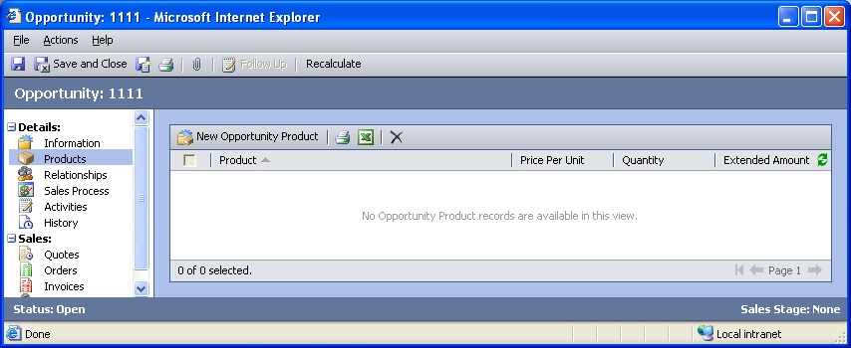

Opportunity Product Form

General Tab
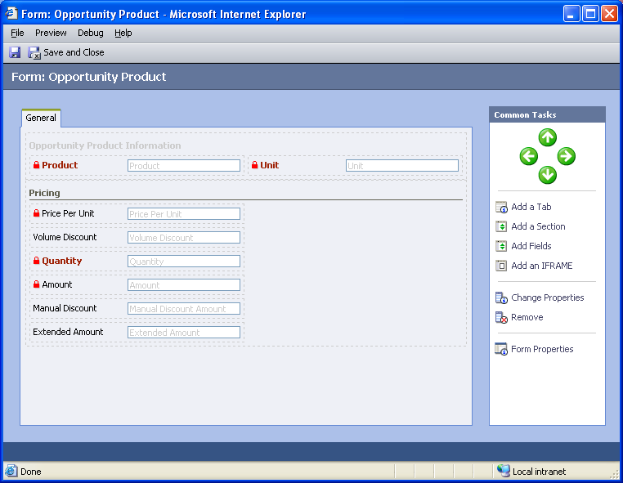

Changes:
Area | Change needed | Report change needed
Display additional fields
Remove or reorder fields
Change labels

New Tabs Needed
New Tab | Fields

Attributes

Existing Attributes Not Used By Default
Display name | Schema name | Type
Created By | createdby | lookup
Created On | createdon | datetime
Description | description | memo
Modified By | modifiedby | lookup
Modified On | modifiedon | datetime
Price Overridden | ispriceoverwritten | boolean
Product Description | productdescription | text
Product Overridden | isprproductoverwritten | boolean
Tax | tax | money

New Attributes Needed
Display name | Schema name | Type

Preview Form
Changes needed
Fields:
Created By
Created On
Modified By
Modified On

Views
No views can be added for the Opportunity Product entity.

Opportunity Product Associated View
Changes needed
Fields:
Product
Price Per Unit
Quantity
Extended Amount
Sorting: Product, ascending

Reports that Use the Opportunity Product Entity
Report | Changes needed to labels | Other changes needed
Competitor Win Loss Details
Products by Account
Products by Account Detail
Products by Contact
Products by Contact Detail

New Reports Needed
New Report | Business need

Relationships and Mapping

Relationships Needed with New Entities
Entity | Attribute | Type of relationship

New Mappings Needed
Entity | Attribute | Type of mapping

