Use this document during review meetings to identify any customizations required to the Microsoft CRM Opportunity entity.

Contents
Opportunity Entity 1
Opportunity List 2
Opportunity Form 2
General Tab 2
Administration Tab 3
Notes Tab 3
New Tabs Needed 4
Attributes 4
Existing Attributes Not Used By Default 4
New Attributes Needed 4
Preview Form 4
Views 4
Closed Opportunities 4
My Open Opportunities (default) 5
Open Opportunities 5
Open Opportunities 5
Opportunities Closing Next Month 5
Opportunities Opened Last Week 5
Opportunities Opened This Week 5
Opportunity Advanced Find View 6
Opportunity Associated View 6
Opportunity Lookup View 6
Opportunities Opened Last Week 6
Quick Find All Opportunities 6
New Views Needed 7
Reports that Use the Opportunity Entity 7
New Reports Needed 7
Relationships and Mapping 7
Relationships Needed with New Entities 7
New Mappings Needed 7

Opportunity Entity

Changes:
Change needed
Rename entity
Rename messages for entity
Description

Opportunity List
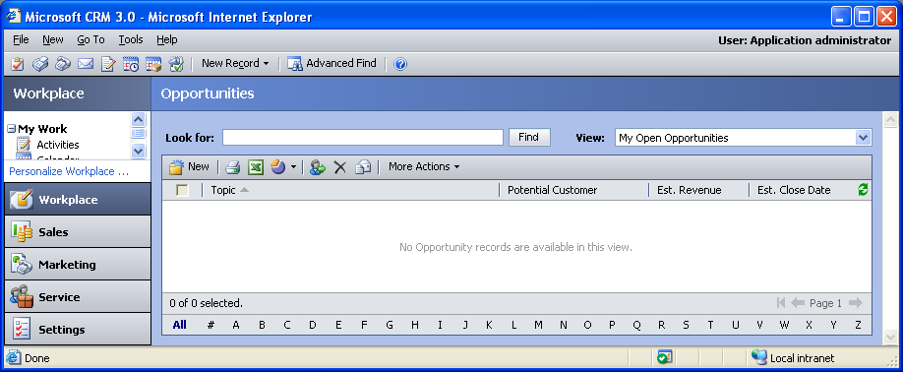

Changes:
Change needed
Default view: My Open Opportunities

Opportunity Form

General Tab
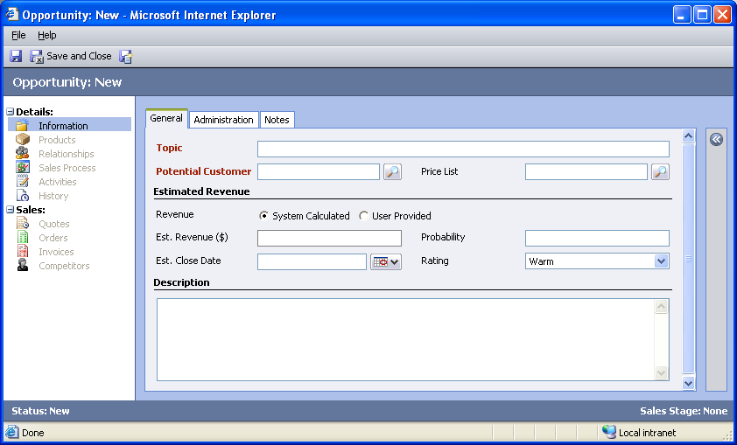

Changes:
Area | Change needed | Report change needed
Display additional fields
Remove or reorder fields
Change labels

Administration Tab
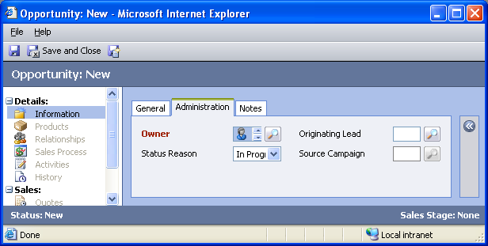

Changes:
Area | Change needed | Report change needed
Display additional fields
Remove or reorder fields
Change labels

Notes Tab
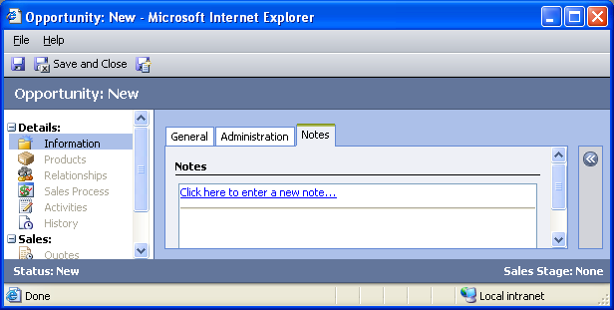

Changes:
Area | Change needed | Report change needed
Display additional fields
Remove or reorder fields
Change labels

New Tabs Needed
New Tab | Fields

Attributes

Existing Attributes Not Used By Default
Display name | Schema name | Type
Actual Close Date | actualclosedate | datetime
Actual Revenue | actualvalue | money
Created By | createdby | lookup
Created On | createdon | datetime
Modified By | modifiedby | lookup
Modified On | modifiedon | datetime
Priority | prioritycode | picklist
Sales Stage | salesstagecode | picklist
Status | statecode | state
Step Name | stepname | text

New Attributes Needed
Display name | Schema name | Type

Preview Form
Changes needed
Fields:
Rating
Probability
Status Reason

Views

Closed Opportunities
Changes needed
Fields:
Topic
Potential Customer
Status
Actual Revenue
Actual Close Date
Sorting: Topic, ascending

My Open Opportunities (default)
Changes needed
Fields:
Topic
Potential Customer
Status
Est. Revenue
Est. Close Date
Sorting: Topic, ascending

Open Opportunities
Changes needed
Fields:
Topic
Potential Customer
Status
Est. Revenue
Est. Close Date
Sorting: Topic, ascending

Open Opportunities
Changes needed
Fields:
Topic
Potential Customer
Status
Est. Revenue
Est. Close Date
Sorting: Topic, ascending

Opportunities Closing Next Month
Changes needed
Fields:
Topic
Potential Customer
Status
Est. Revenue
Est. Close Date
Sorting: Est. Close Date, ascending

Opportunities Opened Last Week
Changes needed
Fields:
Topic
Potential Customer
Status
Est. Revenue
Est. Close Date
Sorting: Topic, ascending

Opportunities Opened This Week
Changes needed
Fields:
Topic
Potential Customer
Status
Est. Revenue
Est. Close Date
Sorting: Topic, ascending

Opportunity Advanced Find View
Changes needed
Fields:
Topic
Potential Customer
Est. Revenue
Status Reason
Sorting: Topic, ascending

Opportunity Associated View
Changes needed
Fields:
Topic
Est. Revenue
Status Reason
Est. Close Date
Sorting: Topic, ascending

Opportunity Lookup View
Changes needed
Display Fields:
Topic
Potential Customer
Find Fields:
Topic
Sorting: Topic, ascending

Opportunities Opened Last Week
Changes needed
Fields:
Name
Topic
Status Reason
Created On
Sorting: Created On, descending

Quick Find All Opportunities
Changes needed
Display Fields:
Topic
Potential Customer
Est. Revenue
Est. Close Date
Find Fields:
Topic
Sorting: Topic, ascending

New Views Needed
New View | Fields and Sorting

Reports that Use the Opportunity Entity
Report | Changes needed to labels | Other changes needed
Account Distribution
Account Distribution Detail
Account Overview Sub-Report
Campaign Comparison
Campaign Opportunity Estimated Revenue Detail
Campaign Opportunity Realized Revenue Detail
Campaign Performance Sub-Report
Competitor Win Loss
Competitor Win Loss Details
Lead Source Effectiveness
Products By Account
Products By Account Detail
Products By Contact
Products By Contact Detail
Sales History
Sales History Detail
Sales Pipeline
Sales Pipeline Detail

New Reports Needed
New Report | Business need

Relationships and Mapping

Relationships Needed with New Entities
Entity | Attribute | Type of relationship

New Mappings Needed
Entity | Attribute | Type of mapping

