Use this document during review meetings to identify any customizations required to the Microsoft CRM Phone Call entity.

Contents
Phone Call Entity 1
Phone Call Form 2
Phone Call Tab 2
Notes Tab 3
New Tabs Needed 3
Attributes 3
Existing Attributes Not Used By Default 3
New Attributes Needed 4
Preview Form 4
Views 4
All Phone Calls 4
My Completed Phone Calls 4
My Phone Calls (default) 4
Phone Call Advanced Find View 5
Phone Call Lookup View 5
My Phone Calls 5
Quick Find All Phone Calls 5
New Views Needed 5
Reports that Use the Phone Call Entity 6
New Reports Needed 6
Relationships and Mapping 6
Relationships Needed with New Entities 6

Phone Call Entity

Changes:
Change needed
Rename entity
Rename messages for entity
Description
Default view: My Phone Calls

Phone Call Form

Phone Call Tab
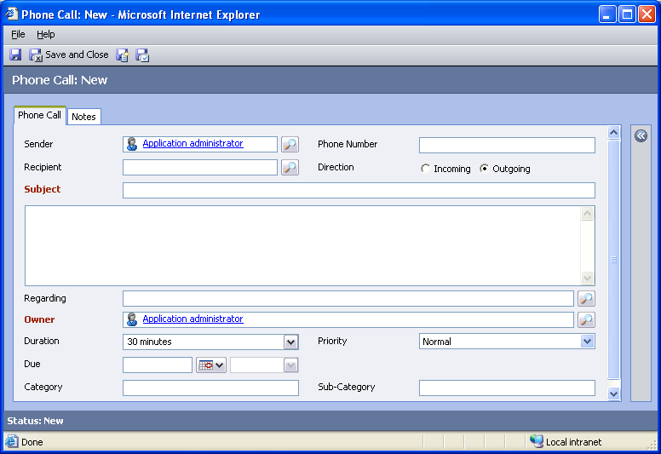

Changes:
Area | Change needed | Report change needed
Display additional fields
Remove or reorder fields
Change labels

Notes Tab
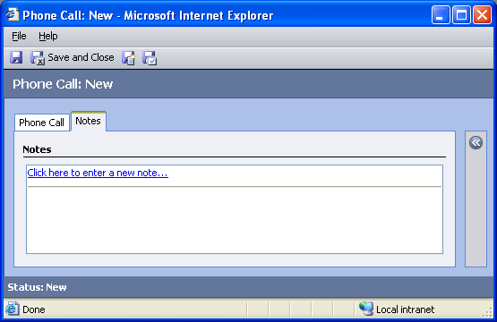

Changes:
Area | Change needed | Report change needed
Display additional fields
Remove or reorder fields
Change labels

New Tabs Needed
New Tab | Fields

Attributes

Existing Attributes Not Used By Default
Display name | Schema name | Type
Activity Status | statecode | state
Actual End | actualend | datetime
Actual Start | actualstart | datetime
Created By | createdby | lookup
Created On | createdon | datetime
Modified By | modifiedby | lookup
Modified On | modifiedon | datetime
Start Date | scheduledstart | datetime
Status Reason | statuscode | status

New Attributes Needed
Display name | Schema name | Type

Preview Form
Changes needed
Fields:
Priority
Created By
Due
Created On

Views

All Phone Calls
Changes needed
Fields:
Subject
Sender
Recipient
Regarding
Direction
Phone Number
Priority
Due Date
Activity Status
Owner
Sorting: Subject, ascending

My Completed Phone Calls
Changes needed
Fields:
Sender
Recipient
Subject
Regarding
Actual End
Sorting: Actual End, descending

My Phone Calls (default)
Changes needed
Fields:
Recipient
Phone Number
Subject
Regarding
Priority
Due
Sorting: Due, ascending

Phone Call Advanced Find View
Changes needed
Fields:
Subject
Activity Status
Priority
Due
Created By
Regarding
Sorting: Subject, ascending

Phone Call Lookup View
Changes needed
Display Fields:
Subject
Due
Activity Status
Find Fields:
Subject
Sorting: Subject, ascending

My Phone Calls
Changes needed
Fields:
Subject
Sender
Recipient
Regarding
Activity Status
Created On
Sorting: Created On, descending

Quick Find All Phone Calls
Changes needed
Display Fields:
Subject
Activity Status
Priority
Due
Created By
Regarding
Find Fields:
Subject
Sorting: Subject, ascending

New Views Needed
New View | Fields and Sorting

Reports that Use the Phone Call Entity
No default reports use the Phone Call entity.

New Reports Needed
New Report | Business need

Relationships and Mapping
No default relationships in the Phone Call entity are mappable.

Relationships Needed with New Entities
Entity | Attribute | Type of relationship

