Use this document during review meetings to identify any customizations required to the Microsoft CRM Sales Literature entity.

Contents
Sales Literature Entity 1
Sales Literature List 1
Sales Literature Form 2
General Tab 2
New Tabs Needed 2
Attributes 2
Existing Attributes Not Used By Default 2
New Attributes Needed 3
Preview Form 3
Views 3
All Sales Literature (default) 3
Quick Find View Sales Literature 3
Sales Literature Advanced Find View 3
Sales Literature Associated View 3
Sales Literature Lookup View 4
Reports that Use the Sales Literature Entity 4
New Reports Needed 4
Relationships and Mapping 4
Relationships Needed with New Entities 4

Sales Literature Entity

Changes:
Change needed
Rename entity
Rename messages for entity
Description

Sales Literature List
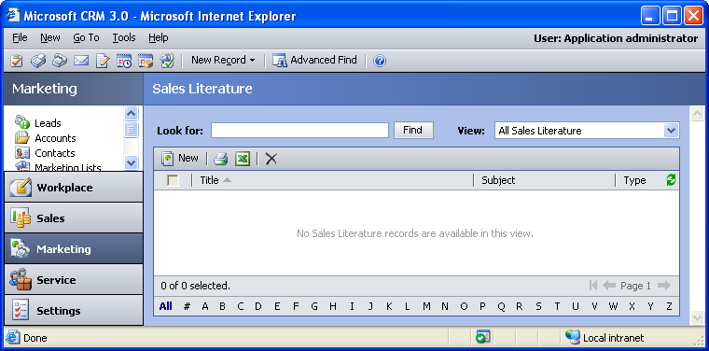

Changes:
Change needed
Default view: All Sales Literature

Sales Literature Form

General Tab
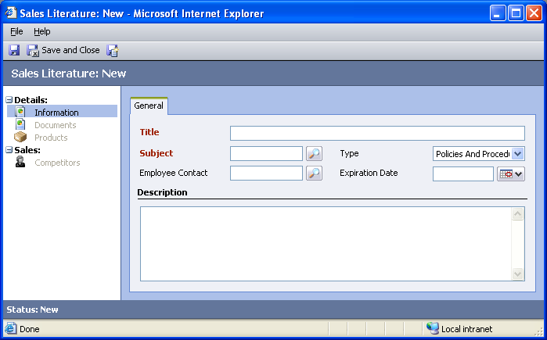

Changes:
Area | Change needed | Report change needed
Display additional fields
Remove or reorder fields
Change labels

New Tabs Needed
New Tab | Fields

Attributes

Existing Attributes Not Used By Default
Display name | Schema name | Type
Created By | createdby | lookup
Created On | createdon | datetime
Customer Viewable | iscustomerviewable | boolean
Key Words | keywords | memo
Modified By | modifiedby | lookup
Modified On | modifiedon | datetime

New Attributes Needed
Display name | Schema name | Type

Preview Form
Changes needed
Fields:
Expiration Date
Employee Contact

Views

All Sales Literature (default)
Changes needed
Fields:
Title
Subject
Type
Sorting: Title, ascending

Quick Find View Sales Literature
Changes needed
Display Fields:
Title
Subject
Type
Find Fields
Title
Sorting: Title, ascending

Sales Literature Advanced Find View
Changes needed
Fields:
Title
Subject
Sorting: Title, descending

Sales Literature Associated View
Changes needed
Fields:
Title
Subject
Sorting: Title, descending

Sales Literature Lookup View
Changes needed
Display Fields:
Title
Type
Find Fields
Title
Sorting: Title, ascending

Reports that Use the Sales Literature Entity
Report | Changes needed to labels | Other changes needed
Campaign Performance Sub-Report

New Reports Needed
New Report | Business need

Relationships and Mapping
No default relationships in the Sales Literature entity are mappable.

Relationships Needed with New Entities
Entity | Attribute | Type of relationship

