Use this document during review meetings to identify any customizations required to the Microsoft CRM Service Activity entity.

Contents
Service Activity Entity 1
Form 1
Service Activity Tab 2
Details Tab 3
New Tabs Needed 3
Service Calendar Form 3
General Tab 4
New Tabs Needed 4
Preview Form 4
Attributes 5
Existing Attributes Not Used By Default on Form 5
New Attributes Needed 5
Views 5
All Service Activities 5
My Service Activities 5
Quick Find All Service Activities 6
Service Activity Advanced Find View 6
Service Activity Lookup View 6
New Views Needed 6
Reports that Use the Service Activity Entity 6
New Reports Needed 6
Relationships and Mapping 7
Relationships Needed with New Entities 7

Service Activity Entity

Changes:
Change needed
Rename entity
Rename messages for entity
Description

Form
This form is used to create a new service activity from the Service Calendar.

Service Activity Tab
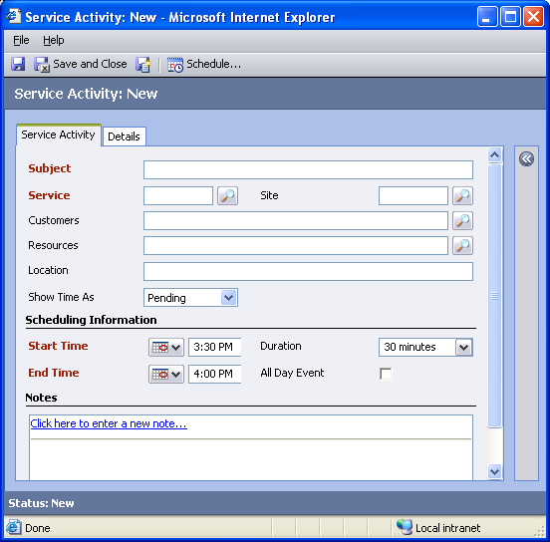

Changes:
Area | Change needed | Report change needed
Display additional fields
Remove or reorder fields
Change labels

Details Tab
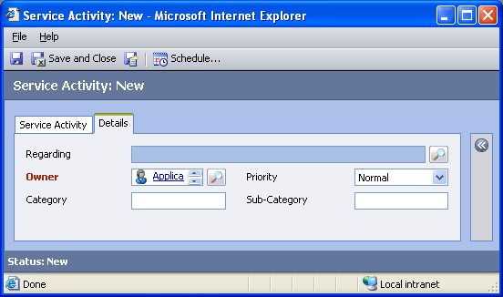

Changes:
Area | Change needed | Report change needed
Display additional fields
Remove or reorder fields
Change labels

New Tabs Needed
New Tab | Fields

Service Calendar Form
This form is used to view information about a service activity from the Service Calendar. To get to this form, in the Service Calendar, in the Type box select Service Activity, select a service activity, and then at the bottom of the page, click the down arrow below the Zoom scale.

Service Activity Tab
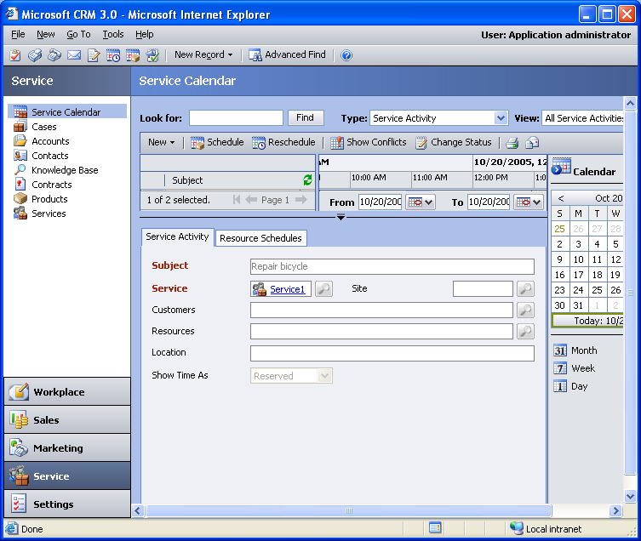

Changes:
Area | Change needed | Report change needed
Display additional fields
Remove or reorder fields
Change labels

New Tabs Needed
New Tab | Fields

Preview Form
Changes needed
Fields:
Service
Site
Show Time As
Delivery Location

Attributes

Existing Attributes Not Used By Default on Form
Display name | Schema name | Type
Actual Duration | actualdurationminutes | integer
Actual End | actualend | datetime
Actual Start | actualstart | datetime
Created By | createdby | lookup
Created On | createdon | datetime
Description | description | memo
Modified By | modifiedby | lookup
Modified On | modifiedon | datetime
Status | statecode | state

New Attributes Needed
Display name | Schema name | Type

Views

All Service Activities
Changes needed
Fields:
Subject
Regarding
Customers
Resources
Service
Site
Priority
Scheduled Start
Scheduled End
Sorting: Scheduled Start, ascending

My Service Activities
Changes needed
Fields:
Customers
Service
Subject
Regarding
Site
Priority
Scheduled Start
Scheduled End
Sorting: Scheduled Start, ascending

Quick Find All Service Activities
Changes needed
Display Fields:
Subject
Customers
Resources
Service
Site
Scheduled Start
Scheduled End
Find Fields:
Service
Subject
Sorting: Scheduled Start, ascending

Service Activity Advanced Find View
Changes needed
Fields:
Subject
Status
Scheduled Start
Scheduled End
Created By
Regarding
Sorting: Subject, ascending

Service Activity Lookup View
Changes needed
Display Fields:
Subject
Scheduled End
Status
Find Fields:
Subject
Sorting: Subject, ascending

New Views Needed
New View | Fields and Sorting

Reports that Use the Service Activity Entity
Report | Changes needed to labels | Other changes needed
Service Activity Volume
Service Activity Volume Detail

New Reports Needed
New Report | Business need

Relationships and Mapping
No default relationships in the Service Activity entity are mappable.

Relationships Needed with New Entities
Entity | Attribute | Type of relationship

