Use this document during review meetings to identify any customizations required to the Microsoft CRM Task entity.

Contents
Task Entity 1
Task Form 2
Task Tab 2
Notes Tab 3
New Tabs Needed 3
Attributes 3
Existing Attributes Not Used By Default 3
New Attributes Needed 4
Preview Form 4
Views 4
All Tasks 4
My Tasks (default) 4
Quick Find All Tasks 4
Task Advanced Find View 5
Task Lookup View 5
New Views Needed 5
Reports that Use the Task Entity 5
New Reports Needed 5
Relationships and Mapping 5
Relationships Needed with New Entities 5

Task Entity

Changes:
Change needed
Rename entity
Rename messages for entity
Description
Default view: My Tasks

Task Form

Task Tab
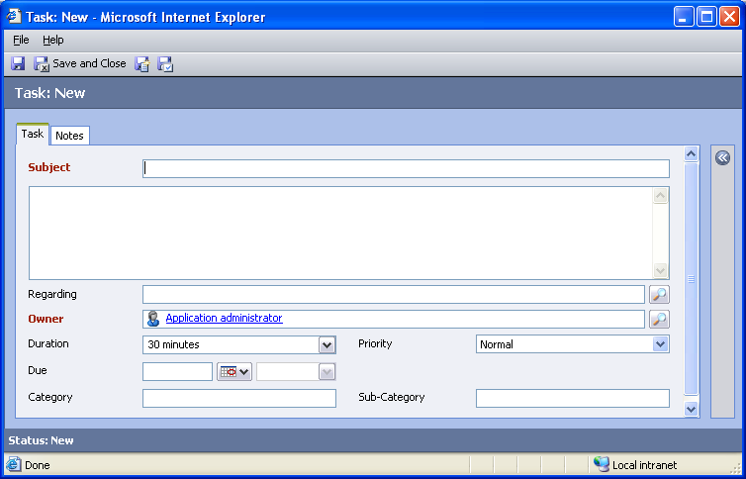

Changes:
Area | Change needed | Report change needed
Display additional fields
Remove or reorder fields
Change labels

Notes Tab
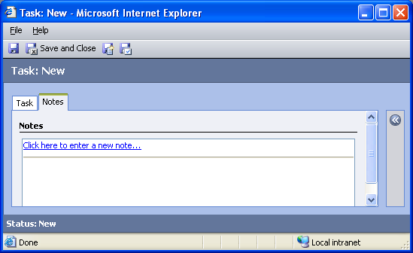

Changes:
Area | Change needed | Report change needed
Display additional fields
Remove or reorder fields
Change labels

New Tabs Needed
New Tab | Fields

Attributes

Existing Attributes Not Used By Default
Display name | Schema name | Type
Activity Status | statecode | state
Actual End | actualend | datetime
Actual Start | actualstart | datetime
Created By | createdby | lookup
Created On | createdon | datetime
Modified By | modifiedby | lookup
Modified On | modifiedon | datetime
Percent Complete | percentcomplete | integer
Start Date | scheduledstart | datetime
Status Reason | statuscode | status

New Attributes Needed
Display name | Schema name | Type

Preview Form
Changes needed
Fields:
Priority
Created By
Due
Created On

Views

All Tasks
Changes needed
Fields:
Subject
Regarding
Owner
Priority
Due Date
Status Reason
Sorting: Subject, ascending

My Tasks (default)
Changes needed
Fields:
Subject
Regarding
Due Date
Priority
Sorting: Due Date, ascending

Quick Find All Tasks
Changes needed
Display Fields:
Subject
Activity Status
Priority
Due Date
Created By
Regarding
Find Fields:
Subject
Sorting: Subject, ascending

Task Advanced Find View
Changes needed
Fields:
Subject
Activity Status
Priority
Due Date
Created By
Regarding
Sorting: Subject, ascending

Task Lookup View
Changes needed
Display Fields:
Subject
Due Date
Activity Status
Find Fields:
Subject
Sorting: Subject, ascending

New Views Needed
New View | Fields and Sorting

Reports that Use the Task Entity
Report | Changes needed to labels | Other changes needed
Campaign Performance Sub-Report
Campaign Task Detail

New Reports Needed
New Report | Business need

Relationships and Mapping
No default relationships in the Task entity are mappable.

Relationships Needed with New Entities
Entity | Attribute | Type of relationship

