Use this document during review meetings to identify any customizations required to the Microsoft CRM Territory entity.

Contents
Territory Entity 1
Territory List 1
Territory Form Not Customizable 2
General Tab 2
Attributes 2
Views 2
All Territories (default) 2
Territory Advanced Find View 2
Territory Lookup View 2
Territory Quick Find View 3
New Views Needed 3
Reports that Use the Territory Entity 3
New Reports Needed 3
Relationships and Mapping 3
Relationships Needed with New Entities 3

Territory Entity

Changes:
Change needed
Rename entity
Rename messages for entity
Description

Territory List
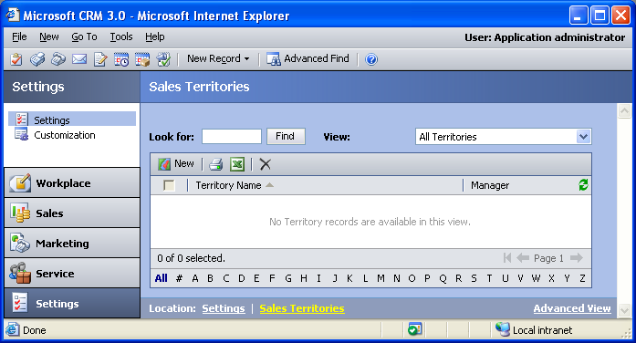

Changes:
Change needed
Default view: All Territories

Territory Form Not Customizable

General Tab
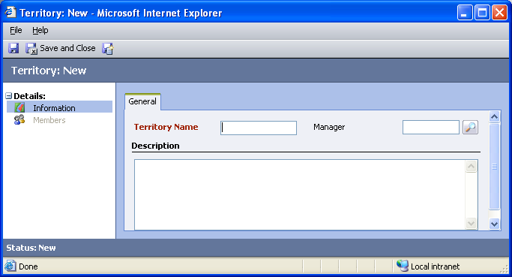

Attributes
The descriptions of attributes can be changed, but attributes cannot be added or deleted from the Territory entity.

Views

All Territories (default)
Changes needed
Fields:
Territory Name
Manager
Sorting: Territory Name, ascending

Territory Advanced Find View
Changes needed
Fields:
Territory Name
Manager
Sorting: Territory Name, ascending

Territory Lookup View
Changes needed
Display Fields:
Territory Name
Find Fields:
Territory Name
Sorting: Territory Name, ascending

Territory Quick Find View
Changes needed
Display Fields:
Territory Name
Manager
Find Fields:
Territory Name
Manager
Sorting: Territory Name, ascending

New Views Needed
New View | Fields and Sorting

Reports that Use the Territory Entity
No default reports use the Territory entity.

New Reports Needed
New Report | Business need

Relationships and Mapping
No default relationships in the Territory entity are mappable.

Relationships Needed with New Entities
Entity | Attribute | Type of relationship

