Use this document during review meetings to identify any customizations required to the Microsoft CRM User entity.

Contents
User Entity 1
User List 2
Form 2
General Tab 2
Addresses Tab 3
New Tabs Needed 3
Service Calendar Form 3
General Tab 4
New Tabs Needed 4
Preview Form 4
Attributes 5
Existing Attributes Not Used By Default on Form 5
New Attributes Needed 5
Views 6
All Salespersons 6
Disabled Users 6
Enabled Users (default) 6
Local Business Users 6
My Direct Reports 6
Quick Find All Users 7
Restricted Access Users 7
Service Calendar Form 7
Salesperson Associated View – By Territories 7
Subsidiary Users 7
User Advanced Find View 7
User Associated View 8
User Lookup View 8
New Views Needed 8
Reports that Use the User Entity 8
New Reports Needed 9
Relationships and Mapping 9
Relationships Needed with New Entities 9
New Mappings Needed 9

User Entity

Changes:
Change needed
Rename entity
Rename messages for entity
Description

User List
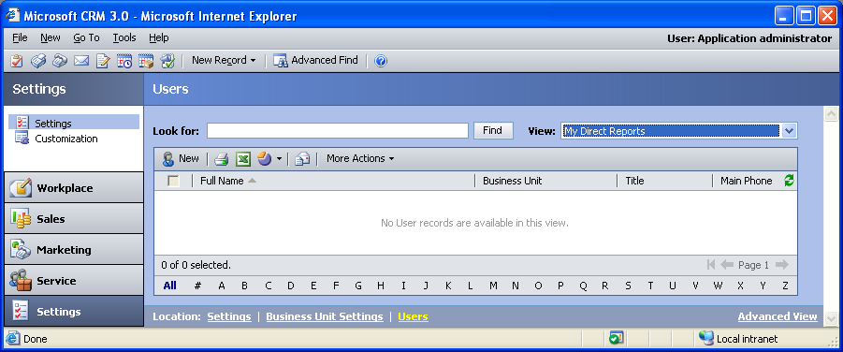

Changes:
Change needed
Default view: Enabled Users

Form
This form is used to create a new user.

General Tab
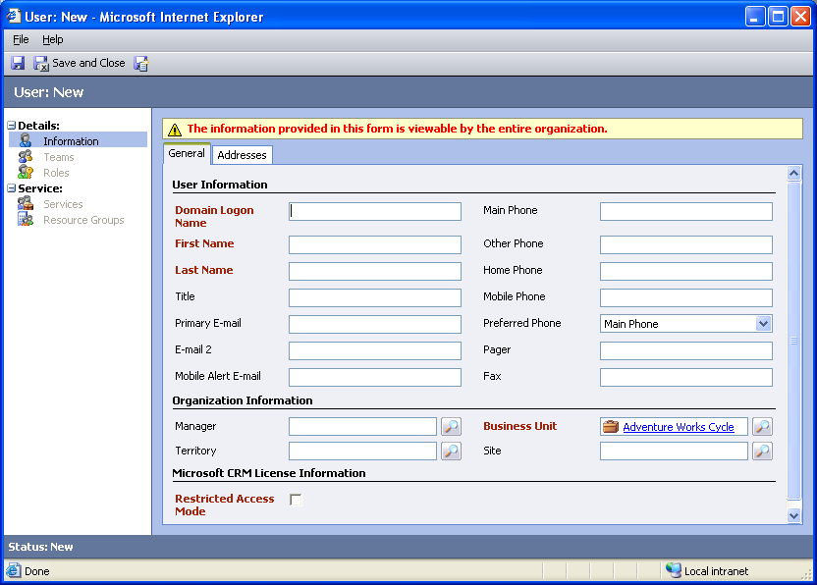

Changes:
Area | Change needed | Report change needed
Display additional fields
Remove or reorder fields
Change labels

Addresses Tab
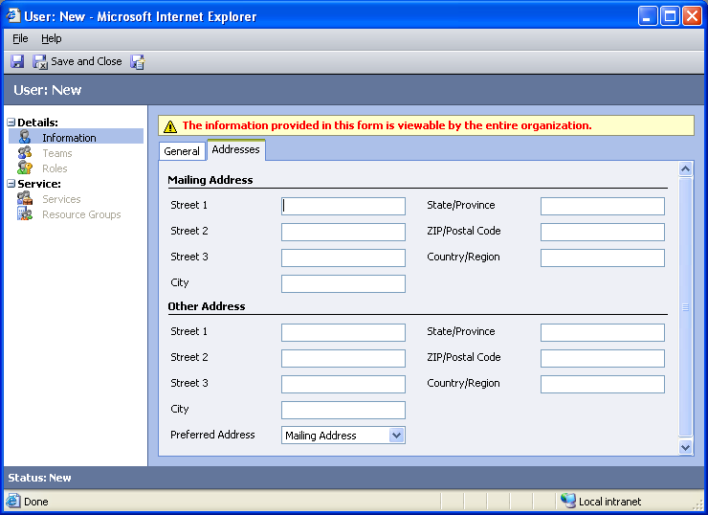

Changes:
Area | Change needed | Report change needed
Display additional fields
Remove or reorder fields
Change labels

New Tabs Needed
New Tab | Fields

Service Calendar Form
This form is used to view information about a user from the Service Calendar. To get to this form, in the Service Calendar, in the Type box select User, select a user, and then at the bottom of the page, click the down arrow below the Zoom scale.

General Tab
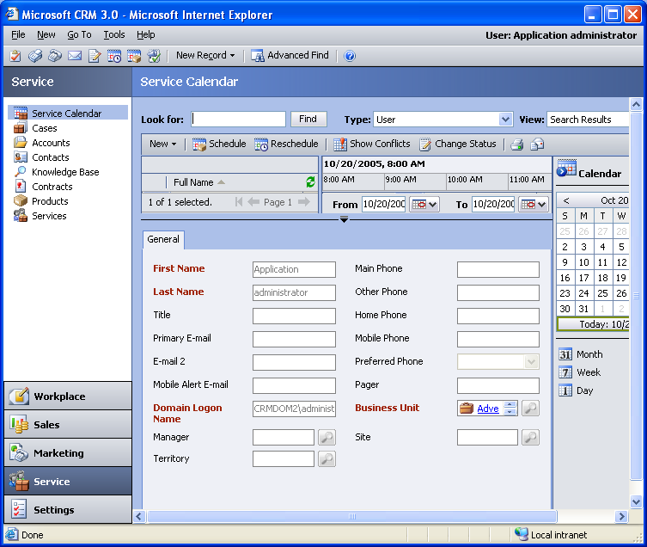

Changes:
Area | Change needed | Report change needed
Display additional fields
Remove or reorder fields
Change labels

New Tabs Needed
New Tab | Fields

Preview Form
Changes needed
Fields:
Mailing Street 1
Mailing City
Mailing State/Province
Primary E-mail
Mobile Phone
Mailing ZIP/Postal Code

Attributes

Existing Attributes Not Used By Default on Form
Display name | Schema name | Type
Address 1: County | address1_county | text
Address 1: Latitude | address1_latitude | float
Address 1: Longitude | address1_longitude | float
Address 1: Name | address1_name | text
Address 1: Post Office Box | address1_postofficebox | text
Address 2: County | address2_county | text
Address 2: Fax | address2_fax | text
Address 2: Latitude | address2_latitude | float
Address 2: Longitude | address2_longitude | float
Address 2: Name | address2_name | text
Address 2: Post Office Box | address2_postofficebox | text
Address 2: Telephone 1 | address2_telephone1 | text
Address 2: Telephone 2 | address2_telephone2 | text
Address 2: Telephone 3 | address2_telephone3 | text
Address 2: UPS Zone | address2_upszone | text
Address 2: UTC offset | address2_utcoffset | integer
Created By | createdby | lookup
Created On | createdon | datetime
Employee | employeeid | text
Full Name | fullname | text
Job Title | jobtitle | text
Middle Name | middlename | text
Modified By | modifiedby | lookup
Modified On | modifiedon | datetime
Nickname | nickname | text
Photo URL | photourl | text
Preferred E-mail | preferredemailcode | picklist
Salutation | salutation | text
Skills | skills | text

New Attributes Needed
Display name | Schema name | Type

Views

All Salespersons
Changes needed
Fields:
Full Name
Territory
Title
Main Phone
Sorting: Full Name, ascending

Disabled Users
Changes needed
Fields:
Full Name
Business Unit
Title
Main Phone
Sorting: Full Name, ascending

Enabled Users (default)
Changes needed
Fields:
Full Name
Business Unit
Title
Main Phone
Sorting: Full Name, ascending

Local Business Users
Changes needed
Fields:
Full Name
Business Unit
Title
Main Phone
Sorting: Full Name, ascending

My Direct Reports
Changes needed
Fields:
Full Name
Business Unit
Title
Main Phone
Sorting: Full Name, ascending

Quick Find All Users
Changes needed
Display Fields:
Full Name
Main Phone
Business Unit
Site
Title
Primary E-mail
Find Fields:
First Name
Full Name
Last Name
Primary E-mail
Sorting: Full Name, ascending

Restricted Access Users
Changes needed
Fields:
Full Name
Business Unit
Title
Main Phone
Sorting: Full Name, ascending

Service Calendar Form
This form is not used anywhere in Microsoft CRM.

Salesperson Associated View – By Territories
Changes needed
Fields:
Full Name
Business Unit
Main Phone
Sorting: Full Name, ascending

Subsidiary Users
Changes needed
Fields:
Full Name
Business Unit
Title
Main Phone
Sorting: Full Name, ascending

User Advanced Find View
Changes needed
Fields:
Full Name
Business Unit
Title
Main Phone
Sorting: Full Name, ascending

User Associated View
Changes needed
Fields:
Full Name
Business Unit
Title
Status
Sorting: Full Name, ascending

User Lookup View
Changes needed
Display Fields:
Full Name
Main Phone
Business Unit
Site
Title
Primary E-mail
Find Fields:
First Name
Full Name
Last Name
Primary E-mail
Sorting: Full Name, ascending

New Views Needed
New View | Fields and Sorting

Reports that Use the User Entity
Report | Changes needed to labels | Other changes needed
Account Overview
Account Summary
Account Summary Sub-Report
Campaign Activity Status
Campaign Activity Status Detail
Campaign Activity Status Sub-Report
Campaign Comparison
Campaign Opportunity Estimated Revenue Detail
Campaign Opportunity Realized Revenue Detail
Campaign Performance
Campaign Performance Sub-Report
Campaign Placed Order Detail
Campaign Response Detail
Campaign Task Detail
Case Summary Table
Case Summary Table Detail
Competitor Win Loss
Competitor Win Loss Details
Invoice Status
Invoice Status Detail
Lead Source Effectiveness
Neglected Accounts
Neglected Accounts Detail
Neglected Cases
Neglected Cases Detail
Neglected Leads
Neglected Leads Detail
Products By Account
Products By Account Detail
Products By Contact
Products By Contact Detail
Sales History
Sales History Detail
Sales Pipeline
Sales Pipeline Detail
Service Activity Volume
Service Activity Volume Detail
Top Knowledge Base Articles
Top Knowledge Base Articles Detail
User Summary
Neglected Leads

New Reports Needed
New Report | Business need

Relationships and Mapping

Relationships Needed with New Entities
Entity | Attribute | Type of relationship

New Mappings Needed
Entity | Attribute | Type of mapping

