

Performance Management Scorecards and Dashboards for IT Operations Data

A framework for creating IT Operations scorecards, dashboards, and analytics with Microsoft SQL Server, Systems Center Operations Manager, and Microsoft Office PerformancePoint Server 2007

Prepared for Microsoft by:

Rex Parker
Lily Business Intelligence
for Slalom Consulting

Published: August 2008
For the latest information, please see http://www.microsoft.com/BI
Contents
Overview 2
Framework Capabilities 2
Framework Scope 3
Example Solutions 3
Framework Requirements 6
Skill Set Requirements 6
Product Requirements 6
Building the Solution 7
Collect the Source Data 9
Performance Star Schema Overview 9
State Star Schema Overview 10
Data Warehouse Views 12
Performance Counters Star Schema Source Views and Queries 12
State Star Schema Source Views and Queries 18
Integrating Data from Multiple Data Warehouses and Other Systems 21
Build the OLAP Cube 23
Create the Data Source View 23
Create the OLAP Cube – Measure Groups, Measures, and Dimensions 24
Run the Cube Wizard 25
Modify Measure Groups, Measures and Dimensions 26
Add Hierarchies and Modify Attributes 28
Create Calculated Measures 35
Process the Cube 38
Put it All Together - Create Dashboards, Scorecards, and Analytic Reports 39
Office PerformancePoint 2007 Scorecards 40
Why Office PerformancePoint 2007 Scorecards? 40
Create Key Performance Indicators (KPIs) 40
Balanced IT Scorecards 49
Service Level Agreement (SLA) Scorecards 52
Analytic Reports and Dashboards 54
Office PerformancePoint Server 2007 Reports 54
Office PerformancePoint 2007 Dashboards 58
Next Steps – Future Application Areas 62
Conclusion 64
Evaluation Software …………………………………………………………………………………64
Appendix A: Operations Manager Data Warehouse Sample Queries 65
Performance Counters Map Query 65
Populate the SQL Entities Performance Counters Dimension Table 65
Populate the Entity Monitors Dimension Table 66
Populate the Performance Rules Fact Table 67
Populate the Date Dimension Table 68
Populate the Hour Dimension Table 69
Populate the Entity Monitors Dimension Table 70
Populate the State Dimension 71
Populate the State Staging Table 71
Populate the State Fact Table 72
Appendix B: Operations Manager BI Star Schema Diagrams 73
State Star Schema 73
Performance Counters Star Schema 73
Supporting Tables 74

Overview
This document provides direction and samples for creating a Business Intelligence framework for data collected by Microsoft®Systems Center Operations Manager. This framework is architected to enable web-based dashboards that can provide an integrated (balanced) view of IT performance. Dashboards include scorecards that allow any type of key performance indicators (KPIs) to be rolled up into a score for a particular application area, overall IT performance, or anywhere in-between. Analytic views and reports are included in the dashboard to add context and relevance to KPIs, so that users can investigate performance issues by drilling into (slicing and dicing) the data.

Framework Capabilities
 This paper includes direction, code samples, and example solutions for an IT Operations Business Intelligence framework, including performance management scorecards and dashboards. This framework should be considered a starting point rather than a finished solution.

Capabilities of this framework include:
- Scorecards that support KPIs (measured values and targets) from various data sources such as Analysis Services, Microsoft Office Excel® 2007, Excel Services in Microsoft Office SharePoint® Server 2007 and fixed data entry
- Aggregate (or roll-up) seemingly disparate metrics into a single overall “score” for IT performance – for example: application availability, performance counters (free disk space, database free space, transaction/user counts) may be aggregated in the same scorecard
- A user-friendly OLAP data model that stores pre-aggregated data for fast ad-hoc query performance
- Data trending to help identify patterns and exceptions
- Ad-hoc analytics (with the OLAP data model and client tools) help users determine root cause for under-performing metrics
- Drill-down and drill-to-detail can provide event detail to help users understand issues or performance characteristics such as capacity spikes, application downtime, etc.
- Web-based dashboards and scorecards may be distributed easily to virtually any user with Microsoft Office PerformancePoint Server 2007 and Microsoft Office SharePoint Server 2007
- An analytic data model (OLAP cube) that may be used with many client tools including Office Excel 2007, ProClarity, and Reporting Services
- A robust security model that provides data security starting at web sites and dashboards, all the way down to cell-level detail
- OLAP data model “sandbox” that can facilitate data integration for multiple Microsoft System Center Operations Manager data warehouse instances, or from other IT monitoring systems – without zero impact to the System Center Operations Manager operational database or data warehouse

Framework Scope
The examples in this document are scoped to include data from a specific set of facts and managed entities.
- Performance Counters – performance counter data for managed entities – example: Windows Computers – disk free space, free memory, CPU utilization. All performance counters are included for a specific set of managed entities (see below).
- Performance Counter Managed Entities:
  - Microsoft SQL Server® 2008 Enterprise Database Engine
  - SQL Server 2008 Computers - Windows Computers running SQL Server
  - SQL Server Instances
- State – measures the state of the following monitors:
  - Availability
  - Performance
  - Security
  - Health
  - Configuration
- State Managed Entities:
  - SQL Server Database Engine
  - SQL Server Computers - Windows Computers running SQL Server
  - SQL Server Instances
  - Internet Information Services
    - Web Sites
    - Application Pools
The managed entities included in these examples have been selected as to prevent some data integrity issues when building the OLAP cubes. These issues are described in more detail in a later section. In addition, we will discuss how to add other types of managed entities (such as Office SharePoint Server 2007 or Microsoft Exchange servers) to the solution.

Example Solutions
The following screenshots include examples of web-based scorecards and dashboards that have been created with this framework. The first example is an IT operations “overview” dashboard page. The scorecard includes metrics from different performance areas including: application availability, database and Windows server performance counters. Analytic views provide detail uptime/downtime data, and trend lines for critical performance counters.

Figure 1: Sample Dashboard Page - IT Operations "Overview"
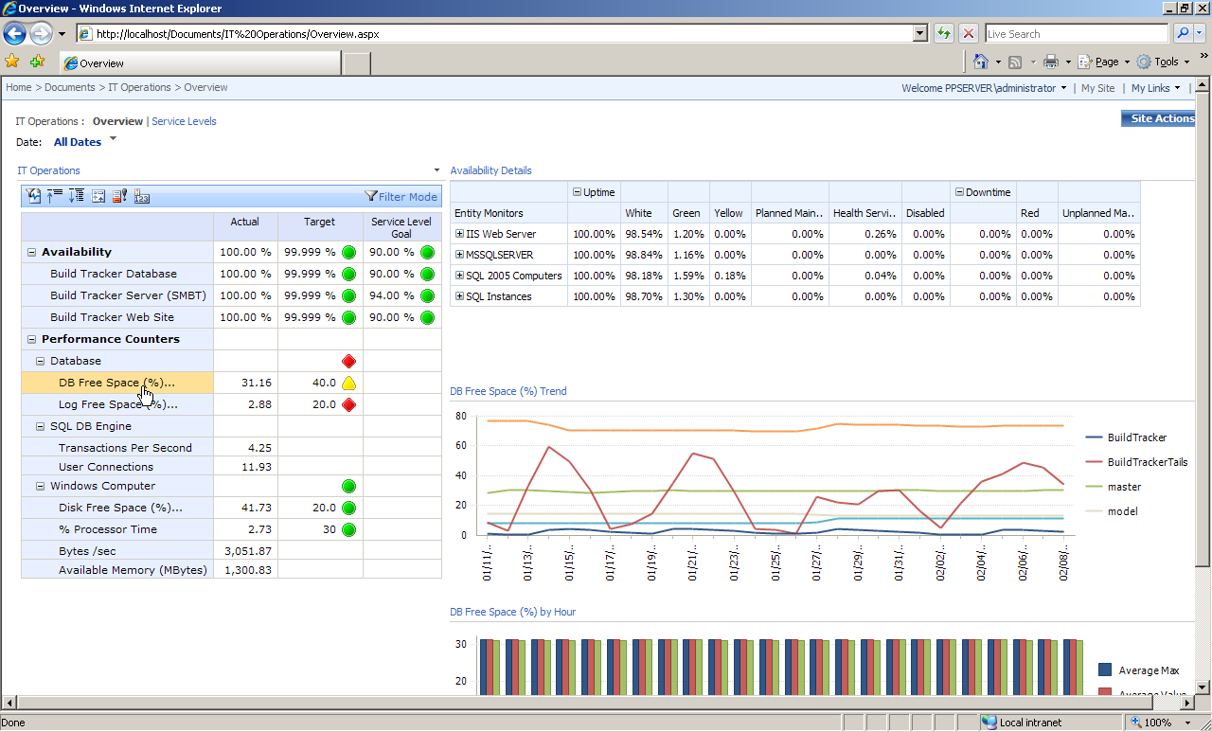

The following example shows a dashboard page for measuring service level agreements (SLAs.) The scorecard includes availability KPIs for various system components, or managed entities including web sites, databases, and windows servers. The KPIs include multiple targets for measuring status against an internal IT target and an external service level agreement. Managed entities may be grouped into custom categories such as “Gold, Silver, and Bronze” as shown below, or lines or business (LOB) throughout the organization.

Analytic views provide detailed performance counter information and trends to help the user identify why a particular managed entity is not meeting targets. Analytic views may be configured to be in-context to the selected KPI; meaning that when a particular KPI is selected, the analytic views that are displayed are filtered to, or unique to the selected KPI – so that the entire dashboard remains in-context. In the example below, the availability metric for a Windows server (ESSENTIALSDF) is selected, and the analytic views display (from top to bottom):
- All performance counters that are collected for that server
- Trend line of CPU utilization for a rolling 24-hour period
- Trend line of memory utilization for a rolling 24-hour period

Figure 2: Sample Dashboard Page - Service Level Agreements (SLAs)
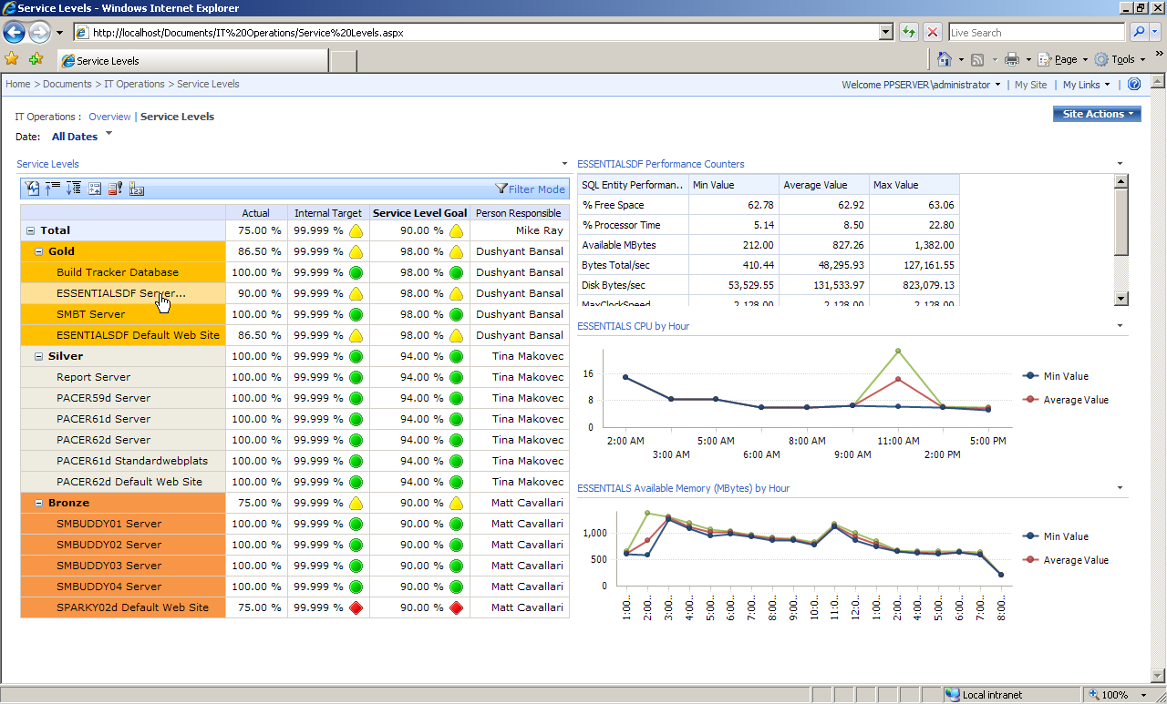

Any number of client tools may be used to analyze the data in the Analysis Services OLAP cube, including Office Excel 2007 and ProClarity. This can simplify data access for all users, by allowing them to use tools they are already proficient with. For example, the following screen shot shows an Ofice Excel 2007 pivot table “heat map” of available disk space for all Windows servers.

Figure 3: Sample Pivot Table - Disk Free Space by Server
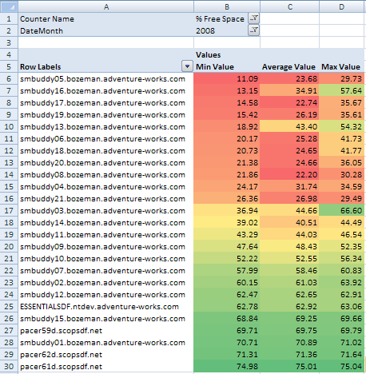

 This framework is intended to complement (and is not a replacement for) the reporting capabilities that are provided out-of-the-box in Operations Manager. Reports may be used in Office PerformancePoint Server2007 dashboards to provide additional details for KPIs and scorecards. Report integration is discussed in a later section.

Framework Requirements
This section outlines the skill sets and products required to implement, modify, or maintain this framework.

Skill Set Requirements
- Basic knowledge of T-SQL
- Basic knowledge of SQL Server 2005 Integration Services
- Basic understanding of data warehousing and OLAP concepts including star schemas, facts and dimensions
- Intermediate knowledge of SQL Server 2005 Analysis Services
- Intermediate knowledge of Operations Manager. Understanding of terminology used with Operations Manager is assumed in this document.
- Familiarity with the Manager data warehouse (see the Operations Manager Report Authoring Guide)
- Basic knowledge of Office PerformancePoint Server 2007 Monitoring and Analytics
- Basic knowledge of Office SharePoint Server 2007 or Windows® SharePoint Services
A finished sample including sample data sets, SSIS packages, OLAP cubes, and dashboard files is available for download. Please view the online version of this document for instructions on downloading the sample.

Product Requirements
- Microsoft SQL Server 2005 (database engine, Analysis Services, Integration Services) – system requirements here
  - NOTE: SQL Server 2005 Developer Edition was used for this framework; other editions may work but were not tested. It is believed that the framework should work with Standard Edition or above.
- Office SharePoint Server 2007 – system requirements here
- OR Windows SharePoint Services 3.0 SP1 – system requirements here
- Windows SharePoint Services 3.0 SP1) Office PerformancePoint Server 2007 – system requirements here
- System Center Operations Manager 2007 – system requirements here
- Windows Server® 2003
  - NOTE: Windows Server 2003® Enterprise Edition was used for this framework; other editions may work but were not tested.

Building the Solution
The following sections contain directions for how to create the Business Intelligence framework, from source data to finished dashboards and scorecards. The screenshots and examples used in the following sections were created with the sample dataset and solution mentioned previously.
 After reviewing this document, it is recommended that the sample dataset and solution are downloaded and installed, so the examples in this paper can be walked-through alongside a live, completed solution.

The following diagram illustrates the major components of the framework, and the flow of data from source data to the finished dashboards. Data processes are numbered one through six in the diagram, with detailed descriptions to follow.

Figure 4: Data Flow Diagram
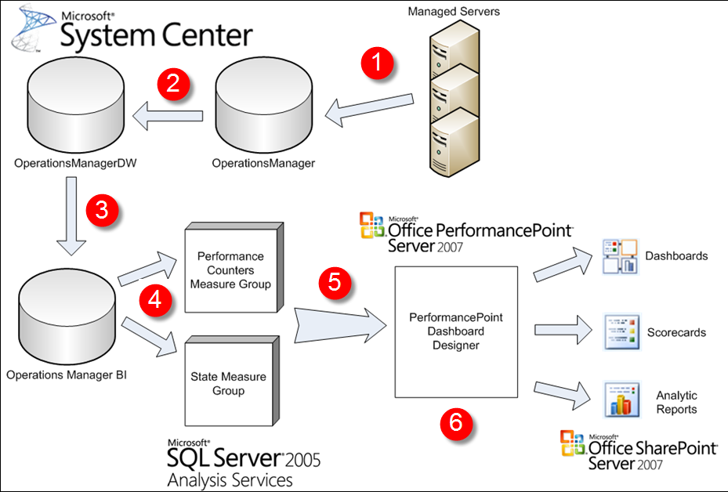

- System Center Operations Manager managed servers collect monitor state and performance counter data saved in the Operations Manager operational database.
- The Operations Manager data warehouse (OperationsManagerDW) collects data from the operational database. Data is pre-aggregated and stored in tables architected to support production reporting requirements.

Steps one and two are out-of-the box processes for Operations Manager. The Business Intelligence framework begins with the following step, the population of a new Business Intelligence database.

- Collect the Source Data - A small subset of data in the Operations Manager data warehouse is transformed and loaded into the Business Intelligence framework database (OperationsManagerBusiness Intelligence). This database contains the star schemas for the Analysis Services OLAP cubes.
- Build OLAP Cubes - Analysis Services OLAP cubes are built and processed from data stored in the OperationsManagerBI database.
- Put it All Together - Create Office PerformancePoint Server 2007 Dashboards, Scorecards, and Analytic Reports - Data from the OLAP cubes is used to populate PerformancePoint Server scorecards, dashboards, and analytic reports. These components are originally created using the Office PerformancePoint Server 2007 Dashboard Designer.
- Deploy Dashboards, Scorecards, and Analytic Reports in SharePoint - Scorecards, dashboards, and analytic reports are made available to the user community through SharePoint Server. Once the scorecards, dashboards, and analytic reports are initially created and deployed, they should not need to be deployed again – these components will be refreshed as new data becomes available in the OLAP cubes.

Collect the Source Data
The first task is to collect source data and load it into star schemas, from which OLAP cubes can be built. The data source for this framework is the SCOM data warehouse. Data from the SCOM data warehouse is loaded into a new database, OperationsManager Business Intelligence. This new database contains the star schemas for the OLAP cubes. Note that data is loaded from the data warehouse, not the operational database. Retrieving data from the data warehouse (rather than the operational database) gives us several advantages, including:
- Data is pre-aggregated, which makes hourly and daily data loads more efficient
- The data warehouse is architected to support production reporting, making the database schema less normalized and more intuitive to query than the operational database
- The data warehouse is less subject to change than the operational database, which makes the SSIS packages more manageable
- The data warehouse schema is well documented in the Operations Manager Report Authoring Guide, which can be downloaded from the Operations Manager Product Team Blog.

The extraction of data from the data warehouse into a new Business Intelligence database enables the new Business Intelligence database to act as a “sandbox” for developing new Business Intelligence applications. Furthermore, data from other systems and other Operations Manager data warehouses may be integrated in the Business Intelligence database, without impacting the Operations Manager data warehouse. While real-time data applications and operational reporting are better suited to the Operations Manager data warehouse, it is believed that a separate Business Intelligence database, such as the database discussed in this section, is a better environment for building out other types of Business Intelligence applications including Performance Management scorecards and dashboards.

Before examining the source data, it is important to understand what data is needed for the star schemas. As previously stated, there are two sets of facts included in this framework: performance and state.

Performance Star Schema Overview
The Performance Counters star schema is shown in the following figure. The hub of the star schema is a fact table containing numeric measures relevant to performance counters and dimension keys.

Figure 5: Performance Star Schema
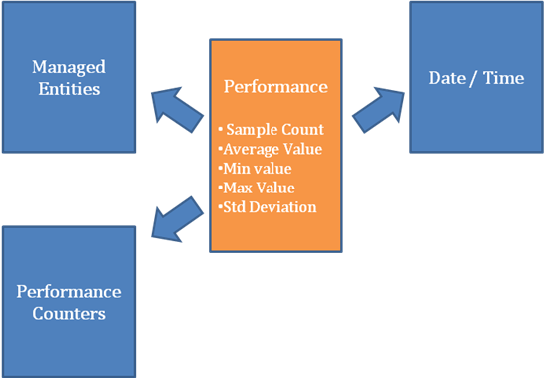

Numeric measures included in this star schema are:
- Sample count – the number of times that a performance counter has been sampled during a specified time period (hourly, in this example)
- Performance counter values – average, minimum, maximum, and standard deviation
Additional measures (such as “percent change” measures) will be calculated in the OLAP cube and do not require storage in the star schema.
Dimensions included in the performance star schema are:
- Managed Entities – SQL Server-related entities
- Performance Counters
  - Note: Managed entities and performance counters will be grouped into a single dimension table
- Date – calendar date by month or by week
- Time

State Star Schema Overview
The State star schema is shown in the following figure. The hub of the star schema is a fact table containing numeric measures relevant to monitor state and dimension keys.

Figure 6: State Star Schema
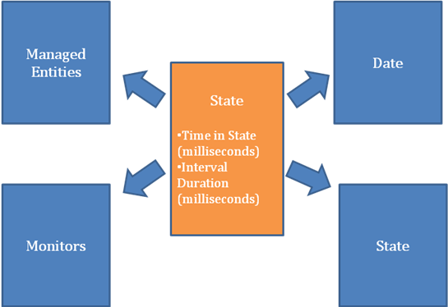

Numeric measures included in this star schema are:
- Time in State (or State milliseconds) –the amount of time (in milliseconds) that the monitor is in each state (red, yellow, green, etc.) during a specified time period (daily, in this example)
- Interval Duration – measures how frequently (in milliseconds) that the monitor state is collected
Additional measures (such as “percent change” measures) will be calculated in the OLAP cube and do not require storage in the star schema.
Dimensions included in the performance star schema are:
- Managed Entities - SQL Server and Internet Information Services (IIS)-related entities
- Monitors – Availability, Performance, Security, Health, and Configuration
  - Note: Managed entities and monitors will be grouped into a single dimension table
- State – Monitors may be in one particular state at a given time:
  - White
  - Green
  - Yellow
  - Red
  - Planned Maintenance
  - Unplanned Maintenance
  - Health Service Unavailable
  - Disabled
  - Note: States can be combines into higher-level buckets such as “uptime” and “downtime”. These groupings will be calculated in the OLAP cube.
- Date – calendar date by month or by week. Since state data is gathered daily in this solution, there is no time information in the state star schema.
The physical star schema diagrams used in this framework are shown in Appendix B.
Now that we have a high-level understanding of the data needed for the star schemas, we can collect data from the SCOM data warehouse. The next section describes the source views and queries needed to populate the star schema, as well as detailed star schema table descriptions.

Data Warehouse Views
For this project, data warehouse views are used to populate the OperationsManager Business Intelligence database. Views are less subject to change than data warehouse tables, which helps make this solution more manageable and easy to maintain. Most of the queries against the data warehouse views are very straight-forward, but some transformations are required to create unique dimension keys. Unique dimension keys are required so that well-formed hierarchies may be created, without any potential duplication of fact data. This is of particular concern when creating managed entities dimensions.
Examples of the fact and dimension table queries are included in Appendix A of this document. For more information about querying the SCOM data warehouse, please see the Operations Manager Report Authoring Guide. Appendix B of the Operations Manager Report Authoring Guide, in particular, contains information useful for creating/modifying these queries.

Performance Counters Star Schema Source Views and Queries

Managed Entities Dimensional Data
Managed entities have a natural hierarchy structure as follows:
● Top Level Group
●● Type
●●● Path
●●●● Entity Name
An example managed entity hierarchy is shown below:

Figure 7: Managed Entity Sample Hierarchy
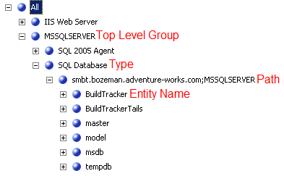
Managed entity information is found primarily in the [dbo].[vManagedEntity] view, shown below. The unique key for a managed entity is [ManagedEntityRowId]. The [ManagedEntityGuid] is unique as well, but we will use the smaller data type for keys in the dimension table. There are many cases where we will get duplicate keys when constructing the dimension table, these cases are discussed later in this section.

Figure 8: [OperationsManagerDW].[dbo].[vManagedEntity] Column List
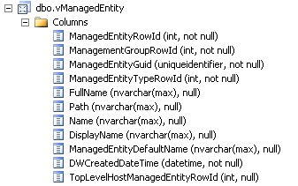
To construct a hierarchy, we must consider which managed entities are contained in other managed entities. For example, databases and servers are both listed in the [dbo].[vManagedEntity] table. In order to construct a hierarchy in which the databases roll up to a server, then we must use relationship information. Relationship information is found in [dbo].[vRelationship], shown below.

Figure 9: [OperationsManagerDW].[dbo].[vRelationship] Column List
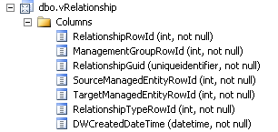
The relationship view stores managed entity source/target pairs, where targets roll up to a source. Since targets may move (databases may be moved from one server to another, or computers may be moved from one domain to another), there may be multiple instances of a managed entity in the relationship view which can result in having duplicate dimension keys. This is a classic case of a slowly changing dimension. This may be handled in various ways, the most common methods are:
- Type 1 slowly changing dimension: overwrite history by only keeping the most recent source/target pair
- Type 2 slowly changing dimension: generate a unique key for each source/target pair
For the purposes of this sample framework, we have chosen to use a Type 1 slowly changing dimension. To determine the most recent source/target pair, we can use the view [dbo].[RelationshipManagementGroup], which contains an effective date range (from date and to date) for source/target pair relationships.
A Type 2 slowly changing dimension could also be created by 1) generating a new, unique key for managed entities (using an identity field or by generating GUIDs) and 2) matching up the new key to the date that a fact is recorded by using the data range in the [dbo].[RelationshipManagementGroup] view.

Another duplicate key situation will occur if a managed entity rolls up to more than one group. For example: A Windows computer may belong to a group called “SQL Server 2005 Computers” and another group called “Domain Computers”. Monitor and Performance Counter data may be recorded multiple times for the same Windows computer if both groups are included in the same OLAP cube. To resolve this issue, the OLAP cubes in this framework contain data for a subset of groups that do not contain overlapping managed entities. The groups are:
Performance
- SQL Server 2005 Computers
- MSSQLSERVER (databases)
- SQL Server Instances
State
- SQL Server 2005 Computers
- MSSQLSERVER (databases)
- SQL Server Instances
- IIS Web Server
In other words, a distinct star schema may be created for each set of groups that are to be included in the framework. If another group, such as “Exchange Servers” are to be added to the OLAP cube, then we will likely have duplicate keys, as the Exchange Server servers are also likely to be SQL Servers 2005 computers. To resolve this issue, create a new fact table for Exchange Server data, and a new dimension table for Exchange Server managed entities.
Groups are filtered in the query in the WHERE clause of the dimension query. In the sample query in Appendix A, the WHERE clause is as follows:
WHERE vManagedEntity_2.DisplayName in ('SQL Instances', 'SQL 2005 Computers', 'MSSQLSERVER')

To check for the existence of duplicate keys, populate a table with the finished query for the managed entities hierarchy. (See Appendix A) Run a distinct count query on the ManagedEntityRowId in the table. If the number of distinct ManagedEntityRowIds is less than the number of rows in the table, than you have duplicate keys and will need to resolve the issue.

How to Determine Valid Groups
Determining valid groups (such as ‘SQL 2005 Computers’ or ‘SQL Instances’) on which to filter the dimension table query is probably the most complex query in the framework. To start, we will make the assumption that we are interested in “containment” relationships.
The “groups” that we will filter on are actually managed entities (source) that “contain” other managed entities (targets). To determine which source/target pairs fit our assumption, we can use a table-value function in the data warehouse named [dbo].[RelationshipDerivedTypeHierarchy]. The T-SQL snippet below will return a list of RelationshipTypeRowIds that are valid containment relationships for source/target pairs.
SELECT RelationshipTypeRowId, [Level]
FROM dbo.RelationshipDerivedTypeHierarchy ((SELECT RelationshipTypeRowId FROM vRelationshipType WHERE (RelationshipTypeSystemName = 'System.Containment')), 0)

Now, we need to find source managed entities that are relevant to the types of managed entities that we want to have in the OLAP cube, and that have a relationship type that is returned by the query above. For example, the following T-SQL snippet will return a list of SQL-related source managed entities and their relationship types.
SELECT DISTINCT
me.DisplayName
,r.RelationshipTypeRowId
,rt.RelationshipTypeDefaultName
FROM
vManagedEntity me inner join vRelationship r on
me.ManagedEntityRowId = r.SourceManagedEntityRowId
inner join vRelationshipType rt on
r.RelationshipTypeRowId = rt.RelationshipTypeRowId
WHERE me.DisplayName like '%SQL%'

Matching up the source managed entity results with the “containment” relationship types will give us valid managed entities on which to filter the dimension table query. The sample queries used to populate group information in this framework are shown in Appendix A.
This topic is probably the most complex topic in this paper, and some experimentation may be required to build dimensions for other, non-SQL, groups of managed entities. For more detailed information regarding managed entity queries, please see the Operations Manager Report Authoring Guide.

Performance Counters Dimensional Data
Performance counter information is found primarily in two views: [dbo].[vPerformanceRule] and [dbo].[vPerformanceRuleInstance].

Figure 10: [OperationsManagerDW].[dbo].[vPerformanceRule] Column List
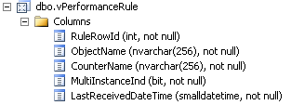

Figure 11: [OperationsManagerDW].[dbo].[vPerformanceRuleInstance] Column List
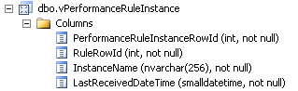

The Instance view contains performance counters (or performance rules) for objects that have multiple instances on a single managed entity. Examples of objects with multiple instances:

Table 1: Sample Object Instances
Managed Entity | Object | Instances
Windows Computer | Logical Disk | - C:  - D:  - F:
Windows Computer | Network Interface | - Broadcom NetXTreme Gigabit Ethernet  - MS TCP Loopback Interface

Putting these views together results in the following natural hierarchy for performance counters:

● Object Name
●● Instance Name
●●● Counter Name
Sample hierarchy members are shown below.

Figure 12: Performance Counters Sample Hierarchy
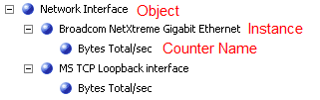

Not all objects have instances, so this is a ragged hierarchy. When browsing the hierarchy in an OLAP client, an empty member will appear below an object if there are no instances, as shown below. In most cases, the data warehouse will contain an instance named something like “_Total” which will fill in the space in the hierarchy.

Figure 13: Ragged Hierarchy Example
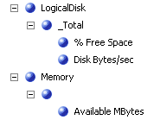

Ragged hierarchies are very common. However, if the empty member names are not desired, “dummy” names may be inserted into the dimension table, or there are other options in Analysis Services for “filling in the blanks” such as repeating the parent name if the member name is empty.

Combine Managed Entities and Performance Counters in a Single Hierarchy
At this point, we have data from the data warehouse for managed entities and performance counters. Separate dimension tables may be created for each dataset, but it could be useful to combine the datasets into a single dimension. In the OLAP cube, this would enable a single top-to-bottom drill down hierarchy, where a user could start at a top-level group (SQL Server 2005) and drill down a specific performance counter on a specific database. Attributes can provide single level hierarchies so that the user can “mix-and-match” attributes into custom hierarchies (this is described in a later section, SQL Entities Performance Counters Dimension.)
When combining managed entities and performance rule instances in a single dimension table, we may have duplicate keys (the same performance rule instance running on multiple managed entities.) In order to ensure unique dimension keys, a composite key may be created by concatenating the PerformanceRuleInstanceRowId with the ManagedEntityRowId (the ID of the managed entity on which the performance rule instance is running.) This ID combination may be found in the tables that contain the performance rule facts, or measures (detailed in a later section, here)

This composite key can be created and stored in a “mapping” table. This mapping table will be used in the query to create the managed entity/performance rule dimension table. The mapping table query is shown in Appendix A.

Date and Time (Hour) Dimensions
Time and date dimension data is not queried from views in the data warehouse, but is generated based on a range of dates. The range of dates used to populate a date dimension table is typically the broadest range of dates in the fact table(s). The primary key for the date dimension is the integer value for the date. All date attributes are generated from the date field using T-SQL DATEPART and DATENAME functions.
Hourly data for the time dimension is built manually using a fixed range (24 hour days). Multiple hour labels are included in the dimension table: 12-hour labeling (1:00pm) and 24-hour labeling (1300).
There are many well-known queries and stored procedures for generating date and time data, examples used for this framework are shown in Appendix A.

Performance Counter Facts
Performance counter facts are stored in the data warehouse with varying levels of aggregation:
- [Perf].[vPerfRaw] – unaggregated performance counter data
- [Perf].[vPerfHourly] – performance data aggregated at the hourly level
- [Perf].[vPerfDaily] – performance data aggregated at the daily level
When deciding what level of data to use for the star schema, query performance should be considered (along with user requirements.) The performance counter views are very straightforward and query performance is relatively fast. It was determined that, while raw data could be used for the star schema, hourly data would be sufficient for the purposes of this framework. Hourly data can be queried from the [Perf].[vPerfHourly] view. The columns in the [Perf].[vPerfHourly] view are shown below.

Figure 14: [OperationsManagerDW].[Perf].[vPerfHourly] column list
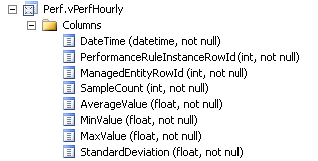
The query to populate the star schema fact table is very straightforward with the exception of joining the performance rule instance / managed entity id composite key discussed in the previous section. In addition to the columns in the [Perf].[vPerfHourly] view, the composite key is selected from the mapping table. In addition, date and hour keys are parsed from the DateTime field (Date and Time keys are discussed in a later section, Date and Time Dimensions.) The full select statement is shown in Appendix A.

State Star Schema Source Views and Queries

Entity Monitors Dimensional Data
Monitor data is provided in the [dbo].[vMonitor] view, shown below.

Figure 15: [OperationsManagerDW].[dbo].[vMonitor] column list
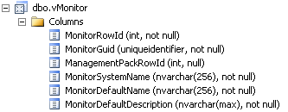

This view contains ID and description fields for the various monitors that may be running on managed entities. To simplify the star schema, the list of monitors is filtered in the query WHERE clause to: Availability, Performance, Configuration, Security, and Health.

As with the Performance Counters dimension table, Entity Monitors are combined with managed entities into a single dimension table (covered in this previous section.) The full dimension table query is shown in Appendix A.

Monitor State Dimension
The state dimension table contains the various states that a monitor may be in at any given time. There are a limited number of states (white, green, yellow, red, etc…) and they are typically presented in particular order. While a select query of distinct states could likely be written from a fact table (see next section) , this framework uses a series of inserts and hard-coded values. The primary reason for this is to ensure proper ordering of the states by controlling the name and key values. This query is shown in Appendix A.

State Facts
Similar to the Performance Counter fact views, the Operations Manager data warehouse store State facts in varying levels of aggregation:

- [dbo].[vStateFull] – unaggregated state data
- [dbo].[vStateHourlyFull] – state data aggregated at the hourly level
- [dbo].[vStateDailyFull] – state data aggregated at the daily level

Queries against these views will take a relatively long time to run. The view definitions are much more complex than the performance counters fact views. The “statemilliseconds” for one of the state values is derived, as opposed to selected from a table. Furthermore, the view must be “un-flattened” to be useful in a star schema fact table. This is done with an UNPIVOT function in the select query. For performance reasons, state data for the star schema in this framework is being pulled from the daily table. The column list for this view is shown below.

Figure 16: [OperationsManagerDW].[State].[vStateDailyFull] column list
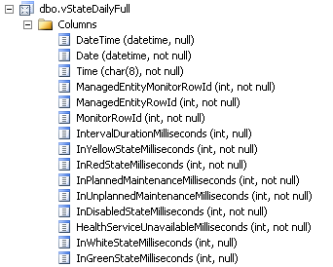

Caution should be exercised when querying this view – queries should be filtered to return a very small number of rows, until the query is part of a SSIS package that can be scheduled to run unattended. While daily incremental update queries should be small and relatively fast, the query to populate an initial dataset of historical state data can be expected to run for hours, if not days, depending on the size of the dataset. While the query for the state fact table has not been formally benchmarked, an informal test showed that a million row query (using TOP 1000000 in the select statement) returned in six hours (on a dual-core desktop with 4 Gbytes of RAM).

The query in the SSIS package that accompanies this paper uses a TOP 1000 clause to limit the result set from this view. Once the package is installed in an environment that may support much larger queries, the TOP clause may be modified to return more rows, or eliminated from the query.

There are two main issues that must be addressed before the view data may be inserted into the fact table. First, the data must be “un-flattened.” The view contains a column for the number of milliseconds for each monitor state (InYellowStateMilliseconds, InRedStateMilliseconds, etc.) In the star schema, the fact table must include a single column for state milliseconds, with a column that contains a key to relate that fact to the specific monitor state. (See Monitor State Dimension above) To “un-flatten” the data, an UNPIVOT function is used in the select statement. A sample UNPIVOT T-SQL code snippet is shown below.

unpivot ( [StateMilliseconds] for [StateKey]
in
(vsf.InYellowStateMilliseconds
,vsf.InRedStateMilliseconds
,vsf.InPlannedMaintenanceMilliseconds
,vsf.InUnplannedMaintenanceMilliseconds
,vsf.InDisabledStateMilliseconds
,vsf.HealthServiceUnavailableMilliseconds
,vsf.InWhiteStateMilliseconds
,vsf.InGreenStateMilliseconds)) unPvt

To illustrate this transformation, we will first run a select statement on the vStateDailyFull view. The results are shown below.

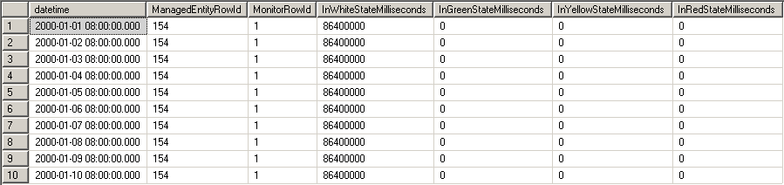

Now, we will run a select statement containing the UNPIVOT function to “unflatten” the result set. The result set is shown below.

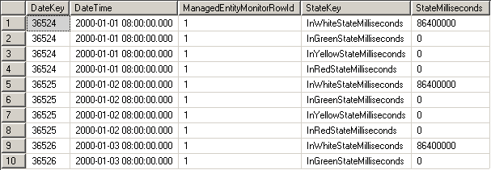

The other issue is that the text descriptions for monitor state must be converted to integer keys that may be joined to the dimension table. To help solve these issues, a two-step process is used to populate the state fact table. First, a staging table is populated with the flattened state data. Secondly, the fact table is populated with a query from the staging table that converts the state text descriptions to an integer key. Once the fact table is populated, the staging table may be truncated.

The staging table query and the fact table queries are shown in Appendix A.

At this point, we have populated all star schema dimension tables and fact tables, and we are ready to build the OLAP cube.

Integrating Data from Multiple Data Warehouses and Other Systems
The star schemas have been designed to support data extraction from a single SCOM data warehouse. However, data from multiple SCOM data warehouses may be combined in the Operations Manager BI database with the creation of new dimension keys. Generating new dimension keys will eliminate overlap between member keys from different data warehouses. Identity fields are often used to generate new dimension keys. It may also be necessary to insert a key to identify the data warehouse. After the unique keys have been generated, the fact table may be updated with the new keys by joining the fact table to the dimension tables on the combination of native keys (from the source system) and the source data warehouse key.
The same key generation technique may be applied to integrate data from other IT Operations systems or applications. Other applications may not have data to fill in each dimension table column – and that data would have to be user-generated. For example: many IT shops manage disk space by running a script or application (often home-grown) that crawls a file system and returns a list of files and file sizes. This data would seem a natural fit for the Operations Manager Business Intelligence database. To fit this data into the star schema, we could consider files to be object instances in the Performance Counters dimension, and “file size” can be a new performance counter. Each file can become a new row in the dimSQLEntitiesPerfCounters dimension table. A key and description already exist in the dimension table for the server. We can choose a type and top-level group to assign to this instance/performance counter combination. In this case, SQL 2005 Computers | Windows Computers makes sense. We then have to fill in the Object, Instance, and Counter Name information for these new rows. The object would be a roll-up object for the files, for example “All_Files”. Each file would be an instance. The counter name (“File Size”) would be generated, since a file size counter may not already exist.
The following table shows how some sample dimension table rows may look. User-generated information is shaded in yellow, and new data from the file size application is shaded in grey. Additional attributes related to file size, such as Owner, may be added as columns in the dimension table, for drill to detail purposes.
New DimKey (ID Field) | Group, Type, ManagedEntity Names and IDs link to a server that is already in the dimension table (from SCOM) | InstanceName | ObjectName | CounterName | Owner
1 |  | C:\README.txt | All_Files | FileSize | adventure-works\mray
2 |  | F:\Program Files\...\app.config | All_Files | FileSize | adventure-works\Administrator
3 |  | C:\Documents and Settings\...\forest.jpg | All_Files | FileSize | adventure-works\mray

This is a very high-level discussion of how to integrate data from multiple warehouses and other applications, but hopefully these concepts will help provide some direction and/or ideas on how this may be accomplished. A more detailed discussion may be the topic of a future white paper.

Build the OLAP Cube
With the star schema database in place and populated, the next step is to build OLAP cubes. All steps and screenshots in this section were created with SQL Server Analysis Services 2005. The “auto-build” feature of the cube wizard is not used in this document, the measure groups and dimensions will be built manually.
This section describes how the sample cube that accompanies this paper was built. The order in which the cube will be built is as follows:
- Create the Data Source View
- Run the Cube Wizard – to create the starting point for the cube
- Rename the measure groups, measures, and dimensions that were created by the cube wizard (for better usability)
- Edit dimensions and create hierarchies
- Create calculated members
- Process the cube

Create the Data Source View
The first step is to build a data source from the Operations Manager BI database. Next, we build a data source view. All tables are used in the data source view, with the exceptions of the mapping table ([dbo].[mapPerformanceCounters]) and the staging table ([dbo].[stageFactStateDaily].) In fact, once the Operations Manager BI database is populated, the mapping and staging tables may be truncated or deleted- they are not used for building the OLAP cube.
When selecting the tables in the data source view wizard, the wizard UI should look as follows:

Figure 17: Data Source View Wizard - Select Tables
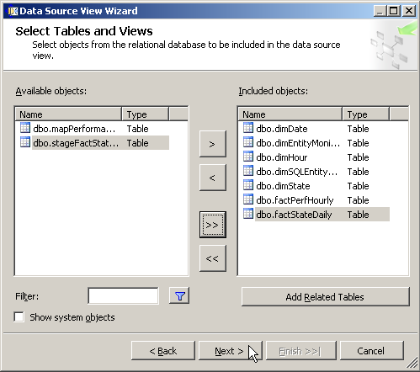

Upon wizard completion, relationships must be established between the fact and dimension tables. The key columns are primary keys in the dimension tables, and foreign keys in the fact tables. The following table lists the relationships that must be created.

Table 2: Data Source View Relationships
From Fact Table Column… | To Dimension Table Column…
[factStateDaily].[StateKey] | [dimState].[StateKey]
[factStateDaily].[DateKey] | [dimDate].[DateKey]
[factStateDaily].[ManagedEntityMonitorRowId] | [dimEntityMonitors].[ManagedEntityMonitorRowId]
[factPerfHourly].[DateKey] | [dimDate].[DateKey]
[factPerfHourly].[HourKey] | [dimHour].[HourKey]
[factPerfHourly].[PerformanceRuleInstanceRowId] | [dimSQLEntityPerfCounters].[PerformanceRuleInstanceRowId]

When the tables are arranged, the data source view should look similar to the diagram below:

Figure 18: Data Source View Diagram
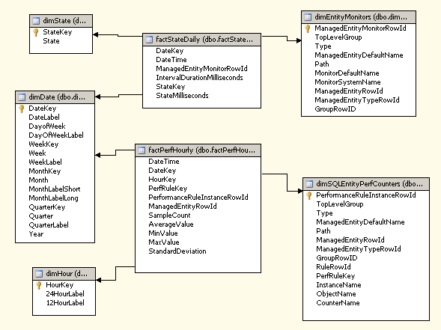

Later in this section, we will create some derived columns to help build some of the dimensions.

Create the OLAP Cube – Measure Groups, Measures, and Dimensions
Now that the data source view is created, we can build the OLAP cube. This section contains directions for using the cube wizard to build the cube, but the cube may also be created manually if desired.

Run the Cube Wizard
Launch the cube wizard, and select the recently created data source view. The fact tables and dimension tables should be identified as shown in the following figure. Note that there are two fact tables that will be used to create two measure groups. No need to identify time dimension tables at this point, as there will be two dimensions that will be typed as time dimensions – Date and Hour.

Figure 19: Cube Wizard - Identify Fact and Dimension Tables
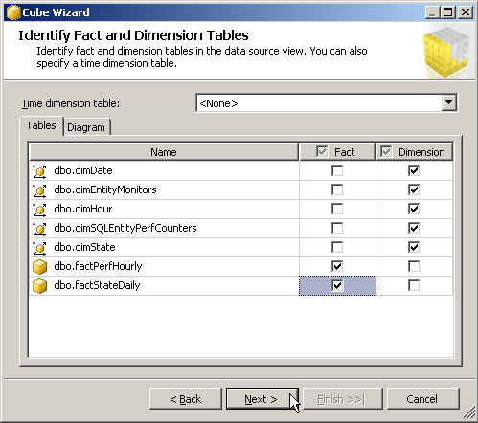

Next, select the measure groups and measures. The cube wizard should identify two measure groups, “Fact Perf Hourly” and “Fact State Daily.” Unselect all measures that are either ID fields, or Key fields. There should be two measures to unselect, “Perf Rule Key” and “Managed Entity Row ID” from the Fact Perf Hourly measure group. Note that none of the selected measures will be exposed in the cube, but they are required to create calculated measures. This is due to the non-additive nature of the measures. Example: it makes no sense to add a performance counter such as “% CPU utilization” over time, but it is valuable to look at the average, and likely the minimum and maximum values. For the measures in Fact State Daily measure group, it may make little sense to see the total number of milliseconds that a monitor was in a particular state, but it is valuable to see the percent of time that a monitor was in a particular state – for example, “Availability = %98.5”. Averages, percent of totals, and other calculations will be covered in a following section.

Figure 20: Cube Wizard - Select Measures
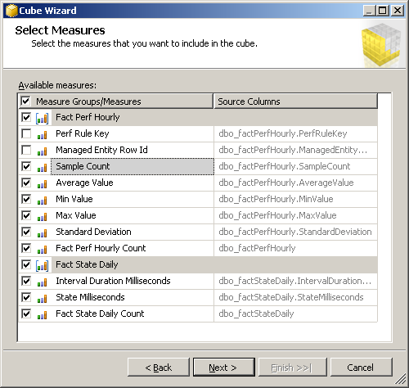

The next screen in the cube wizard shows the dimensions that the wizard will create. Upon inspection, the dimensions only contain attributes, and no hierarchies. Many of the selected attributes are not required, but they may be left checked at this point. Finish the cube wizard to get to the cube editor, where the calculations and hierarchies will be created.

Modify Measure Groups, Measures and Dimensions
At this point, the names of the cube measure groups and dimensions should be cleaned up to be more user-friendly. The measure names that were loaded from the cube should also be renamed to make them more intuitive to use in calculations. As discussed previously, the majority of the calculations will be averages, created using sum and count measures, or “percent of total.” These calculations will be discussed in a later section. It is suggested to append sum and count to the measure names, to help make our calculations more intuitive to create (and read.) This is also a good time to verify the aggregate functions used for the measures. The new measure names and correct aggregate functions are shown in the following table.

Table 3: Change Measure Names
Measure Group or Measure Name from Wizard | New Measure Group or Measure Name | Aggregate
Fact State Daily | State | N/A
Interval Duration Milliseconds | Interval Duration Milliseconds Sum | SUM
State Milliseconds | State Milliseconds Sum | SUM
Fact State Count | Fact State Count | COUNT
Fact Perf Hourly | Performance Counters | N/A
Sample Count | Sample Count | SUM
Average Value | Average Value Sum | SUM
Min Value | Min Value Sum | SUM
Max Value | Max Value Sum | SUM
Standard Deviation | Standard Deviation Sum | SUM
Fact Perf Count | Fact Perf Count | COUNT

Note that the “Sample Count” measure is aggregated with the SUM function. This may be misleading, given the name of the measure, but it is correct. Also note that the measures Min Value and Max Value are aggregated with the SUM function. This is valid, as we will use these for calculated averages. However, true minimum and maximum values are also needed. Create two new measures in the Performance Counters measure group, based on the “Min Value” and “Max Value” columns. Name the measures “Min Value” and “Max Value” and set the aggregate functions to MIN and MAX, respectively.
After the steps above have been completed, the cube structure should appear as shown below.

Figure 21: Completed Measure Groups and Measures
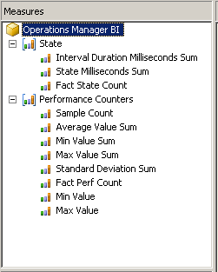

The dimension names should be renamed as well. Suggested names are shown below. Note that the “dimHour” dimension has been renamed to “Time”. The “Period Calculations” dimension shown below will not yet exist. This is a custom dimension that will be discussed in a later section, Period Calculations Dimension.

Figure 22: Solution Explorer - Dimension Names
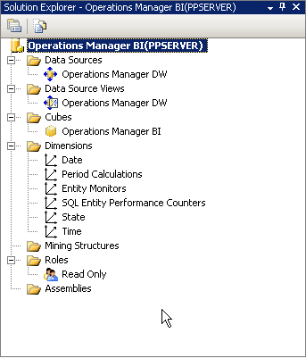

Add Hierarchies and Modify Attributes
The following sections go into detail on how to add hierarchies to the dimensions, and modify the attributes to be more useful.

Date Dimension
Before modifying attributes, set the Date dimension type to “Time”. Then, ensure that all attributes are typed appropriately (“Quarter” typed as Quarters, “Year” typed as Years, etc.) If this is not done, MDX expressions that use time functions will not work, and OLAP client applications may not be able to properly read the cube.

The date dimension should have the attributes shown in the following figure. Rename attributes as appropriate.

Figure 23: Date dimension attributes
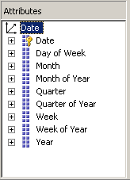

The dimension table was built to support two types of date hierarchies:
- “Date.Month” - Calendar Date by Year, Quarter, Month
- “Date.Week” - Calendar Date by Year, Week, Day

The hierarchies may be created by dragging the appropriate attributes onto the “hierarchies and levels” pane. Attribute relationships should be established as well. The two date hierarchies should appear as shown in the figures below.

Figure 24: Date.Month Hierarchy
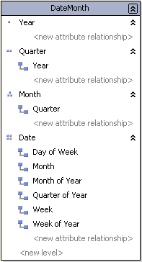

Figure 25: Date.Week hierarchy
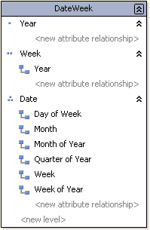

Time Dimension
As with the date dimension, first ensure that the dimension is set to type “Time” and that all attributes are set to the appropriate type. In this dimension, all attributes are of the “Hours” type.

There should be little to no further modifications needed for the Time dimension (formerly “dimHour…”) There are two attributes in the dimension, one attribute for a 12-hour time label (1:00 AM, 2:00 AM, for example) and one attribute for a 24-hour time label (0100, 0200, etc.) To make the dimension a little more user-friendly, a new single-level attribute simply titled “Hour” may be created. Select whichever naming convention that should be used by default. In our example cube, we selected 24-hour naming for the “Hour” attribute. This attribute title will also be more attractive when viewed in a client application.

Note that there are no hierarchies in the Time dimension, only attributes. When completed, the attribute list should appear as shown below.

Figure 26: Time dimension attributes
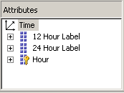

SQL Entity Performance Counters Dimension
This dimension (along with the Entity Monitors dimension) is particularly rich with attributes and potential hierarchies. With this example, we take the approach of providing one all-encompassing hierarchy, and many attributes. The upside to providing many relevant attributes is that users can mix-and-match attributes to approximate custom hierarchies. Furthermore, attributes provide a high degree of flexibility in how analytic views and reports are created. Having irrelevant attributes in the dimension, however, can lead to user confusion and frustration. Many of the attributes that were created in the cube wizard are not needed, and may be removed. In particular, many of the ID fields, such as EntityMonitorID, may be removed. The following figure shows the suggested list of attributes for this dimension.

Figure 27: SQL Entity Performance Counters attributes
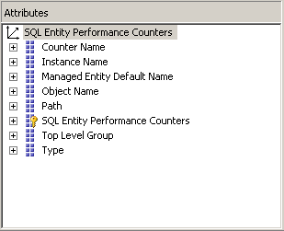

The all-encompassing hierarchy mentioned above utilizes all of the attributes (except for the dimension key.) This hierarchy is shown below.

Figure 28: Performance Counters hierarchy
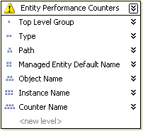

Note the warning icon next to the hierarchy title. This indicates that we do not have attribute relationships defined for the hierarchy. With the star schema defined in this document, attribute relationships are not possible for this hierarchy. This situation is acceptable for a sample cube, as long as the dimension table is properly constructed and the hierarchy behaves as expected. But, attribute relationships are desirable for a production-grade solution as attribute relationships improve cube performance, among other benefits.

The schema can be modified to support attribute relationships by adding columns in the dimension table for unique member keys at each level. For example: a managed entity typically has multiple instances of objects (for example: one or more network cards on a server.) Each instance may have one or more performance counters. In the dimension table, there will be one row per performance counter / instance combination, each with a unique key (recall the Performance Counter mapping table.) However, object names will exist on multiple managed entities, and will be repeated throughout the dimension table. This prevents an attribute relationship from being created at the Object Name level in the hierarchy. One way to create a unique key at the Object Name level is to concatenate the Managed Entity ID and the Object Name or ID. An attribute may be created based on the new, unique key and used in the hierarchy.

Once the hierarchy is completed, users should be able to drill from the top level all the way down to a specific performance counter on a particular instance/object/managed entity. An example drill path is shown below.

Figure 29: SQL Performance Counters hierarchy drill-down
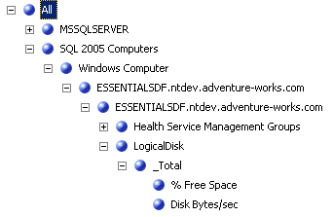

Entity Monitors Dimension
The Entity Monitors dimension is very similar to the Performance Counters dimension. The same design principle of a single, deep, hierarchy with many attributes is applied here. To clean up the dimension attributes, remove any “ID” field attributes and rename attributes as appropriate. The list of suggested attributes is shown in the following figure.

Figure 30: Entity Monitors attributes
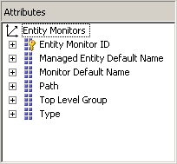

The hierarchy for this dimension is shown below.

Figure 31: Entity Monitors hierarchy
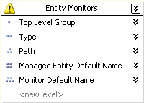

Similar to the Performance Counters hierarchy, the Entity Monitors hierarchy does not have attribute relationships. Please refer to the previous section, SQL Entity Performance Counters Dimension, for a discussion of this issue.

Once the hierarchy is completed, users should be able to drill from the top level all the way down to a specific monitor on a particular managed entity. An example drill path is shown below.

Figure 32: Entity Monitors hierarchy drill-down
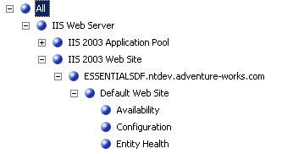

State Dimension
The state dimension table includes a key and name column for each possible state of a monitor (red, yellow, green, etc.) However, it is very common to place states into higher level groupings - “uptime” and “downtime.” The dimension table contains the state descriptions, but not how the states are grouped. So, where and how should the grouping level be created? The way that states roll up can vary depending on the requirements of the Operations Manager deployment or may vary on a report-by-report basis. On order to allow more flexibility in how the state groupings are defined, we can use derived columns, or named calculations, in the cube data source view as opposed to hard-coding the values in the dimension table. With this technique, a cube administrator can modify the state grouping without altering the underlying data source.

To create the named calculations, select the dimState dimension table in the data source view editor.

Figure 33: New Named Calculation
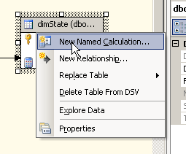
In this example, the first named calculation will be named “UpDownKey” and a simple T-SQL case statement will be used to define the calculation. This calculation should return a key value of 1 or 2 depending on the value of the StateKey column. Recall that each monitor state has a key and a description, as stored in the dimension table [dbo].[dimState].
Figure 34: [dbo].[dimState] table contents
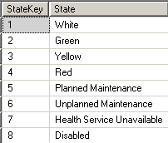

We will group the monitor states according to Operations Manager default groupings which are:
- Uptime – White, Green, Yellow, Planned Maintenance, Health Service Unavailable, and Disabled
- Downtime – Red and Unplanned Maintenance

Using these default groupings, the T-SQL statement for the key value named calculation is as follows:

CASE
WHEN StateKey = 1 THEN 1
WHEN StateKey = 2 THEN 1
WHEN StateKey = 3 THEN 1
WHEN StateKey = 4 THEN 2
WHEN StateKey = 5 THEN 1
WHEN StateKey = 6 THEN 2
WHEN StateKey = 7 THEN 1
WHEN StateKey = 8 THEN 1
ELSE 2 END

Next, we will create a named calculation to assign descriptions to the key values. This named calculation is named “UpDownDesc” and the T-SQL is as follows:

CASE
WHEN StateKey = 1 THEN 'Uptime'
WHEN StateKey = 2 THEN 'Uptime'
WHEN StateKey = 3 THEN 'Uptime'
WHEN StateKey = 4 THEN 'Downtime'
WHEN StateKey = 5 THEN 'Uptime'
WHEN StateKey = 6 THEN 'Downtime'
WHEN StateKey = 7 THEN 'Uptime'
WHEN StateKey = 8 THEN 'Uptime'
ELSE 'Downtime' END

Creating two named calculations may seem redundant, but creating a key calculation and a description calculation allows us to assign a integer key and a descriptive name to these members, which is typically a best practice. And more importantly, using an integer will allow the “Uptime” and “Downtime” members to be sorted by key as opposed to name. Since we want “Uptime” to appear first in the hierarchy, we have assigned “Uptime” a key value of 1.

Now that we have created the grouping columns, we can now create an additional attribute named “Up Down Key.” Next, create a hierarchy from the two attributes so that State rolls up to the “Up Down Key.” The attributes and hierarchy should appear as shown below.

Figure 35: State attributes
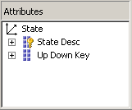

Figure 36: State hierarchy
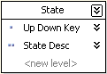

The following figure shows the finished result in the dimension browser. Note the proper order of the “Uptime” and “Downtime” members. To ensure this ordering, set the “order by” property of the attribute to “key.”

Figure 37: State hierarchy drill down
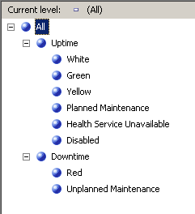

Period Calculations Dimension
The Period Calculations dimension is an empty or “shell” dimension used to store calculated members. In the sample cube, the shell dimension to store time-based calculations such as Period-to-Date and Period-to-Period Growth. While optional, shell dimensions are a common and extremely useful method for creating time-based calculations in any OLAP cube, with numerous advantages over using the built-in time calculations in SQL Server Analysis Services 2005.

The sample OLAP cube that accompanies this paper contains the shell dimension and accompanying MDX time-based calculations. More details about shell dimensions and time calculations can be found on many Analysis Services-related web sites, including a paper by David Shroyer, OLAP Business Solutions, located here:
http://www.obs3.com/pdf/A%20Different%20Approach%20to%20Time%20Calculations%20in%20SSAS.pdf

The book MDX Solutions: With Microsoft SQL Server Analysis Services by George Spofford also contains a good discussion of shell dimensions and time calculations.

Create Calculated Measures
As previously mentioned, the majority of the measures in this cube are calculated measures, due to the semi-additive nature of the measures that we need to analyze. Most of the measures in the Performance Counters measure group will be average values, while the primary measure in the State measure group will be a “Percent of Total” value.

Performance Counter Calculated Measures
Recall that we renamed the physical measure with a “Sum” or “Count” connotation in an earlier section, primarily so they are more usable in calculations. The basic calculation that we will use over and over again for our average calculations is simply a sum divided by count. The “sum” part of our calculation is the physical measure aggregated with the SUM aggregate function (Average Value Sum, Min Sum, Max Sum, and Std Deviation Sum.) The “count” part of our calculation is the built-in COUNT measure that Analysis Services created for each fact table (“Fact Perf Count”, in this case.)
The basic MDX formula for “average value” is as follows:

[Measures].[Average Value Sum] / [Measures].[Fact Perf Count]

To ensure that we do not have divide by zero errors, we will put a conditional check around the basic formula. The finished MDX formula is:

iif([Measures].[Fact Perf Count] <> 0, [Measures].[Average Value Sum] / [Measures].[Fact Perf Count], NULL)

The same basic syntax is used to create the remainder of the average calculations for this measure group, using the SUM measure of the value that is to be averaged, and the COUNT measure for the relevant fact table.

State Calculated Members
Average calculations may be created for “Interval Milliseconds,” which measures the number of milliseconds between monitor polling intervals, and “State Milliseconds,” which measures the number of milliseconds that a monitor is in a particular state. “Average state milliseconds” does not appear to be a useful, or necessarily valid, calculation, but is included in this example for demonstration purposes.

The primary measure for the State measure group will be “State % of Total” which will return the percent of time that a monitor is in a particular state. For this calculation, we want to divide the “State Milliseconds” SUM measure for the selected monitor state by the “State Milliseconds” SUM measure for all monitor states and return this value as a percentage. The basic formula, in MDX is:

[Measures].[State Milliseconds Sum] / ([Measures].[State Milliseconds Sum], [State].[All])

Again, we want to check for a possible divide by zero error by adding a conditional check. The finished formula is:

iif(([Measures].[State Milliseconds Sum], [State].[All]) <> 0, [Measures].[State Milliseconds Sum] / ([Measures].[State Milliseconds Sum], [State].[All]), NULL)

Be sure and set the format string for this calculation to “Percent.”

Clean Up the Measures
Now that the calculated measures have been created, we have some “clean-up” tasks that will increase the usability of the OLAP cube:
- Assign the calculated measures to their associated measure groups
- Hide unused measures

By default, calculated measures are visible in all measure groups. However, we do not want the Performance Counter calculations to show up in the State measure group, as the will not work there, and it will confuse end users. To limit the calculation to a specific measure group, select the “Calculation Properties” button on the “Calculations” tab. Set the “Associated Measure Group” property for each calculation. The Calculation Properties dialog is shown below.

Figure 38: Calculation Properties
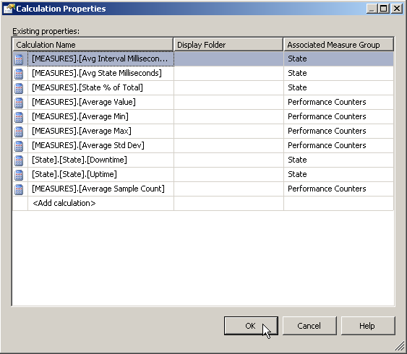

Measures that are only used for calculations, and are not relevant to display should be hidden as to not confuse or frustrate end users. All measures that were renamed with a SUM or COUNT connotation should be hidden, with the exception of the “Sample Count” measure in the Performance Counters group. (While the usefulness of the Sample Count measure is questionable, it is visible in the sample cube for demonstration purposes.) Measure are hidden by toggling the “Visible” property – in the Properties tab for physical measures, and the calculation editor for calculated members.
After performing these clean-up tasks, the list of cube measures should appear nice and tidy, as shown below.

Figure 39: Cube measure list, organized by measure group
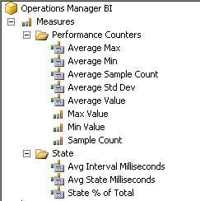
At this point, the cube structure is complete, and the cube is ready to be processed.

Process the Cube
Building the Analysis Services project and processing the cube is typically a straight-forward exercise; however there are some caveats to discuss for the sample cube and sample data source that accompany this paper.
The fact tables in the sample data set contain facts for all managed entities, and all monitor groups. Recall that we filtered the dimension table members to a subset of managed entity groups (SQL Server and IIS-related entities) and a subset of monitor states (Availability, Performance, Security, Configuration, and Health.) As a result, there are facts in the fact table that do not have relevant keys in the associated dimension tables, which will result in “missing key” errors when processing the cube.
The non-relevant facts were included in the sample database, so that cubes for different entity groups (SharePoint, Windows Servers, etc.) could be experimented with easily. To process the cube and have the non-relevant facts thrown out of the cube data, the Cube Process settings may be changed. These settings are located in the cube process dialog (“Change Settings…” button.) On the “Dimension key errors” tab, select the “Ignore errors count” radio button, and set the “Key not found” option to “Ignore error”. These settings are shown below.

Figure 40: Cube Process - Change Setting dialog
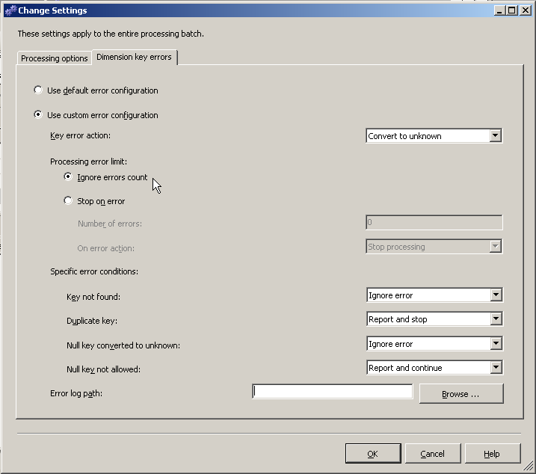

Note: this condition may be acceptable for a sample OLAP cube, but this is a dangerous condition for a production-grade cube. For a production-grade cube, the non-relevant facts should be filtered from the fact table during the data extract (from the Operations Manager data warehouse to the Operations Manager BI database.) This will ensure that the fact tables are clean and will also have an added performance benefit of moving fewer rows of data. Furthermore, ignoring known key errors in a production-grade cube may hide other key errors that are unknown which can result in bad data in the cube.

Put it All Together - Create Performance Point Dashboards, Scorecards, and Analytic Reports
The Operations Manager BI OLAP cube provides the foundation for creating IT operations scorecards, dashboards, and analytics. One of the benefits of using SQL Server Analysis Services is that there are a wide variety of client tools available in the Microsoft Business Intelligence stack, including Office PerformancePoint Server 2007 and Office Excel 2007 in addition to any number of third-party products. This paper will focus on Office PerformancePoint Server 2007, and the capabilities that can be deployed above and beyond out-of-the box reporting. Specifically, we will focus here on sample topic areas that are included in the samples that accompany this paper, including:
- Balanced IT Scorecards – roll-up diverse KPIs for a “balanced” view of IT performance
- Service Level Agreements – measure performance against both internal metrics, and agreed-upon service levels
- Analytics – drill down analytics that provide more detail and insight specific to KPIs of interest
- Dashboards – deploy web-based scorecards and analytics through SharePoint Server

Figure 41: Sample PerformancePoint Dashboard

This paper is not intended to be a comprehensive overview of Office PerformancePoint Server 2007. For more information on Office Performance Server2007, please visit the product page on the web, or the Office PerformancePoint Server Product Team Blog.

Office PerformancePoint 2007 Scorecards

Why Office PerformancePoint 2007 Scorecards?
Office PerformancePoint 2007 scorecards offer many capabilities that make them ideal forBusiness Intelligence or Performance Management projects with a wide range of requirements. Some of the specific capabilities that we will take advantage of in the following sections include:
- Multiple data source support
- Flexible scoring and measurement
- Objective (roll-up) KPIs

Multiple Data Source Support
PerformancePoint supports the creation of KPIs from multiple data sources, including:
- SQL Server Analysis Services
- Offcie Excel 2007/ Excel Services
- Fixed Entry
- ODBC
A KPI typically consists of the following components: actual value, target value, goal, and measured progress against goal (status). Each component can be sourced from independent data sources – that is, an actual value may come from an Analysis Service OLAP cube, while the target value comes from Excel.

Flexible Scoring and Measurement
When working with many types of KPIs, it is important to have options for how to measure successful status against goal. With Office PerformancePoint Server 2007, KPIs may be configured to indicate that:
- Increasing values are better (such as % Availability)
- Decreasing values are better (such as % Downtime)
- Closer to target is better (such as % Disk Free Space, where you neither want too little free disk space and too much free disk space may indicate storage resources that could re-allocated)

Status can be indicated with traditional traffic lights (red, yellow, green) or with any number of buckets (up to ten) and custom graphical indicators.

Objective (Roll-Up) KPIs
IT operations KPIs can vary widely by numeric type, scale, precision, etc. For example, performance counters widely vary by numeric type (percent, bytes/second, Mbytes available.) Aggregating these KPIs into a single overall score can be problematic and error-prone, often requiring complex, hand-entered formulas. This problem is not unique to IT operations – business users often require scorecards that combine diverse metrics from HR, Finance, Operations, and Sales into high-level scores. Objective KPIs, along with the features mentioned above, provide a relatively simple, easily maintainable way to accomplish this.

Create Key Performance Indicators (KPIs)
Before we create scorecards, we must create KPIs. This section will walk through the process of creating three KPIs – a KPI that measure availability, A KPI that measures a specific performance counter, and an objective KPI to return an aggregated score. KPIs (and all the components described in this section) are created in the Office PerformancePoint Server 2007 Dashboard Designer.

Web Site Availability KPI
To begin this process, we must have an Analysis Services data source configured for the Operations Manager BI OLAP cube. Next, launch the KPI Wizard; right-click on the KPI folder in the workspace browser and select “New KPI”. On the first screen, shown below, select “Blank KPI” (Objective KPIs will be covered in a later section.)

Figure 42: Select a KPI template
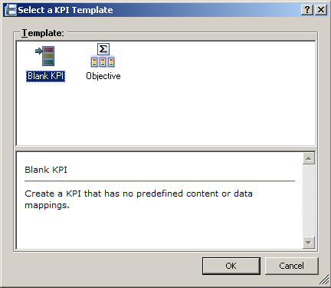

Name the KPI, and assign the KPI to a display folder (optional, but recommended.) Display folders help keep Office PerformancePoint Server 2007 components organized on the server. In this example, the KPI is named “Sample Availability KPI”, assigned to a display folder named “Samples”. Check the “Grant read permission…” checkbox. The wizard UI should appear as shown below. Click “Finish” to close the wizard.

Figure 43: Name the KPI
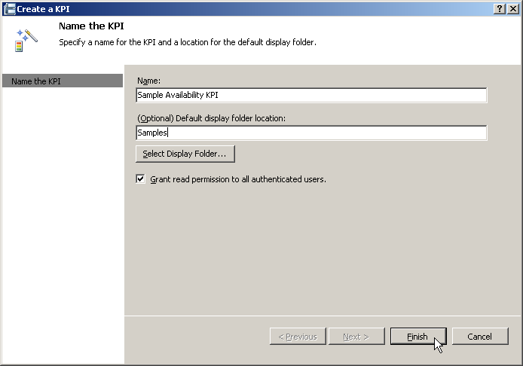

The KPI values (actual and target) may now be configured, or mapped, to the data source. Actual and target values are configured independently, as they can come from different data sources if desired. These values are mapped in the KPI Editor.

Figure 44: KPI Editor – Actual and Target(s)
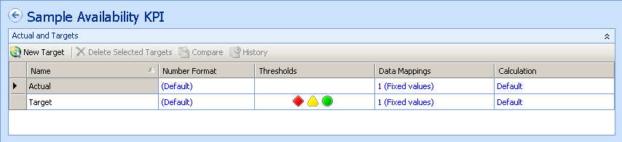

To create a data mapping for the Actual value, click on the Data Mappings field. This launches a dialog to select a data source. The default data source is Fixed Entry, so the first step is to click on the “Change Source…” button on the bottom right-hand corner of the dialog. Select the data source that has been created for the Operations Manager BI OLAP cube. In the sample, this data source is called “Operations Manager Business Intelligence”.

The next screen allows us to select measures and dimension members (a tuple) for the data mapping. Recall that availability information comes from the “State” measure group. So, we need to select the measure that will return the % time that the Availability monitor is in the “uptime” state. This measure is called “State % of Total,” described in a previous section. Click on the “Select Dimensions” icon to filter the measure by the appropriate dimension members. To filter on the Availability monitor, select the “Entity Monitor.Monitor Default Name”. This is an attribute hierarchy in the Entity Monitors dimension, described here. To select the Availability member, click on the “Default” member field. This will launch a view of the hierarchy as shown below. Expand “All”, select “Availability”, and click “Ok”.

Figure 45: Select Members - Availability
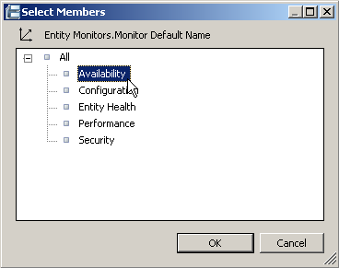

Now that we have selected the measure, and the appropriate monitor, we need to select the State. This is in the State dimension, described here. Click on the “Select Dimensions” icon again, and select the “State.State” hierarchy. Click on the “Default” member field to view the hierarchy. Expand “All” and select the “Uptime” member.

At this point we have a KPI that will measure the percent of time that the availability monitor is reporting “uptime” for all managed entities in the cube. We can filter this KPI for specific managed entities by adding another dimension to the KPI. Some examples:
- To measure availability for ALL web sites, add the “Entity Monitor.Type” hierarchy and select the “IIS 2003 Web Sites” member.
- To measure availability for a specific web site, add the “Entity Monitor.Entity Monitors” hierarchy. This is the drill-down hierarchy for managed entities and monitors described here. Drill into the hierarchy to locate the desired web site, as shown in the screen shot below.

Figure 46: Select Members - Specific Web Site
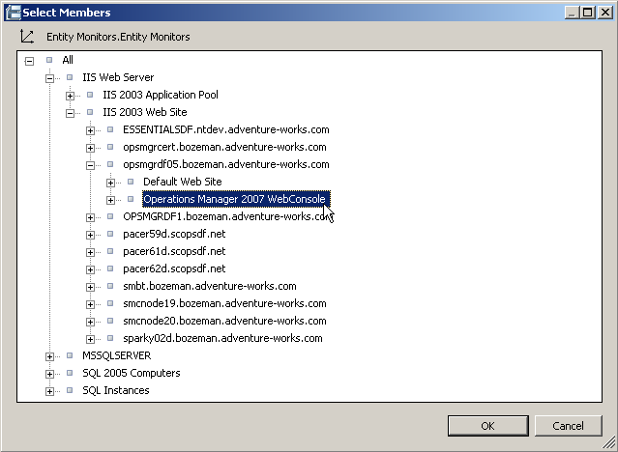

In this example, we will filter the KPI for all web sites. The data source mapping dialog should now look like:

Figure 47: Dimension Data Source Mapping - % Availability for all Web Sites
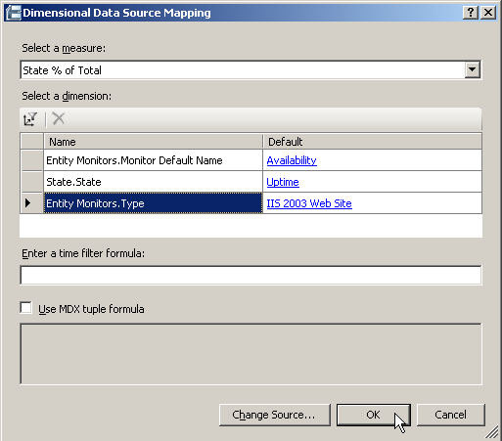

We could continue to filter the KPI to provide finer levels of detail. For example, we could filter by the “Date” dimension to get recent values only. Alternatively, a dashboard filter can be used to filter the scorecard data (and other associated reports on a dashboard.) Sample dashboard filters are included in the samples that accompany this paper.

It may be useful to preview the KPI at this point. To do this, we must create a scorecard. Right-click on the Scorecard folder in the workspace browser and select “New Scorecard”. This will launch the scorecard wizard, which is very similar to the KPI wizard in that we select a template and then name the scorecard. Select the “Blank Scorecard” template in the “Standard” category. Name the scorecard “Sample Overview Scorecard” and assign it to the “Sample” display folder. Click “Ok” to finish. A blank scorecard should now be visible in the editor pane. To preview our new KPI, expand the “KPIs” folder in the “Available Items” pane on the right-hand side of the Dashboard Designer, and expand the “Samples” display folder. Click and drag the “Sample Availability KPI” to the rows of the scorecard. To display the KPI actual value, select the “Edit” tab in the ribbon and click on the “Update” icon. The scorecard should look something like this:

Figure 48: KPI Preview in Sample Overview Scorecard
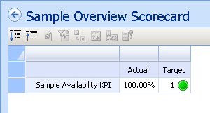

The KPI is returning a value of %100 for the actual value. Note that the target is “1” with a green (“on target”) icon. Since we have not yet configured the data mapping for the target, the default values are being shown. Select the “Sample Availability KPI” in the workspace browser to return to the KPI editor, where the target value can now be configured.

The target value is configured with the same dialog screens that were used for the actual value. Select the data mapping field for the target value. For the target value, we will use a manually-entered number instead of a tuple from the OLAP cube, so we do not have to change the data source. Enter a target value in the “Value:” text box. Since we will format this number as a percent, enter the value in decimal form. For example, to establish a target of 95%, enter 0.95 in the value text box. Select the “Number Format” field to format the number as a percent. Select the “Override number format” checkbox, and enter % to display on right. PerformancePoint does not automatically multiply percents by 100, so enter 100 for the Multiplier. The “Format Numbers” dialog should now appear as below. Click “OK” to finish.

Figure 49: Format Numbers as percent
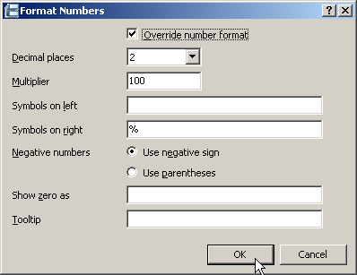

Now, select the scorecard in the workspace browser, and select “Update” to refresh the scorecard view. The scorecard should look something like this:

Figure 50: KPI Preview with Actual and Target
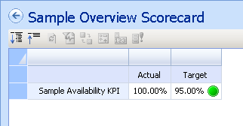

That completes the process for creating a simple KPI. Note that a single KPI can have multiple targets, and this will come into play when creating a Service Level Agreement scorecard.

To save the KPI, it can be published to the Office PerformancePoint Server 2007. Click on the ribbon Home tab, and click on the “Publish All” button. This should be done periodically to ensure that changes are saved to the server and no work will be lost in the event of a catastrophe.

Numeric Formatting Caveats
Note that we did not use custom number formatting for the actual value. Also, the percentage formatting was multiplied in the format dialog, not the data mapping dialog. These steps may seem confusing. Some notes about numeric formatting in Office PerformancePoint Server 2007:
- By default, numeric formatting is inherited from the data source. If the cube measure is formatted properly, no additional formatting is needed in Office PerformancePoint Server 2007.
- Percentages fixed entry values should be entered as decimal (0.95 vs 95%) when compared to actual values that are formatted as percent to ensure that the internal algorithms that Office PerformancePoint Server 2007 uses to calculated scores will work properly.
  - Since, in this case, fixed entry percentage values should be entered as decimal values, the value should be multiplied by 100 in the numeric formatting dialog.
- If the actual value is formatted as a “standard” number, than the target value that is entered must also be a standard number. This is the case with the “Disk Free Space” KPI that is created in the following section.

Disk Free Space KPI (Performance Counter)
The process for creating a KPI based on a performance counter is very similar to the process outlined for the Web Site Availability KPI. The primary difference is in the dimension mapping. For this example, create a new KPI named “Sample Performance Counter KPI” in the “Samples” display folder. For the actual value data mapping, use the “Operations Manager Business Intelligence ” data source.

Recall that the Performance Counters measure group contains measures for average values, minimum and maximum, and standard deviation. For this example, select the “Average Value” measure. To filter the KPI for a particular performance counter, add the “SQL Entity Performance Counters.Counter Name” dimension and select the “%Free Space” member. We now have a KPI that will return % Free Space for all managed entities in the cube. To filter the KPI to a particular server, add the “SQL Entity Performance Counters.Entity Performance Counters” hierarchy, and expand members to find the desired server (at the managed entity level). An example is shown below, where a server named “ESSENTIALS.ntdev.adventure-works.com” is selected.

Figure 51: Select a specific managed entity (Windows server)
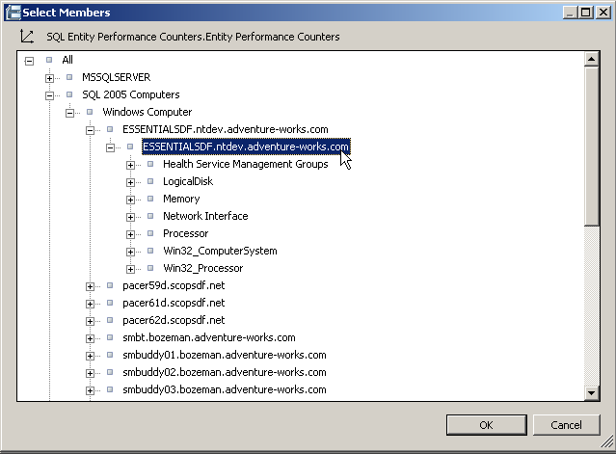

The completed data mapping for the sample performance counters KPI is shown below.

Figure 52: Dimensional Data Source Mapping - Server Free Disk Space
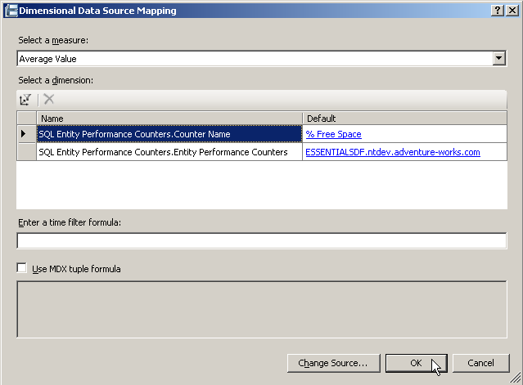

Now we can add a target value to the KPI. In this case, enter a value of “80” in the fixed entry value for target. Format the target as a percent, but do not multiply by 100 as we did with the availability metric.

To preview the new KPI, add the KPI to the sample scorecard and update the scorecard to refresh the data values. The scorecard should now look something like:

Figure 53: Sample Scorecard with Availability and Performance Counter KPIs
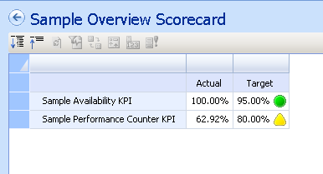

Note that there is no percentage sign by default on the actual value for the performance counter KPI. The format displayed is the numeric format inherited from the cube. Bear in mind that the Performance Counters measure group returns values for performance counters of different types such as throughput (Mbytes/ second), user connections (count), and disk free space (percent) – so it is not practical to add specific numeric formatting in the cube. However, we can add more specific numeric formatting on a case-by-case basis in Office PerformancePoint Server 2007. Return to the KPI editor and select the Number Format field for the Performance Counter KPI. Override numeric formatting and add the “%” symbol to the right.

This is also why we did not enter a decimal value for the target and multiply by 100 in the format dialog. Since the actual value was formatted as a standard number, we need to enter a standard number for the target value.

Now that we have completed the data mappings and formatting for the KPIs, it would be a good time to rename the KPIs to something more meaningful. To edit the name of a KPI, select the KPI and click on the “Properties” tab. Rename the Availability KPI to “Web Site Availability (All Sites)” and the Performance Counters KPI to “ESSENTIALSDF Disk Free Space”. After these changes, the sample scorecard should now appear as shown below (don’t forget to hit the “Update” button.)

Figure 54: Sample Scorecard with Renamed KPIs
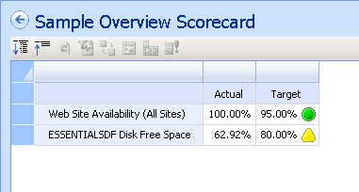

We will now create an Objective KPI to group these KPIs together.

Objective (or Grouping) KPI
Objective KPIs can be used to aggregate (or roll-up) two or more KPIs into a single score, or they may be used to simply group one of KPIs together on a scorecard. For this example, we will create a simple grouping KPI. To create an objective KPI, select the “Objective KPI” template in the new KPI wizard. In the KPI editor, an objective KPI looks very similar to a “blank” KPI, with one notable exception. For the objective KPI, the calculation fields are set to “No value” as shown below. For a “Blank KPI” template, the calculation field is set to “Default.” Since we do not want to query a data source for the values of this objective KPI, no data mappings are required.

Figure 55: KPI Editor - Objective KPI
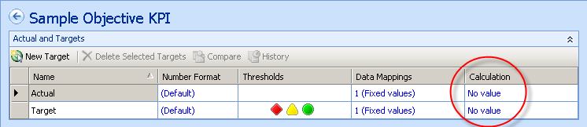

Drag the objective KPI onto the sample scorecard, above the two KPIs that are already on the scorecard. Note that all three KPIs are aligned at the same level. Often, the objective KPI should act as a grouping KPI (parent) and the KPIs below it should be indented. To indent the children KPIs, select the Edit tab in the ribbon. Select the KPI that should be indented and select the “Decrease Level” button, as shown below.

Figure 56: Edit Ribbon Tab | Format Buttons
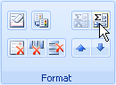

When this step is completed, the scorecard should look something like this:

Figure 57: Grouped KPIs
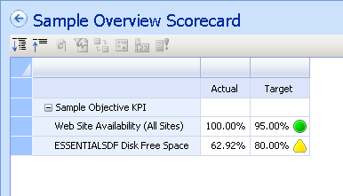

Note that the objective KPI can be expanded and collapsed, just like a parent member in a cube hierarchy.

Once these three basic KPI types are understood (Availability, Performance Counters, Objectives) virtually any type of KPI and scorecard may be created. The following sections will look at unique considerations for two types of scorecards: “Balanced” overview scorecards and Service Level Agreement (SLA) scorecards.

Balanced IT Scorecards
The first sample we will examine is a balanced IT scorecard, an example of which is shown below.

Figure 58: Sample "Balanced" IT Scorecard
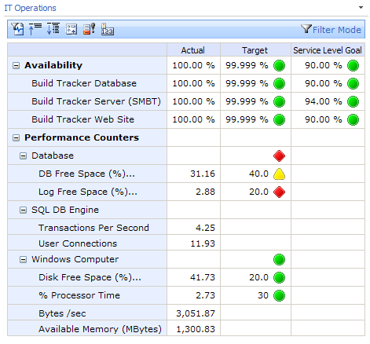

In this example, we can see many different ways that seemingly disparate KPIs are measured and aggregated.
- Objective KPIs – the score “Windows Computers” performance counters consists of different types of KPIs (% disk free space, % CPU, network card through-put, and available memory), some with measured goals, some without, aggregated into a single high-level score (green, or “on-target” in the example above)
Furthermore, note that KPIs for application availability is combined with performance counters for several different types of managed entities on a single scorecard.
Most of the concepts used to create the above scorecard were addressed in the previous section, including:
- Creating Availability, Performance Counter, and Objective KPIs
- Formatting scorecards – indenting child (or grouped) KPIs
New concepts shown in the above scorecard that we will cover below are:
- Objective KPIs with a score
- KPI Weighting
- KPIs with no target
- Multiple KPI targets (this concept will be covered in a later section, Service Level Agreement (SLA) Scorecards)
- Adding “Person Responsible” to the Scorecard (this concept will be covered in a later section, Service Level Agreement (SLA) Scorecards)

Scored Objective KPIs
To display a score for an objective KPI, edit the target value calculation field in the KPI editor. Select “Default”, which will display the normalized weighted score for the children KPIs. Scores are normalized so that different types of KPIs may be evaluated similarly and aggregated into a score. Once we specify a calculation method for the objective KPI, a value is displayed. (Note that this is a value that requires a data mapping, not the score of actual against target) Often, there is no value for an objective KPI target. To remove the value, we can trick that scorecard into displaying a blank value. To do this, enter 0 for the fixed entry data value for target, and override the number formatting to enter a blank space ‘ ‘ for the zero value (enter a space in the “Show zero as:” field in the Format Numbers dialog.) In the sample scorecard created in the previous section, this would appear as follows:

Figure 59: Objective KPI with a Score
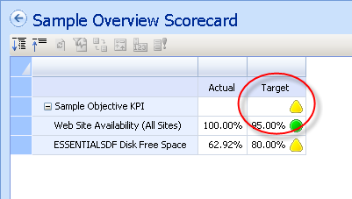

To verify that the scores (actual vs target) are being calculated as expected, they may be displayed in the scorecard next to the status icon. To display the scores, select the target column, and the “Properties” icon in the Scorecard Editor group in the Edit ribbon tab. Check the “Show Score” option. The scorecard should now look something like this:

Figure 60: Displaying Scores in a Scorecard
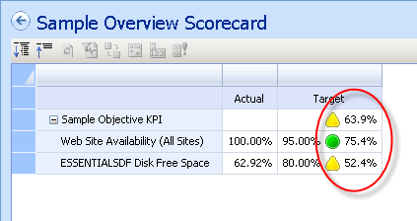

Note that we have not edited thresholds or scoring algorithms for these KPIs. Thresholds and scoring algorithms are relatively advanced concepts, and are not covered in detail in this paper. For more information on thresholds and scoring algorithms, please see the Office PerformancePoint Server 2007 product documentation, or the following Office Performance Point Server Team Blog articles:

- Scoring Algorithm Used in PerformancePoint Scorecards
- Effects of Best and Worst Values on KPI Scores
- Band by Stated Score

KPI Weighting
KPIs may be assigned different weights, which will impact the roll-up scores. For example, availability metrics may be weighted higher than individual performance counters in a balanced scorecard. In our sample scorecard, select the scorecard row containing the web site availability KPI and select “Properties” in the ribbon. Change the “Score rollup weight:” field to 2, as shown below.

Figure 61: KPI View Settings
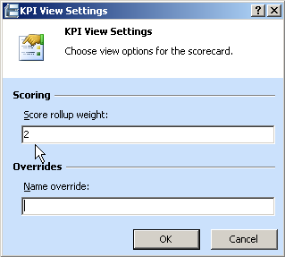

This will assign a weight for the availability KPI that is twice that of the disk free space KPI, which should change the score for the objective KPI. As we can see in the figure below, this is the case. The objective score was increased from 63.9% to 67.8%, which is expected since the availability KPI has a better score than the disk free space KPI and is now weighted higher.

Figure 62: Effect of Weighting on the Objective Score
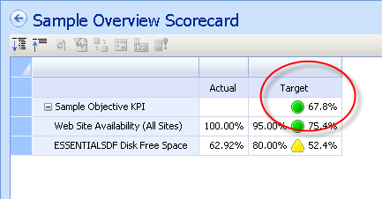

KPIs with No Targets
In rare cases, a KPI may be included on a scorecard that does not have a valid target. In the sample balanced scorecard shown earlier in the section, the “User Connections” KPI does not have a target. This is a value that may not make sense to measure against a target, but it may be an important metric to track on a daily basis. To remove a target from a KPI, simply select the target row in the KPI editor and click on the “Delete Selected Targets” button.

Figure 63: Delete Selected Targets
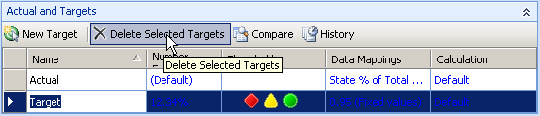

Service Level Agreement (SLA) Scorecards
The concepts discussed so far in the document can also enable the creation of KPIs and scorecards that monitor compliance with Service Level Agreements (SLAs). An example SLA scorecard is shown below.

Figure 64: Service Level Agreements (SLA) Scorecard
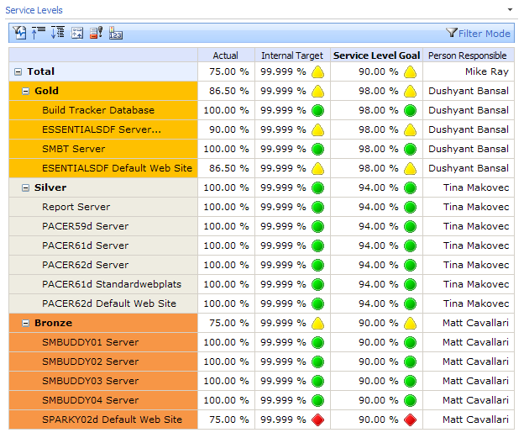

The SLA scorecard makes use of objective KPIs to group availability KPIs into three buckets, gold, silver, and bronze. This same technique could be used to group KPIs by service lines or lines of business. An additional objective KPI, “Total” is used to aggregate the gold, silver, and bronze levels into a single overall score for Service Level compliance.
Two new scorecard concepts will be discussed below:
- Multiple KPI targets
- Adding “Person Responsible” to the Scorecard

Multiple KPI Targets
It may be desirable to measure a KPI value against multiple targets. In the example above, the availability KPIs are measures against an internal IT department goal (99.999) and a service level goal that has been negotiated with the business users.

To add additional targets to a KPI, click on the “New Target” button in the KPI editor. In the sample scorecard that we have been building out, select the web site availability KPI and add a target named “Service Level Goal”. Enter a target value in the same way the first target was entered. The KPI editor should now appear as shown below.

Figure 65: Add Service Level Target
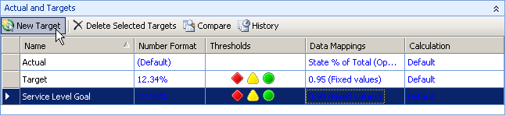

The next step is to add the new target column to the scorecard. To do this, expand the “Metrics” folder in the Available Items pane. A new metric, Service Level Goal, should appear. Drag this item to the right of the target column in the scorecard.

Figure 66: Available Items Pane - Metrics Folder
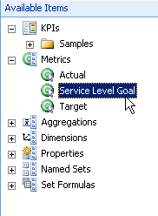

Hit the update button, and the scorecard should now look something like this:

Figure 67: Scorecard with Multiple Targets
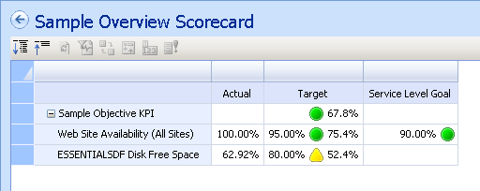

Person Responsible
A helpful addition to a scorecard is contact information – who to contact if the KPI is not performing as expected, or who to contact if a business user has any questions about the KPI. This is particularly true with SLAs, as these agreements typically have one owner, or one key stakeholder. “Person Responsible” is a property that can be utilized for this purpose. The Person Responsible property is available on the Properties tab for all Office PerformancePoint 2007 components. To add Person Responsible to the sample scorecard, select the Web Site Availability KPI, open the Properties tab, and enter the desired value. In this sample, we will enter “Mike Ray” as the person responsible.

Person responsible is added to the scorecard much like multiple targets in the previous section. Select the scorecard, and expand the Properties folder in the available items pane. Drag the “Person Responsible” item to the right of the Service Level Goal target on the scorecard. The scorecard should now appear as shown below.

Figure 68: Sample Scorecard with Person Responsible
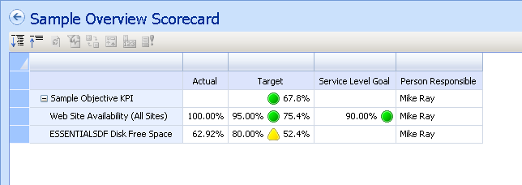

Other Data Sources for SLA Goals
SLA goal information is often stored outside of a production database. In some cases, SLA goals are stored in an Excel spreadsheet, and in the worst case, are stored only in a word document or some other unstructured data source. The examples shown above use fixed number entry to enter SLA goals, and this may be the only alternative if the goals are stored in an unstructured data source.

Office PerformancePoint Server 2007 KPIs support tabular data sources such as Office Excel 2007 and Office SharePoint Server 2007 lists that offer a better alternative for storing SLA goals (in the case that application – database storage and management of SLA goals is not available.) When building an SLA scorecard, it is highly recommended that one of these tabular data sources are used to store SLA goal data.

Analytic Reports and Dashboards

Office PerformancePoint Server 2007 Reports
Office PerformancePoint Server 2007 reports provided needed context and detail to accompany scorecards. For example, a Office PerformancePoint Server 2007 report can provide detailed performance counter data for an aggregated value in a scorecard, or can provide an analytic drill-path to help users analyze the underlying data behind a KPI and understand why a KPI is performing the way it is.Office PerformancePoint Server 2007 supports many types of reports, including:
- Analytic Charts and Grids
- Excel Services
- Reporting Services
- ProClarity Analytic Server
Existing reports, such as reports created in the Operations Manager report console, may be re-used in Office PerformancePoint Server 2007 dashboards. Analytic charts and grids are web-based analytic components that provide interactive drill down analysis for data in the OLAP cube. Effective use of Office PerformancePoint Server 2007 reports can greatly enhance the usability of a scorecard / dashboard solution and can help reduce the amount of ad-hoc report requests by providing users the ability to drill into the data themselves, and help them answer their own questions. Furthermore, Office PerformancePoint Server 2007 reports may be parameterized and linked to other dashboard elements such as scorecards and filters. This is discussed in a later section.

The remainder of this section will walk through creating a sample analytic chart and grid.

Analytic Charts and Grids
Analytic charts and grids are OLAP client tools. These reports are creating in the dashboard designer, with a graphical drag-and-drop authoring environment. Reports may be created by dragging dimensions and measures onto report axes, or custom MDX queries may be written. To create a new analytic grid, right-click on the Reports folder in the workspace browser and select “New Report”. As with other wizards in the dashboard designer, the first steps are to select a template and name the new component. The report template screen displays all of the report types available in Office PerformancePoint Server 2007, as shown in the following figure.

Figure 69: Select a Report Template
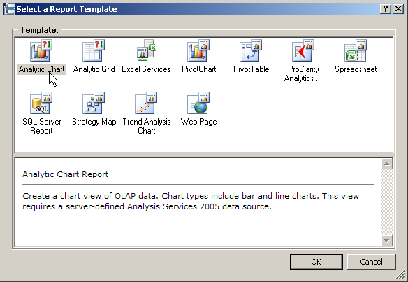

Select “Analytic Grid”, and click “Ok”. Name the report “Performance Counters Grid” and place it in the Samples display folder. Select the Operations Manager Business Intelligence data source (the OLAP cube) and finish the wizard. At this point, we have a blank report palette in the center of the dashboard designer, and a list of measures and dimensions on the right-hand side. If one is familiar with OLAP client tools such as Microsoft Excel Pivot Tables and ProClarity, then the analytic grid designer should be familiar and relatively straight-forward to use.

In this sample, we will create an analytic grid that displays all performance counters (min, max, and average values) for the ESSENTIALSDF server. To create this grid, drag the following measures to the “Columns” axis on the bottom pane of grid designer: Min Value, Average Value, and Max Value. Now, we need to get a list of all the performance counters on the ESSENTIALSDF server. We can do this by placing all performance counters on the grid rows, and placing the ESSENTIALSDF on the background (or filter) axis. Drag the “SQL Entity Performance Counters.Counter Name” attribute hierarchy to the rows axis. Open the hierarchy tree by clicking on the drop-down arrow next to the hierarchy name in the rows axis pane. We want to select all performance counters, so right-click on “All” and select Children, as shown in the following figure.

Figure 70: Select Performance Counter Hierarchy Members
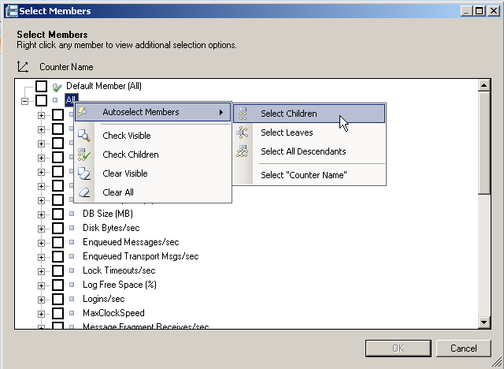

Now, we need to filter the list of performance counters to those counters that run on the ESSENTIALSDF server. We can either use attribute hierarchy that contains managed entity names, or the “Entity Performance Counters” hierarchy to select the server name. Drag the “SQL Performance Counters.Managed Entity Default Name” attribute hierarchy to the background axis and select the “ESSENTIALSDF….” member. This grid should now be filtered and look like the grid shown below.

Figure 71: Performance Counters Grid in the Grid Designer
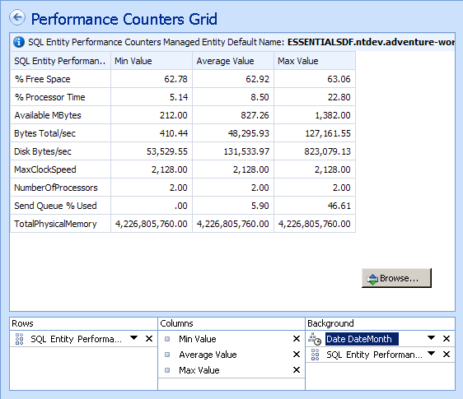

Note in the grid shown above that the “Date.DateMonth” hierarchy is also placed on the background axis. This hierarchy was placed on the background axis to support linking to a dashboard filter. Dashboard filters may be linked to report hierarchies on an analytic chart or grid axis, so it is a good practice to place hierarchies that will be linked to dashboard filters on the grid or chart during report creation. In the following section, an example of a linked dashboard filter will be discussed.

Note that this grid is not designed for drill-down. Flat, single-level attribute hierarchies were used to create this grid, as they are simple and effective to use for detailed reports. Now, we will create a sample interactive Analytic Chart with a trend line that can be drilled upon. To provide the drill-down capability, a multi-level hierarchy will be used (as opposed to a single-level attribute hierarchy). Launch the report wizard, select the Analytic Chart template, and complete the remaining wizard steps. This chart will display trend lines for the “disk free space” performance counter for all servers. Drag the following “Average Value” measure to the background axis. Drag the “SQL Performance Counters.Entity Performance Counters” hierarchy onto the rows axis. This hierarchy will provide a drill path for the user to drill from all servers, to specific servers, to logical disk instances. Drag the “SQL Performance Counters.Performance Counter Name” hierarchy to the background axis and select the “% Free Space” member. This will filter the chart by the “% Free Space” performance counter.

Since this is to be a trend line, drag the “Date.Date Month” hierarchy to the columns axis. Depending on the sparsity of the data, data may not exist for all time periods in the cube. In the sample data set that accompanies this paper, we can select the days in January 2007 to construct a nice trend line. Open the Date hierarchy tree, expand the tree to Jan-2007, right-click and select children as shown below.

Figure 72: Select Date Hierarchy Members
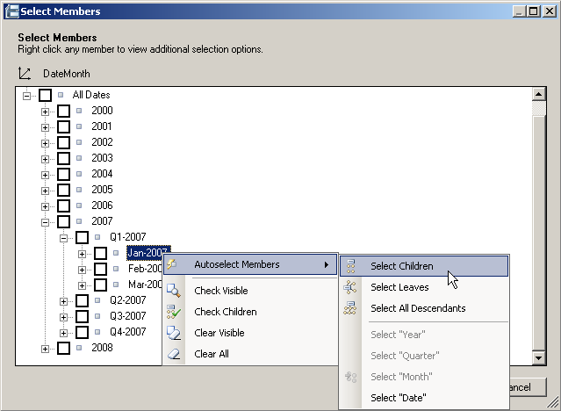

By default, the chart is a bar chart. Change the chart type to a line chart from the Report Type button in the ribbon Edit tab. If there are gaps in the line chart, we can filter empty values to create an unbroken line. Click on the “Browse…” button on the chart editor, and select the “Filter empty bottom axis” button on the browse window toolbar. The chart should now look something like the following:

Figure 73: Disk Free Space Trend Line
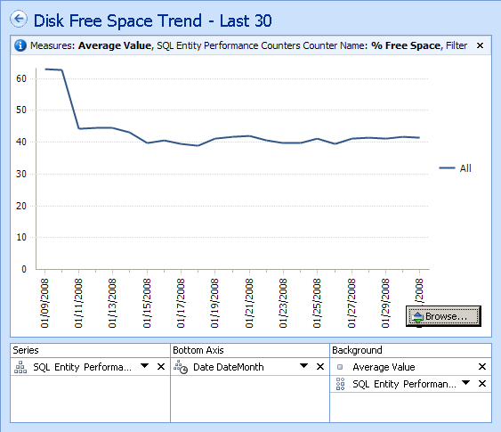

To demonstrate the drill down capability, click on the “Browse…” button once more. Hover over the trend line in the browse window and click on the trend line (the pointer will change to a hand icon when drill-down is available.) The chart will drill down to the next level in the hierarchy. Continue drilling until the chart shows disk free space for each server, as shown below.

Figure 74: Trend Line Drill-Down
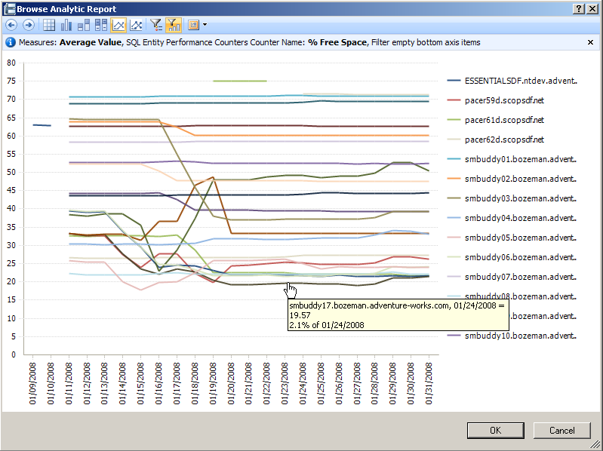

Click the “Cancel” button to return to the chart editor. We are now ready to create a dashboard containing our sample scorecard and sample reports.

Office PerformancePoint 2007 Dashboards
Scorecards and reports can be placed in web-based dashboards and deployed to end users via Office SharePoint Server 2007. Dashboards provide an at-a-glance view of scorecards and reports, with interactivity, and links to ensure that all data views are in-context. Dashboards often provide a “starting point” for monitoring and analyzing IT Operations data, helping eliminate the need for end users to search for the reports that contain the data they need. Dashboards are also popular, as they can provide a collection of scorecards and reports that present a high-level story, or overview of IT Performance, at a single-glance, delivered through a web browser.
This section will walk through the creation of a dashboard, using the sample components built throughout this paper. There are many dashboard capabilities that are not explored in this paper, however, a more robust and full-featured dashboard is available as a sample with the dataset that accompanies this paper. This dashboard is reviewed in the overview section of this document.
To create a new dashboard, right-click on the Dashboards folder in the workspace browser. As with other wizards, we first select a template, than name the dashboard. For this dashboard, select a two-column template. Name the dashboard “Sample Dashboard” and finish the wizard.
Components that are available for placement on a dashboard are shown in the available items pane on the right-hand side of the workspace browser. These items may be dragged and dropped onto dashboard zones. Drag the sample scorecard onto the left-hand zone, and the two reports onto the right-hand zone (one on top of the other.) The dashboard editor should now look something like this:

Figure 75: Dashboard Editor
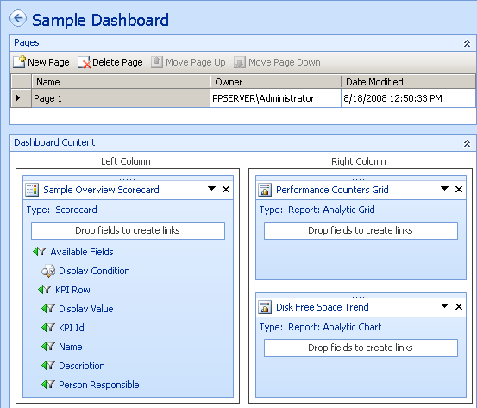

To preview the dashboard, publish the dashboard to Office PerformancePoint Server 2007 and deploy to Office SharePoint Server 2007. When a dashboard is deployed, a new aspx page is generated for each dashboard page, and the pages are pushed to a Office SharePoint Server 2007 Document Library. The dashboard is deployed by clicking on the “Deploy | Office SharePoint Server 2007 site” button in the ribbon Edit tab. The Deploy wizard allows you to select a Office SharePoint Server 2007 site and Document Library to which to publish the dashboard. It may be helpful to create a “sandbox” Document Library in Office SharePoint Server 2007 prior to deploying the dashboard. Select a Site Template, and finish the wizard. The dashboard should appear similar to the following screenshot.

Figure 76: Deployed Sample Dashboard
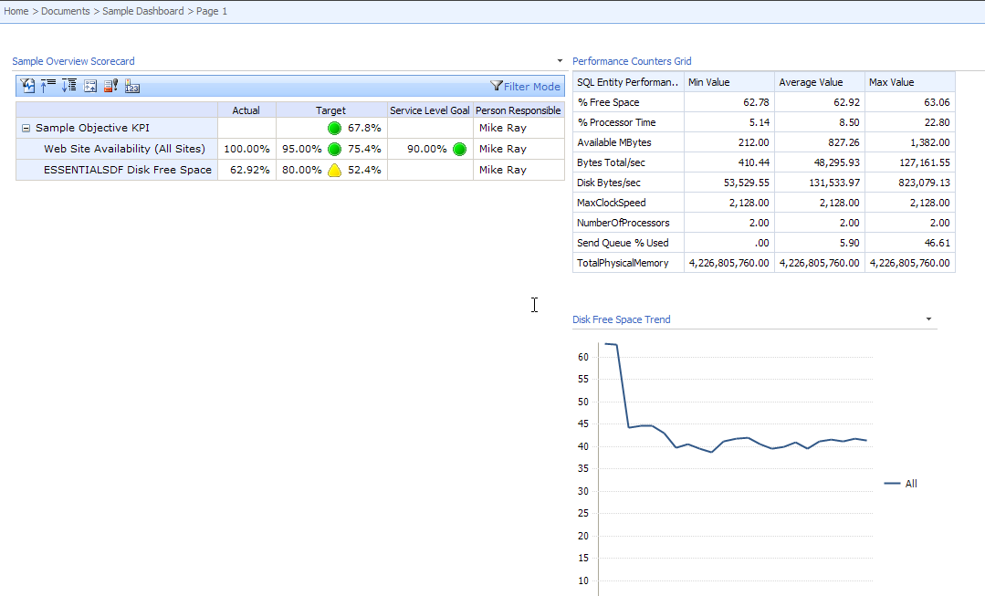

The appearance of the dashboard may vary depending on the site template selected during the deploy wizard. Also, the size of the dashboard elements may look quite different. Dashboard zone sizes and item sizes may be edited to better fit the available screen real estate and to minimize scroll bars. For an in-depth discussion of dashboard sizing options, see the following Office PerformancePoint Server 2007 team blog article: Office PerformancePoint Sever 2007 Dashboard Sizing Explained.
Some other key dashboard features are included in the sample dashboards, shown below (features highlighted with numbered callouts.)

Figure 77: Filter and Linking Features
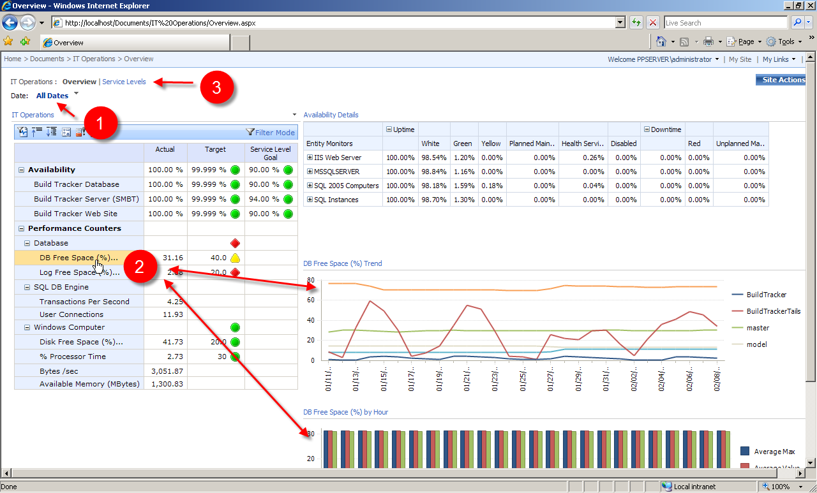

- A “Date” filter has been added to the dashboard, and linked to all views. When a date is selected in the filter, the date value is passed to each view (scorecard and reports) and the view is updated to reflect the data for the new date value. For trend lines, an MDX formula (called a Post Formula) may be written that substitutes a date value with the “previous 30 days” from that date.
- Reports may be linked to scorecard KPIs so that they are only visible when that KPI is selected. This feature is called “Conditional Visibility.” This feature helps present a clean, uncluttered dashboard by ensuring that only those reports that are relevant to the selected KPI are displayed at a given time.
- Dashboards may consist of multiple pages. For ease of navigation between pages, a “page selector” may be included on each page. This is an option in the deploy wizard.

There are many more dashboard features that can be used to create very compelling dashboards to the end users community. For more information on building PerformancePoint dashboards, please refer to:
- Office PerformancePoint Server Team Blog
- Office PerformancePoint Server 2007 Product Documentation
- Office PerformancePoint Server 2007 Product web site

Next Steps – Future Application Areas
The concepts in this paper cover a lot of ground, and represent a significant amount of time and effort to create and deploy. This paper, and the accompanying samples, should help decrease the time to deployment. Many more Business Intelligence and Performance Management solutions may be applied to IT department applications. As more and more Business Intelligence capabilities are built out within the IT department, Business Intelligence capabilities will mature – as will the ability of the IT department to deploy Business Intelligence applications to the business user community. The IT department, in this case, can really help lead an organization, as the IT department will be on the “leading edge” of Business Intelligence capabilities and Performance Management processes.
Some suggestions for future application areas include:
- Office PerformancePoint Server 2007 Planning Applications – use Office PerformancePoint Server 2007 to create IT planning applications for areas such as:
  - IT budget and forecast
  - Skill / Resource management
  - Headcount planning
  - Capacity Planning
- Investigate the use of SQL Server Data Mining for advanced analysis and predictive applications
- Integrate IT key performance indicators into corporate-wide balanced scorecards
- Integrate data from other IT applications – including home-grown applications and 3rd party IT management tools
- Introduce other ad-hoc analysis tools to IT users – such as Excel Pivot Tables, ProClarity, or any number of 3rd party client tools. The use of Office Excel 2007, in particular, can help spread the adoption of Business Intelligence applications, as most users are very comfortable with using Office Excel 2007 already and minimal training should be required. Sample views from other OLAP client tools are shown below.

Figure 78: "Disk Free Space" Excel Pivot Table

Figure 79: ProClarity Decomposition Tree
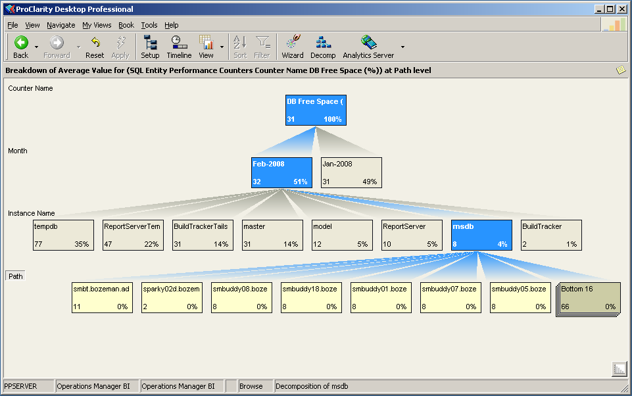

Conclusion
Business Intelligence and Performance Management have become more commonplace in IT department applications. However, Business Intelligence applications for the IT department often take a back-seat to the needs of the business users. It is hoped that the concepts and samples discussed in this paper can help accelerate the creation of IT Operations scorecards, dashboards, and analytics- so that IT department personnel can take advantage of Business Intelligence tools and Performance Management practices to help drive better performance. Feedback on this paper and topic is welcome and encouraged.

Evaluation Software
Evaluate Microsoft Office PerformancePoint Server 2007 SP1 today:
http://technet.microsoft.com/en-us/evalcenter/cc307742.asp

The information contained in this document represents the current view of Microsoft Corporation on the issues discussed as of the date of publication. Because Microsoft must respond to changing market conditions, it should not be interpreted to be a commitment on the part of Microsoft, and Microsoft cannot guarantee the accuracy of any information presented after the date of publication.
This white paper is for informational purposes only. MICROSOFT MAKES NO WARRANTIES, EXPRESS OR IMPLIED, IN THIS
DOCUMENT.
Complying with all applicable copyright laws is the responsibility of the user. Without limiting the rights under copyright, no part of this document may be reproduced, stored in, or introduced into a retrieval system, or transmitted in any form or by any means (electronic, mechanical, photocopying, recording, or otherwise), or for any purpose, without the express written permission of Microsoft Corporation.
Microsoft may have patents, patent applications, trademarks, copyrights, or other intellectual property rights covering subject matter in this document. Except as expressly provided in any written license agreement from Microsoft, the furnishing of this document does not give you any license to these patents, trademarks, copyrights, or other intellectual property.
© 2001 Microsoft Corporation. All rights reserved.
The example companies, organizations, products, domain names, e-mail addresses, logos, people, places, and events depicted herein are fictitious. No association with any real company, organization, product, domain name, e-mail address, logo, person, place, or event is intended or should be inferred.
Microsoft, list Microsoft trademarks used in your white paper alphabetically are either registered trademarks or trademarks of Microsoft Corporation in the United States and/or other countries.
The names of actual companies and products mentioned herein may be the trademarks of their respective owners.

Appendix A: Operations Manager Data Warehouse Sample Queries

Performance Counters Map Query
SELECT DISTINCT
pd.PerformanceRuleInstanceRowId
,ri.RuleRowId
,pd.ManagedEntityRowId
,convert(bigint, convert(varchar, pd.PerformanceRuleInstanceRowId) + convert(varchar, ri.RuleRowId) + convert(varchar, pd.ManagedEntityRowId)) as PerfRuleKey
,ri.InstanceName
,pr.ObjectName
,pr.CounterName
FROM Perf.vPerfDaily pd
INNER JOIN vPerformanceRuleInstance ri ON
pd.PerformanceRuleInstanceRowId = ri.PerformanceRuleInstanceRowId
INNER JOIN vPerformanceRule pr ON
pd.PerformanceRuleInstanceRowId = ri.PerformanceRuleInstanceRowId AND ri.RuleRowId = pr.RuleRowId

Populate the SQL Entities Performance Counters Dimension Table
SELECT DISTINCT
vManagedEntity_2.DisplayName AS 'TopLevelGroup',
met.ManagedEntityTypeDefaultName as 'Type',
vManagedEntity.ManagedEntityDefaultName,
CASE WHEN vManagedEntity.Path is NULL then vManagedEntity.ManagedEntityDefaultName ELSE vManagedEntity.Path END AS 'Path',
vManagedEntity.ManagedEntityRowId,
vManagedEntity.ManagedEntityTypeRowId,
vManagedEntity_2.ManagedEntityRowID as GroupRowID,
prm.PerformanceRuleInstanceRowId,
prm.RuleRowId,
prm.PerfRuleKey,
prm.InstanceName,
prm.ObjectName,
prm.CounterName

FROM vManagedEntity INNER JOIN
(SELECT DISTINCT r.SourceManagedEntityRowId, r.TargetManagedEntityRowId
FROM Relationship AS r INNER JOIN
RelationshipManagementGroup AS rmg ON r.RelationshipRowId = rmg.RelationshipRowId
AND (rmg.FromDateTime <= getutcdate()) AND (ISNULL(rmg.ToDateTime, '99991231') >= getutcdate())
INNER JOIN
(SELECT RelationshipTypeRowId, [Level]
FROM dbo.RelationshipDerivedTypeHierarchy
-- this is a UDF that returns the system containment relationship IDs
((SELECT RelationshipTypeRowId
FROM vRelationshipType
WHERE (RelationshipTypeSystemName = 'System.Containment')), 0) AS RelationshipDerivedTypeHierarchy_1) AS rt ON
r.RelationshipTypeRowId = rt.RelationshipTypeRowId INNER JOIN
(SELECT ManagedEntityRowId
FROM vManagedEntity AS vManagedEntity_1
) AS me ON me.ManagedEntityRowId = r.SourceManagedEntityRowId) AS target ON
vManagedEntity.ManagedEntityRowId = target.TargetManagedEntityRowId INNER JOIN
vManagedEntityType AS met ON met.ManagedEntityTypeRowId = vManagedEntity.ManagedEntityTypeRowId INNER JOIN
vManagedEntity AS vManagedEntity_2 ON target.SourceManagedEntityRowId = vManagedEntity_2.ManagedEntityRowId INNER JOIN
vManagedEntityMonitor as mon ON mon.ManagedEntityRowID = vManagedEntity.ManagedEntityRowId
--this is where we join the mapping table
INNER JOIN tmpManagedEntityPerfRuleMap prm ON prm.ManagedEntityRowId = vManagedEntity.ManagedEntityRowId
-- this hierarchy is scoped to SQL Groups
WHERE vManagedEntity_2.DisplayName in ('SQL Instances', 'SQL 2005 Computers', 'MSSQLSERVER')

Populate the Entity Monitors Dimension Table
SELECT DISTINCT
vManagedEntity_2.DisplayName AS 'TopLevelGroup',
met.ManagedEntityTypeDefaultName as 'Type',
vManagedEntity.ManagedEntityDefaultName,
CASE WHEN vManagedEntity.Path is NULL then vManagedEntity.ManagedEntityDefaultName ELSE vManagedEntity.Path END AS 'Path',
vmon.MonitorDefaultName,
vmon.MonitorSystemName,
vManagedEntity.ManagedEntityRowId,
vManagedEntity.ManagedEntityTypeRowId,
vManagedEntity_2.ManagedEntityRowID as GroupRowID,
mon.ManagedEntityMonitorRowId

FROM vManagedEntity INNER JOIN
(SELECT DISTINCT r.SourceManagedEntityRowId, r.TargetManagedEntityRowId
FROM Relationship AS r INNER JOIN
RelationshipManagementGroup AS rmg ON r.RelationshipRowId = rmg.RelationshipRowId
AND (rmg.FromDateTime <= getutcdate()) AND (ISNULL(rmg.ToDateTime, '99991231') >= getutcdate())
INNER JOIN
(SELECT RelationshipTypeRowId, [Level]
FROM dbo.RelationshipDerivedTypeHierarchy -- this is a UDF that returns the latest relationship for a source/target pair
((SELECT RelationshipTypeRowId
FROM vRelationshipType
WHERE (RelationshipTypeSystemName = 'System.Containment')), 0) AS RelationshipDerivedTypeHierarchy_1) AS rt ON
r.RelationshipTypeRowId = rt.RelationshipTypeRowId INNER JOIN
(SELECT ManagedEntityRowId
FROM vManagedEntity AS vManagedEntity_1
) AS me ON me.ManagedEntityRowId = r.SourceManagedEntityRowId) AS target ON
vManagedEntity.ManagedEntityRowId = target.TargetManagedEntityRowId INNER JOIN
vManagedEntityType AS met ON met.ManagedEntityTypeRowId = vManagedEntity.ManagedEntityTypeRowId INNER JOIN
vManagedEntity AS vManagedEntity_2 ON target.SourceManagedEntityRowId = vManagedEntity_2.ManagedEntityRowId INNER JOIN
vManagedEntityMonitor as mon ON mon.ManagedEntityRowID = vManagedEntity.ManagedEntityRowId INNER JOIN
vMonitor vmon ON vmon.MonitorRowId = mon.MonitorRowId
-- this hierarchy is scoped to IIS and SQL Server Groups and Roll-Up Monitors
WHERE
vManagedEntity_2.DisplayName in ('IIS Web Server', 'SQL Instances', 'SQL 2005 Computers', 'MSSQLSERVER') AND
vmon.MonitorDefaultName in ('Availability', 'Configuration', 'Entity Health', 'Performance', 'Security')

Populate the Performance Rules Fact Table
select
ph.[DateTime]
,convert(int, ph.[DateTime]) as [DateKey]
,datepart(hh, ph.[DateTime]) as [HourKey]
--Create the composite key used in the Performance Rules Dimension Table
,convert(bigint, convert(varchar, ph.PerformanceRuleInstanceRowId) + convert(varchar, ri.RuleRowId) + convert(varchar, ph.ManagedEntityRowId)) as PerfRuleKey
,ph.[PerformanceRuleInstanceRowId]
,ph.[ManagedEntityRowId]
,ph.[SampleCount]
,ph.[AverageValue]
,ph.[MinValue]
,ph.[MaxValue]
,ph.[StandardDeviation]
from [Perf].[vPerfHourly] ph
inner join [dbo].[vPerformanceRuleInstance] ri on
ph.[PerformanceRuleInstanceRowId] = ri.[PerformanceRuleInstanceRowId]

Populate the Date Dimension Table
DECLARE
@startDate datetime
,@endDate datetime
,@dateCounter datetime

BEGIN
SET @startDate = (select MIN([DateTime]) from factPerfHourly)
SET @endDate = GETDATE()
SET @dateCounter = @startDate

WHILE @dateCounter <= @endDate
BEGIN
insert into dbo.dimDate
select
convert(int, @dateCounter) as [DateKey]
,convert(varchar, @dateCounter, 101) as [DateLabel]
,DATEPART(weekday, @dateCounter) as [DayOfWeek]
,DATENAME(weekday, @dateCounter) as [DayOfWeekLabel]
,CONVERT(int, DATENAME(YEAR, @dateCounter)*100 + CONVERT(varchar, DATEPART(week, @dateCounter))) as [WeekKey]
,DATEPART(week, @dateCounter) as [Week]
,'Wk ' + CONVERT(varchar, DATEPART(week, @dateCounter)) + '-' + DATENAME(YEAR, @dateCounter) as [WeekLabel]
,CONVERT(int, DATENAME(YEAR, @dateCounter)*100 + CONVERT(varchar, DATEPART(month, @dateCounter))) as [MonthKey]
,DATEPART(month, @dateCounter) as [Month]
,DATENAME(month, @dateCounter) as [MonthLabelShort]
,LEFT(DATENAME(month, @dateCounter), 3) + '-' + DATENAME(YEAR, @dateCounter) as [MonthLabelLong]
,CONVERT(int, DATENAME(YEAR, @dateCounter)*100 + CONVERT(varchar, DATEPART(quarter, @dateCounter))) as [QuarterKey]
,DATEPART(quarter, @dateCounter) as [Quarter]
,'Q' + CONVERT(varchar, DATEPART(quarter, @dateCounter)) + '-' + DATENAME(YEAR, @dateCounter) as [QuarterLabel]
,DATEPART(YEAR, @dateCounter) as [Year]

SET @dateCounter = DATEADD(day, 1, @dateCounter)
END

END

Populate the Hour Dimension Table
DECLARE
@startHour int
,@endHour int
,@hourCounter int
,@varDate datetime

BEGIN
SET @startHour = 1
SET @endHour = 24
SET @hourCounter = @startHour
SET @varDate = CAST('1/1/2008' as datetime)

WHILE @hourCounter <= @endHour
BEGIN
insert into [dbo].[dimHour]
select
datepart(hh, @varDate) as [HourKey]
,left(convert(varchar, @varDate, 14), 2) + '00' as [24HourLabel]
,case
when datepart(hh, @varDate) = 0 then '12:00 AM'
when datepart(hh, @varDate) = 12 then '12:00 PM'
when datepart(hh, @varDate) = 13 then '1:00 PM'
when datepart(hh, @varDate) = 14 then '2:00 PM'
when datepart(hh, @varDate) = 15 then '3:00 PM'
when datepart(hh, @varDate) = 16 then '4:00 PM'
when datepart(hh, @varDate) = 17 then '5:00 PM'
when datepart(hh, @varDate) = 18 then '6:00 PM'
when datepart(hh, @varDate) = 19 then '7:00 PM'
when datepart(hh, @varDate) = 20 then '8:00 PM'
when datepart(hh, @varDate) = 21 then '9:00 PM'
when datepart(hh, @varDate) = 22 then '10:00 PM'
when datepart(hh, @varDate) = 23 then '11:00 PM'
else convert(varchar, datepart(hh, @varDate)) + ':00 AM'
end as [12HourLabel]
SET @hourCounter = @hourCounter + 1 --increment counter
SET @varDate = DATEADD(hh, 1, @varDate)

END

END

Populate the Entity Monitors Dimension Table
SELECT DISTINCT
vManagedEntity_2.DisplayName AS 'TopLevelGroup',
met.ManagedEntityTypeDefaultName as 'Type',
vManagedEntity.ManagedEntityDefaultName,
CASE WHEN vManagedEntity.Path is NULL then vManagedEntity.ManagedEntityDefaultName ELSE vManagedEntity.Path END AS 'Path',
vmon.MonitorDefaultName,
vmon.MonitorSystemName,
vManagedEntity.ManagedEntityRowId,
vManagedEntity.ManagedEntityTypeRowId,
vManagedEntity_2.ManagedEntityRowID as GroupRowID,
mon.ManagedEntityMonitorRowId

FROM vManagedEntity INNER JOIN
(SELECT DISTINCT r.SourceManagedEntityRowId, r.TargetManagedEntityRowId
FROM Relationship AS r INNER JOIN
RelationshipManagementGroup AS rmg ON r.RelationshipRowId = rmg.RelationshipRowId
AND (rmg.FromDateTime <= getutcdate()) AND (ISNULL(rmg.ToDateTime, '99991231') >= getutcdate())
INNER JOIN
(SELECT RelationshipTypeRowId, [Level]
FROM dbo.RelationshipDerivedTypeHierarchy -- this is a UDF that returns the latest relationship for a source/target pair
((SELECT RelationshipTypeRowId
FROM vRelationshipType
WHERE (RelationshipTypeSystemName = 'System.Containment')), 0) AS RelationshipDerivedTypeHierarchy_1) AS rt ON
r.RelationshipTypeRowId = rt.RelationshipTypeRowId INNER JOIN
(SELECT ManagedEntityRowId
FROM vManagedEntity AS vManagedEntity_1
) AS me ON me.ManagedEntityRowId = r.SourceManagedEntityRowId) AS target ON
vManagedEntity.ManagedEntityRowId = target.TargetManagedEntityRowId INNER JOIN
vManagedEntityType AS met ON met.ManagedEntityTypeRowId = vManagedEntity.ManagedEntityTypeRowId INNER JOIN
vManagedEntity AS vManagedEntity_2 ON target.SourceManagedEntityRowId = vManagedEntity_2.ManagedEntityRowId INNER JOIN
vManagedEntityMonitor as mon ON mon.ManagedEntityRowID = vManagedEntity.ManagedEntityRowId INNER JOIN
vMonitor vmon ON vmon.MonitorRowId = mon.MonitorRowId
-- this hierarchy is scoped to IIS and SQL Server Groups and Roll-Up Monitors
WHERE
vManagedEntity_2.DisplayName in ('IIS Web Server', 'SQL Instances', 'SQL 2005 Computers', 'MSSQLSERVER') AND
vmon.MonitorDefaultName in ('Availability', 'Configuration', 'Entity Health', 'Performance', 'Security')

Populate the State Dimension
insert [dimState]
values (1, 'White')
insert [dimState]
values (2, 'Green')
insert [dimState]
values (3, 'Yellow')
insert [dimState]
values (4, 'Red')
insert [dimState]
values (5, 'Planned Maintenance')
insert [dimState]
values (6, 'Unplanned Maintenance')
insert [dimState]
values (7, 'Health Service Unavailable')
insert [dimState]
values (8, 'Disabled')

Populate the State Staging Table
select
convert(int, [Date]) as [DateKey]
,[DateTime]
,[ManagedEntityMonitorRowId]
,[IntervalDurationMilliseconds]
,[StateKey]
,[StateMilliseconds]
from [dbo].[vStateDailyFull] vsf
unpivot ( [StateMilliseconds] for [StateKey]
in
(vsf.InYellowStateMilliseconds
,vsf.InRedStateMilliseconds
,vsf.InPlannedMaintenanceMilliseconds
,vsf.InUnplannedMaintenanceMilliseconds
,vsf.InDisabledStateMilliseconds
,vsf.HealthServiceUnavailableMilliseconds
,vsf.InWhiteStateMilliseconds
,vsf.InGreenStateMilliseconds)) unPvt

Populate the State Fact Table
select
DateKey
,[DateTime]
,ManagedEntityMonitorRowId
,IntervalDurationMilliseconds
,case StateKey
when 'InWhiteStateMilliseconds' then 1
when 'InGreenStateMilliseconds' then 2
when 'InYellowStateMilliseconds' then 3
when 'InRedStateMilliseconds' then 4
when 'InPlannedMaintenanceMilliseconds' then 5
when 'InUnplannedMaintenanceMilliseconds' then 6
when 'HealthServiceUnavailableMilliseconds' then 7
when 'InDisabledStateMilliseconds' then 8
end as [StateKey]
,StateMilliseconds
from stageFactStateDaily

Appendix B: Operations Manager BI Star Schema Diagrams

State Star Schema
Figure 80: Monitor State Star Schema
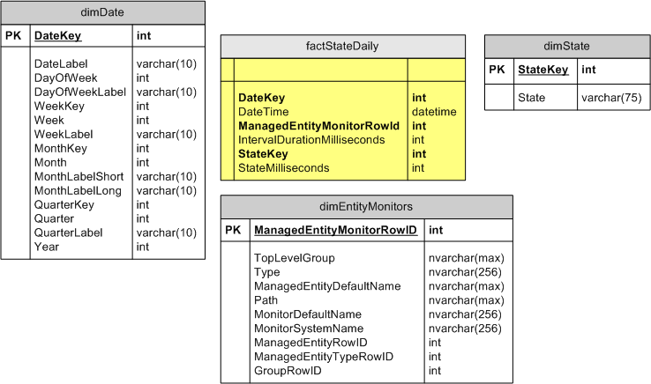

Performance Counters Star Schema
Figure 81: Performance Counters Star Schema
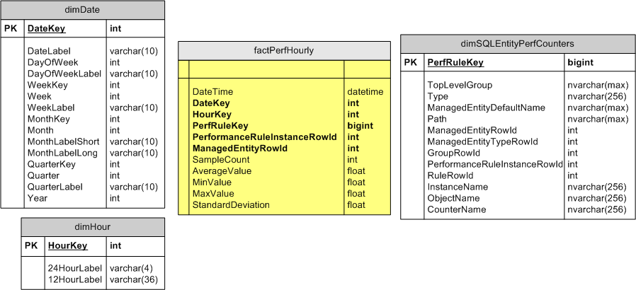

Supporting Tables
Figure 82: Supporting Table - Performance Counters Mapping
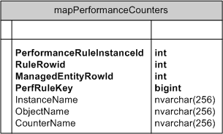

Figure 83: Supporting Table - Monitor State Facts Staging
