

Step-by-Step Guide to Getting Started with Microsoft Windows Server Update Services 3.0
Microsoft Corporation
Published: August 14, 2006
Author: Susan Norwood
Editor: Craig Liebendorfer

Abstract
This guide provides instructions for getting started with Microsoft® Windows Server™ Update Services (WSUS) 3.0. You will find instruction for basic tasks for deploying WSUS 3.0 on your network, including installing WSUS on the Microsoft Windows Server 2003 and Windows Server "Longhorn" operating systems: configuring WSUS 3.0 to obtain updates; configuring client computers to install updates from WSUS 3.0; as well as approving, managing, and distributing updates. Although WSUS 3.0 is a feature-rich, update-management solution, this guide offers only a single way to accomplish any of these tasks.

The information contained in this document represents the current view of Microsoft Corporation on the issues discussed as of the date of publication. Because Microsoft must respond to changing market conditions, it should not be interpreted to be a commitment on the part of Microsoft, and Microsoft cannot guarantee the accuracy of any information presented after the date of publication.

This White Paper is for informational purposes only. MICROSOFT MAKES NO WARRANTIES, EXPRESS, IMPLIED OR STATUTORY, AS TO THE INFORMATION IN THIS DOCUMENT.

Complying with all applicable copyright laws is the responsibility of the user. Without limiting the rights under copyright, no part of this document may be reproduced, stored in or introduced into a retrieval system, or transmitted in any form or by any means (electronic, mechanical, photocopying, recording, or otherwise), or for any purpose, without the express written permission of Microsoft Corporation.

Microsoft may have patents, patent applications, trademarks, copyrights, or other intellectual property rights covering subject matter in this document. Except as expressly provided in any written license agreement from Microsoft, the furnishing of this document does not give you any license to these patents, trademarks, copyrights, or other intellectual property.

Unless otherwise noted, the example companies, organizations, products, domain names, e-mail addresses, logos, people, places, and events depicted herein are fictitious, and no association with any real company, organization, product, domain name, e-mail address, logo, person, place, or event is intended or should be inferred.

©2006 Microsoft Corporation. All rights reserved.

Microsoft, SQL Server, Windows, and Windows Server are either registered trademarks or trademarks of Microsoft Corporation in the United States and/or other countries.

Contents
Step-by-Step Guide to Getting Started with Microsoft Windows Server Update Services 3.0 7
Step 1: Review WSUS 3.0 Installation Requirements 7
Software Requirements for Installing WSUS 3.0 on Windows Server 2003 Service Pack 1 8
Software Requirements for Installing WSUS 3.0 on Windows Server "Longhorn" 8
Disk Requirements and Recommendations 9
Automatic Updates Requirements 9
Permissions 9
Step 2: Install WSUS 3.0 on Your Server 10
Step 3: Configure the Network Connection for WSUS 3.0 15
Step 4: Configure Updates and Set Up Synchronization 19
Step 5: Configure Automatic Updates 24
Step 6: Create a Computer Group for Updates 27
Step 7: Approve and Deploy Updates in WSUS 3.0 28

Step-by-Step Guide to Getting Started with Microsoft Windows Server Update Services 3.0
Microsoft Windows Server Update Services (WSUS) 3.0 provides a comprehensive solution for managing updates within your network. This document provides instructions for basic tasks for deploying WSUS 3.0 on your network. Use this guide to perform the following tasks:
• Install WSUS 3.0 on the Microsoft Windows Server 2003 or Windows Server "Longhorn" operating systems.
• Configure WSUS 3.0 to obtain updates from Microsoft.
• Configure client computers to install updates from WSUS 3.0.
• Approve, manage, and distribute updates.
Although WSUS 3.0 is a feature-rich update-management solution, this guide offers only a single way to accomplish any of these tasks. When there are options to perform a task in different ways, the alternative approaches are noted.
Note
A downloadable copy of this document is available at http://go.microsoft.com/fwlink/?LinkId=71190.

Step 1: Review WSUS 3.0 Installation Requirements
This guide explains how to install WSUS 3.0 on Windows Server 2003 Service Pack 1 and Windows Server Longhorn operating systems.
• The following are the requirements for installations that use the default options. The following hardware is recommended for a server with up to 500 clients:1 gigahertz (GHz) processor
• 1 gigabyte (GB) of RAM

Software Requirements for Installing WSUS 3.0 on Windows Server 2003 Service Pack 1
To install WSUS 3.0 on Windows Server 2003 SP1, you must have the following installed on your computer. If any of these updates require restarting the server when installation is completed, you should restart your server before installing WSUS 3.0.
• Microsoft Internet Information Services (IIS) 6.0.
• Update for Background Intelligent Transfer Service (BITS) 2.0 and WinHTTP 5.1 Windows Server 2003. To download this software, go to the Download Center (http://go.microsoft.com/fwlink/?LinkID=47251).
• Microsoft .NET Framework Version 2.0 Redistributable Package (x86). To download this software, go to the Download Center (http://go.microsoft.com/fwlink/?LinkID=68935). (For 64-bit platforms, also go to the Download Center [http://go.microsoft.com/fwlink/?LinkID=70637].)
• Microsoft Report Viewer Redistributable 2005. To obtain this software, go to the Download Center (http://go.microsoft.com/fwlink/?LinkID=70410).
• Microsoft Management Console 3.0 for Windows Server 2003 (KB907265). To download this software, go to the Download Center (http://go.microsoft.com/fwlink/?LinkID=70412). (For 64-bit platforms, also go to the Download Center [http://go.microsoft.com/fwlink/?LinkID=70638].)

Software Requirements for Installing WSUS 3.0 on Windows Server "Longhorn"
To install WSUS 3.0 on Windows Server "Longhorn," you must have the following installed on your computer. If any of these updates require restarting the server when installation is completed, you should restart your server before installing WSUS 3.0.
• Microsoft Internet Information Services (IIS) 7.0. Ensure that the following components are enabled:
• Windows Authentication
• ASP.NET
• 6.0 Management Compatibility
• IIS Metabase Compatibility
• Microsoft Report Viewer Redistributable 2005. To download this software, go to the Download Center (http://go.microsoft.com/fwlink/?LinkID=70410).
• Microsoft SQL Server™ 2005 Service Pack 1. To download this software, go to the Download Center (http://go.microsoft.com/fwlink/?LinkID=66143).
The .NET Framework 2.0 and BITS 2.0 update are available on Windows Server "Longhorn" as part of the operating system.

Disk Requirements and Recommendations
To install WSUS 3.0, the file system of the server must meet the following requirements:
• Both the system partition and the partition on which you install WSUS 3.0 must be formatted with the NTFS file system.
• A minimum of 1 GB of free space is required for the system partition.
• A minimum of 6 GB of free space is required for the volume where WSUS stores content; 30 GB of free space is recommended.
• A minimum of 2 GB of free space is required on the volume where WSUS Setup installs Windows SQL Server 2005 Embedded Edition (Windows).

Automatic Updates Requirements
Automatic Updates is the client component of WSUS 3.0. Automatic Updates has no hardware requirements other than being connected to the network. You can use Automatic Updates with WSUS 3.0 on computers running any of the following operating systems:
• Microsoft Windows 2000 Professional Service Pack 4, Windows 2000 Server SP4, or Windows 2000 Advanced Server SP4.
• Microsoft Windows XP Professional, Service Pack 1 or Service Pack 2.
• Microsoft Windows Server 2003, all versions and service packs.

Permissions
The following disk permissions must be granted to the specified users for the specified directories:
1. Either the built-in group Users or the NT Authority\Network Service account (on Windows 2003) should have read permission for the root folder on the drive where the WSUS content directory resides. If this permission is missing, BITS downloads will fail.
2. The NT Authority\Network Service account should have "Full Control" permission for the WSUS content directory, usually <SystemDriver>:WSUS\WsusContent. This permission is set by WSUS server setup when it creates the directory, but some security software may reset this permission. If this permission is missing, BITS downloads will fail.
3. The NT Authority\Network Service account should have “Full Control” permission for the following folders in order for the WSUS Administration snap-in to display correctly:
• %windir%\Microsoft .NET\Framework\v1.1.4322\Temporary ASP.NET Files
• %windir%\Temp
For more information about setting permissions, see http://support.microsoft.com/?kbid=332097.

Step 2: Install WSUS 3.0 on Your Server
After ensuring that your server meets the installation requirements, you are ready to install WSUS 3.0. You must log on to the server on which you plan to install WSUS 3.0 by using an account that is a member of the local Administrators group. Only members of the local Administrators group can install WSUS 3.0.
The following procedure uses the default WSUS installation options for Windows Server 2003 Service Pack 1 or Windows Server "Longhorn," which include installing Microsoft SQL Server 2005 Embedded Edition (Windows) for the WSUS 3.0 database software, storing updates locally, and using the IIS Default Web site on port 80.
To install WSUS 3.0
1. Double-click the installer file, WSUSSetup.exe.
Note
The latest version of WSUSSetup.exe is available on the Connect Web site (http://go.microsoft.com/fwlink/?LinkId=71058).
2. On the Welcome page of the installation wizard, click Next.
3. Read the terms of the license agreement carefully, click I accept the terms of the License Agreement, and then click Next.
4. On the Select Update Source page of the installation wizard, you can specify where clients get updates. If you select the Store updates locally check box, updates are stored on the WSUS 3.0 server and you select a location in the file system to store updates. If you do not store updates locally, client computers connect to Microsoft Update to get approved updates. Keep the default options, and click Next.
Figure 1 Select Update Source page
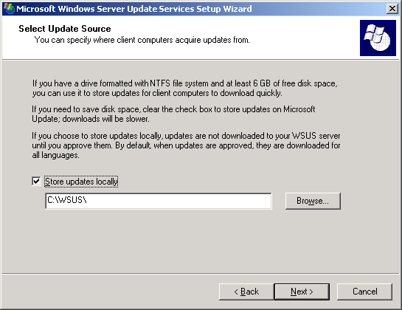

5. On the Database Options page, select the software used to manage the WSUS 3.0 database. By default, WSUS Setup offers to install SQL Server 2005 Embedded Edition (Windows) if the computer on which you are installing runs Windows Server 2003.
If you do not wish to use SQL Server 2005 Embedded Edition (Windows), you must provide a SQL Server instance for WSUS to use, by clicking Use an existing database server on this computer and typing the instance name in the SQL instance name box. Keep the default options, and click Next.
Figure 2 Database Options page
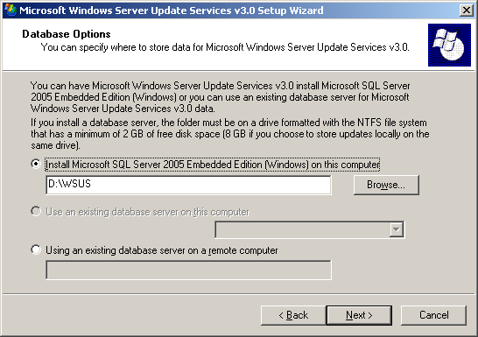

6. On the Web Site Selection page, specify the Web site that WSUS 3.0 will use. If you wish to use the default IIS Web site on port 80, select the first option. If you already have a Web site on port 80, you can create an alternate site on port 8530 by selecting the second option.
Keep the default option and click Next.

Figure 3 Web Site Selection page
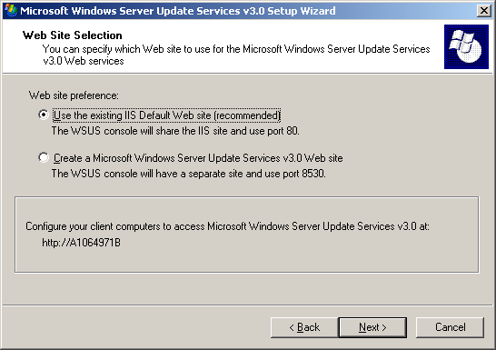

7. On the Ready to Install Windows Server Update Services page, review the selections and click Next.

Figure 4 Ready To Install Windows Server Update Services
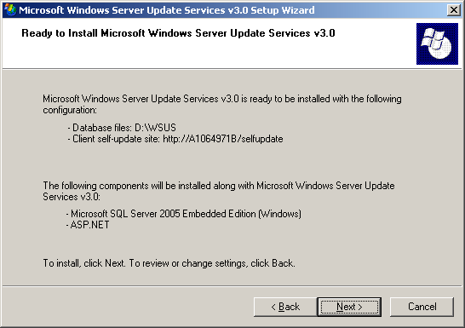

8. The final page of the installation wizard will tell you whether or not the WSUS 3.0 installation was completed successfully. You may also choose to start the configuration wizard at the same time by checking the option Launch WSUS Server Configuration Wizard. Then click Finish.
Figure 5 Completing the installation
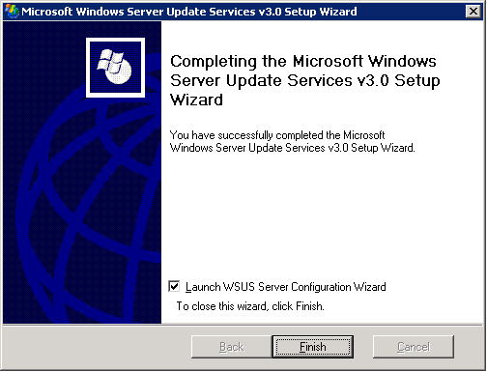

Step 3: Configure the Network Connection for WSUS 3.0
After installing WSUS 3.0, you can run the configuration wizard by checking the Launch WSUS Server Configuration Wizard check box on the last page of the installation wizard (see Figure 5). If you do not choose to configure the server immediately after finishing the installation, you can always do it later through the Options page of the WSUS 3.0 console.
Before beginning the configuration process, be sure you know the answers to the following questions:
1. Is the server's firewall configured to allow clients to access the server?
2. Can this machine connect to the upstream server (such as Microsoft Update)?
3. Do you have the name of the proxy server and the user credentials for the proxy server, if needed?
By default, WSUS is configured to use Microsoft Update as the location to obtain updates. If you have a proxy server on your network, you can configure WSUS to use the proxy server. If there is a corporate firewall between WSUS and the Internet, you might need to configure the firewall to ensure that WSUS can obtain updates.
Note
Although you must have Internet connectivity to download updates from Microsoft Update, WSUS offers you the ability to import updates onto networks not connected to the Internet.
Step 3 contains the following procedures:
• Configure your firewall.
• Specify the way this server will obtain updates (either from Microsoft Update or from another WSUS server).
• Configure proxy server settings, so WSUS can obtain updates.
To configure your firewall
• If there is a corporate firewall between WSUS and the Internet, you might need to configure that firewall to ensure that WSUS can obtain updates. To obtain updates from Microsoft Update, the WSUS server uses port 80 for HTTP protocol and port 443 for HTTPS protocol. This is not configurable.
• If your organization does not allow port 80 and/or port 443 to be open to all addresses, you can restrict access to only the following domains, so WSUS and Automatic Updates can communicate with Microsoft Update:
• http://windowsupdate.microsoft.com
• http://*.windowsupdate.microsoft.com
• https://*.windowsupdate.microsoft.com
• http://*.update.microsoft.com
• https://*.update.microsoft.com
• http://*.windowsupdate.com
• http://download.windowsupdate.com
• http://download.microsoft.com
• http://*.download.windowsupdate.com
• http://wustat.windows.com

•
Note
These instructions for configuring the firewall are meant for a corporate firewall positioned between WSUS and the Internet. Because WSUS initiates all its network traffic, there is no need to configure Windows Firewall on the WSUS server.
Although the connection between Microsoft Update and WSUS requires ports 80 and 443 to be open, you can configure multiple WSUS servers to synchronize with a custom port.

The next two procedures assume that you are using the configuration wizard. In a later section in this step, you will learn how to start the WSUS Administration snap-in and configure the server through the Options page.
To specify the way this server will obtain updates
1. From the first page of the configuration wizard, click Next, or select Choose Upstream Server from the left panel.
2. You will be asked whether this server will get its updates from Microsoft Update or from another WSUS server.
3. If you choose to synchronize from Microsoft Update, you are finished with this page. Click Next, or select Specify Proxy Server from the left panel.
4. If you choose to synchronize from another WSUS server, you need to specify the port on which the servers will communicate (the default is port 80). If you choose a different port, you should ensure that both servers are able to use that port.
5. You may also specify whether to use SSL when synchronizing from the upstream WSUS server. In that case the servers will use port 443 for synchronization.
6. If this server is a replica of the second WSUS server, select the This is a replica of the upstream server check box. In this case all updates must be approved on the upstream WSUS server only.
7. At this point you are finished with upstream server configuration. Click Next, or select Specify proxy server from the left panel.
To configure proxy server settings
1. On the Specify Proxy Server page of the configuration wizard, select the Use a proxy server when synchronizing check box, and then type the proxy server name and port number (port 80 by default) in the corresponding boxes.
2. If you want to connect to the proxy server by using specific user credentials, select the Use user credentials to connect to the proxy server check box, and then type the user name, domain, and password of the user in the corresponding boxes. If you want to enable basic authentication for the user connecting to the proxy server, select the Allow basic authentication (password is sent in clear text) check box.
3. At this point you are finished with proxy server configuration. Click Next to go to the next page, where you can start setting up the synchronization process. The procedures for setting up synchronization are described in the next section.
The following two procedures assume that you are using the WSUS Administration snap-in for configuration. These two procedures show you how to start the WSUS Administration snap-in and configure the server from the Options page.
Note
You cannot save configuration changes that are made while the server is synchronizing. Wait until synchronization is finished to make your changes.
To start the WSUS Administration snap-in
• To start the WSUS Administration snap-in, click Start, point to All Programs, point to Administrative Tools, and then click Microsoft Windows Server Update Services.

Note
You must be a member of either the WSUS Administrators or the local Administrators security groups on the server on which WSUS is installed in order to use the WSUS console.
To specify an update source and proxy server
1. On the WSUS console, click Options in the left panel under the name of this server and then click Update Source and Proxy Server in the middle panel.
2. A dialog box will be displayed with Update Source and Proxy Server tabs.
3. In the Update Source tab, select the location from which this server will obtain updates. If you choose to synchronize from Microsoft Update (the default), you are finished with this wizard page.
4. If you choose to synchronize from another WSUS server, you need to specify the port on which the servers will communicate (the default is port 80). If you choose a different port, you should ensure that both servers are able to use that port.
5. You may also specify whether to use SSL when synchronizing from the upstream WSUS server. In that case the servers will use port 443 to synchronize from the upstream server.
6. If this server is a replica of the second WSUS server, select the This is a replica of the upstream server check box. In this case all updates must be approved on the upstream WSUS server only.
7. In the Proxy server tab, select the Use a proxy server when synchronizing check box, and then type the proxy server name and port number (port 80 by default) in the corresponding boxes.
8. If you want to connect to the proxy server by using specific user credentials, select the Use user credentials to connect to the proxy server check box, and then type the user name, domain, and password of the user in the corresponding boxes. If you want to enable basic authentication for the user connecting to the proxy server, select the Allow basic authentication (password in clear text) check box.
9. Click OK to save these settings.

Step 4: Configure Updates and Set Up Synchronization
Before downloading updates, you will need to specify which updates you want to download. This section describes how to configure the set of updates you wish to download.
The procedures in this step describe how to:
• Save and download information about your upstream server and proxy server.
• Choose the language of the updates you want.
• Choose the products for which you want to get updates.
• Choose the classifications of updates you want.
• Specify the synchronization schedule for this server.
The next five procedures describe how to configure your updates using the configuration wizard. Later procedures describe how to perform this configuration from the WSUS Administration snap-in by choosing specific options.
Save and download your upstream server and proxy information
1. You should have completed configuration of the upstream server and the proxy server in the configuration wizard, and should see the Connect to Upstream Server page.
2. Click the Start Synchronization button, which will save and download your settings and synchronize information about available updates.
3. During the time this synchronization is occurring, the Stop Synchronization button will be active. If there are problems with the synchronization, stop the synchronization, fix the problems, and restart the synchronization.
4. After synchronization has completed successfully, click Next to go on to the Choose Languages page, or select a different page from the left panel.
Choose the language of the updates
1. The Choose Languages page allows you to get updates from all languages or from a subset of languages.
2. If you choose to get updates for only a few languages, select Download updates only in these languages, and select the languages for which you want updates. Click Next to go to the Choose Products page, or select a different page from the left panel.
Choose the products for which you want updates
1. The Choose Products page allows you to specify the products for which you want updates.
2. You may check product categories, such as Windows, or specific products, such as Windows Server 2003. Selecting a product category will cause all of the products under it to be selected. Click Next to proceed to the Choose Classifications page, or select a different page from the left panel.
Choose the update classifications you want
1. The Choose Classifications page allows you to choose the update classifications you wish to obtain. You can choose all the classifications or a subset of them.
2. Click Next to proceed to the Configure Sync Schedule page, or select a different page from the left panel.
Specify the synchronization schedule for this server
1. You will see the Set Sync Schedule page, which allows you to choose whether to perform synchronization manually or automatically.
2. If you choose to synchronize manually on this server, you will have to initiate the synchronization process from the WSUS snap-in.
3. If you choose to synchronize automatically, the WSUS server will synchronize at specified intervals. Set the time of the first synchronization and specify the number of synchronizations per day you wish this server to perform.
After you have completed all of the above configuration steps, select the Finished page in the configuration wizard. You can launch the WSUS snap-in by leaving the Launch the Windows Server Update Services Administration Snap-in check box selected, and you can start the first synchronization by leaving the Begin initial synchronization check box selected.
Figure 6 Completing configuration with the configuration wizard
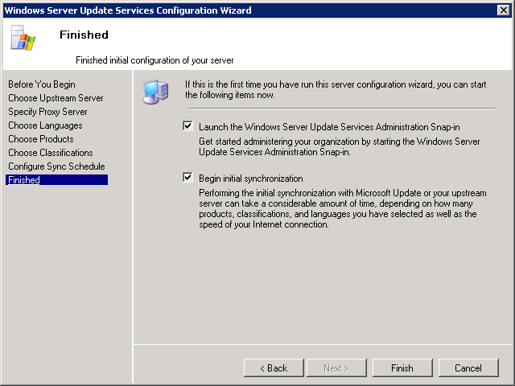

The following procedures explain how to perform the above configuration steps through the Options page of the WSUS Administration snap-in:
• Choose products and classifications
• Update files and languages
Choose products and classifications
1. Launch the WSUS Administration snap-in: Click Start, point to All Programs, point to Administrative Tools, and then click Microsoft Windows Server Update Services.
2. Select Options under your WSUS server in the left pane.
3. In the middle pane, select Products and Classifications.
4. You will see a dialog box with three tabs: Products, Classifications, and Beta Products.
5. In the Products tab, select the product category or specific product for which you want this server to get updates, or else select All Products.
6. In the Classifications tab, select the update classifications you want, or else select All Classifications.
7. In the Beta Products tab, add the beta product IDs for which you want updates.
8. Click OK to save your selections.
Update files and languages
1. In the Options page select Update Files and Languages.
2. You will see a dialog box with two tabs: Update Files and Update Languages.
3. In the Update Files tab, you can choose whether to store update files locally or to have all client computers install from Microsoft Update. If you choose to store update files on this server, you can choose whether to download only those updates that are approved or to download express installation files.
4. In the Update Languages tab, you can choose to get updates for all languages (the default) or to get updates for only the specified languages. If this WSUS server has downstream servers, they will get updates only in the languages specified by the upstream server.
5. Click OK to save these settings.
After you configure the network connection, you can download updates by synchronizing the WSUS server.
Synchronization involves the WSUS server contacting Microsoft Update. After making contact, WSUS determines whether any new updates have been made available since the last time you synchronized. Because this is the first time you are synchronizing the WSUS server, all of the updates are available and are ready for your approval for installation.
Note
This document describes synchronizing with the default settings, but WSUS includes options that enable you to minimize bandwidth use during synchronization.
To synchronize your WSUS server
1. In the WSUS Administration snap-in, select Synchronization Results.
2. Right-click or go to the Actions pane on the right, and then click Synchronize now.
Note
If you do not see the Actions pane on the right side of the console, on the Microsoft Management Console toolbar, click View,click Customize, and ensure that Action pane is selected.
After the synchronization finishes, click Updates in the left panel to view the list of updates.

Step 5: Configure Automatic Updates
WSUS client computers require a compatible version of Automatic Updates. WSUS Setup automatically configures IIS to distribute the latest version of Automatic Updates to each client computer that contacts the WSUS server.
Note
Although most versions of Automatic Updates can be pointed to the WSUS server and they will automatically self-update to the WSUS-compatible version, the version of Automatic Updates included with Windows XP without any service packs cannot update itself automatically.
The best way to configure Automatic Updates depends on your network environment. In an environment with Active Directory, you can use a domain–based Group Policy object (GPO). In an environment without Active Directory, use the Local Group Policy object. Whether you use the Local Group Policy object or a domain-based GPO, you must point your client computers to the WSUS server, and then configure Automatic Updates.
The following instructions assume that your network runs Active Directory. These procedures also assume that you are familiar with Group Policy and use it to manage your network. You need to create a new GPO for WSUS settings, and link the GPO to the domain.
For more information about Group Policy, see the Group Policy Tech Center Web site (http://go.microsoft.com/fwlink/?LinkID=47375).
Step 5 contains the following procedures:
• Add the WSUS Administrative Template.
• Configure Automatic Updates.
• Point your client computer to your WSUS server.
• Manually initiate detection by the WSUS server.
Perform the next three procedures on a domain–based Group Policy object. You will need to create a new GPO or use an existing GPO. If you are using the Group Policy Management Console (GPMC) to manage your GPOs, navigate to the GPO you wish to modify and choose Edit.
In order to view policy settings to manage WSUS, you will need to ensure that the WSUS administrative template file, wuau.adm, is added to the Group Policy Object Editor. Because wuau.adm is released by default in the operating system, it should already be present in the Group Policy Object Editor.
To add the WSUS Administrative Template
1. In Group Policy Object Editor, click either of the Administrative Templates nodes.
2. On the Action menu, click Add/Remove Templates and then click Add.
3. In the Policy Templates dialog box, click wuau.adm, and then click Open.
4. In the Add/Remove Templates dialog box, click Close.
To configure Automatic Updates
1. In Group Policy Object Editor, expand Computer Configuration, expand Administrative Templates, expand Windows Components, and then click Windows Update.
2. In the details pane, double-click Configure Automatic Updates.
3. Click Enabled, and then click one of the following options:
• Notify for download and notify for install: This option notifies a logged-on administrative user before the download and before the installation of the updates.
• Auto download and notify for install: This option automatically begins downloading updates and then notifies a logged-on administrative user before installing the updates.
• Auto download and schedule the install: If Automatic Updates is configured to perform a scheduled installation, you must also set the day and time for the recurring scheduled installation.
• Allow local admin to choose setting: With this option, local administrators are allowed to use Automatic Updates in the Control Panel to select a configuration option of their choice. For example, they can choose their own scheduled installation time. Local administrators are not allowed to disable Automatic Updates.
4. Click OK.
Note
The setting Allow local admin to choose setting appears only if Automatic Updates has updated itself to the version compatible with WSUS.
To point your client computer to your WSUS server
1. In Group Policy Object Editor, expand Computer Configuration, expand Administrative Templates, expand Windows Components, and then click Windows Update.
2. In the details pane, double-click Specify intranet Microsoft update service location.
3. Click Enabled, and type the HTTP URL of the same WSUS server in the Set the intranet update service for detecting updates box and in the Set the intranet statistics server box. For example, type http://servername in both boxes and click OK.
Note
If you are using the Local Group Policy object to point this computer to WSUS, this setting takes effect immediately and this computer should appear in the WSUS administrative console after a short time. You can speed this process up by manually initiating a detection cycle.
After you set up a client computer, it will take a few minutes before it appears on the Computers page in the WSUS console. For client computers configured with a domain-based Group Policy, it will take about 20 minutes after Group Policy refreshes (that is, applies any new policy settings to the client computer). By default, Group Policy refreshes in the background every 90 minutes, with a random offset of 0–30 minutes. If you want to refresh Group Policy sooner, you can go to a command prompt on the client computer and type: gpupdate /force.
For client computers configured with the Local GPO, Group Policy is applied immediately, and the refresh will take about 20 minutes.
Once Group Policy is applied, you can initiate detection manually. If you initiate detection manually, you do not have to wait 20 minutes for the client computer to contact WSUS.
To manually initiate detection by the WSUS server
1. On the client computer click Start, and then click Run.
2. Type cmd in the Open box, and then click OK.
3. At the command prompt, type wuauclt.exe /detectnow. This command-line option instructs Automatic Updates to contact the WSUS server immediately.

Step 6: Create a Computer Group for Updates
Computer groups are an important part of WSUS deployments, even a basic deployment. Computer groups enable you to target updates to specific computers. There are two default computer groups: All Computers and Unassigned Computers. By default, when each client computer initially contacts the WSUS server, the server adds it to each of these groups.
You can create custom computer groups. One benefit of creating computer groups is that they enable you to test updates before deploying updates widely. If testing goes well, you can roll out the updates to the All Computers group. There is no limit to the number of custom groups you can create.
Setting up computer groups is a three-step process:
1. Specify how you are going to assign computers to the computer groups. There are two options: server-side targeting and client-side targeting. Server-side targeting involves manually adding each computer to its group by using WSUS. Client-side targeting involves automatically adding the clients by using either Group Policy or registry keys.
2. Create the computer group on WSUS.
3. Move the computers into groups by using the method you chose in step 1.
This section explains how to use server-side targeting and manually move computers to their groups by using the WSUS Administration snap-in. If you had numerous client computers to assign to computer groups you could use client-side targeting, which would automate moving computers into computer groups.
You can use Step 6 to set up a test group that contains at least one test computer.
Step 6 contains the following procedures:
• Create a group.
• Add a computer to the group.
To create a group
1. In the WSUS Administration snap-in, click Computers and Groups.
2. Right-click or go to the Actions panel and click Add Computer Group.
3. You will see a dialog box Add Computer Group. Specify the name of the new group.
Use the next procedure to assign a client computer to the test group. A client computer appropriate for testing is any computer with software and hardware indicative of the majority of computers on your network, but not a computer assigned to a critical role. In this way, you can tell how well computers like the test computer will fare with the updates you approve.
To add a computer to the group
1. In the WSUS Administration snap-in, click Computers and Groups.
2. Click the group of the computer you want to move.
3. In the list of computers, select the computer you want to move.
4. Right-click Change Membership.
5. You will see a dialog box, Set Computer Group Membership, with a list of groups.
6. Check the group to which you want to move the computer, and then click OK.

Step 7: Approve and Deploy Updates in WSUS 3.0
In this step you approve an update for any test client computers in the test group. Computers in the group will contact the WSUS server over the next 24 hours. After this period, you can use the WSUS reporting feature to determine if those updates have been deployed to the computers. If testing goes well, you can then approve the same updates for the rest of the computers in your organization.
Step 7 contains the following procedures:
• Approve and deploy an update.
• Check the status of the update.
To approve and deploy an update
1. On the WSUS Administration snap-in, click Updates. Doing so will display a summary of updates in the default views (All Updates, Critical Updates, Security Updates, and WSUS Updates). Use All Updates for this procedure.
2. On the list of updates, select the updates you want to approve for installation. Information about a selected update is available in the lower pane of the Updates panel. To select multiple contiguous updates, press and hold down the SHIFT key while selecting; to select multiple non-contiguous updates, press and hold down the CTRL key while selecting.
3. Right-click and select Approve. The Approve Updates dialog box appears.
4. Select one of the groups (for example, Test) and click the arrow to its left. You will see a context menu with the choices Approved for Install, Approved for Removal, and Apply To Children. Click Approved for Install and then click OK.
5. You will see a new window Approval Progress that shows progress of the different tasks affecting the approval of the updates. When approval is completed, click Close to close this window.
Note
Many options are associated with approving updates, such as setting deadlines and uninstalling updates.
After 24 hours, you can use the WSUS reporting feature to determine whether the updates have been deployed to the computers.
To check the status of an update
1. In the WSUS Administration snap-in, click Reports in the left pane.
2. On the Reports page you will see a number of standardized reports. Click the Update Status Summary report. You will see the Updates Report window.
3. If you want to filter the list of updates, select the criteria you want to use (for example, Include updates in these classifications), and then click Run Report on the window's toolbar.
4. You will see the Updates Report window. You can check the status of individual updates by selecting the update in the left panel of the report window. The last section of the report pane shows the status summary of the update.
5. You can save or print this report by clicking the appropriate icon on the toolbar.
If the updates were successfully deployed to the test group, you can approve the same updates for the rest of the computers in your organization.

