

American Power Conversion
Network Management Card (AP961x)

Upgrade Utility Guide v1.1

Note: This document and all the information contained herein
is the property of American Power Conversion and shall not
be reproduced, copied, transmitted or used, in whole or in part,
or used as the basis for the manufacture or sale of items
without written consent from American Power Conversion.

American Power Conversion
American Power Conversion 132 Fairgrounds Road
West Kingston, Rhode Island 02892 Phone (800) 890-4272 www.apc.com
Copyright © 2003 American Power Conversion. All rights reserved
Note: Specifications contained herein are subject to change without notice.
Table of Contents

1. Introduction 1
2. Availability 1
3. Corresponding Upgrade Tools with Product Types 1
4. Before You Begin 1
5. Installing the NMC Upgrade Utility 2
6. Executing the NMC Upgrade Utility 4
7. Cleaning Up After the NMC Upgrade Utility 8
8. Manual Upgrade of the Network Management Card 8
9. Conclusion 9

Introduction
This guide is intended as a reference for usage of an APC provided, firmware upgrade tool for the Network Management Card (NMC). This tool will automatically upgrade a single, or multiple NMC’s from version 1.x.x firmware to version 2.1.0 firmware. During this process, multiple files will be uploaded to the NMC to complete this upgrade process. Depending on your network topology and number of NMC’s to be upgraded, this process may take several minutes per NMC. Do not abort this process prior to completion, as incompletely loaded firmware updates to a NMC may produce unexpected behavior.

Availability
This guide and the upgrade tools it details are available from the CD bundled with your equipment, or freely from the support section of the APC web site (www.apc.com).

Corresponding Upgrade Tools with Product Types
Each upgrade tool is specific to an APC product type. For correct operation, the proper upgrade tool must be used with the corresponding APC product type. If however, an incorrect upgrade tool and product pair combination are used, no damage to the APC product will result. Simply repeat the upgrade process with the correct product and upgrade tool combination to obtain a successful firmware upgrade for your products.

The chart below details the proper combination of APC product to NMC upgrade tool:

If you have this APC product | Use this upgrade tool
Smart UPS, Matrix UPS | apc_hw02_aos210_sumx210.exe
Symmetra Single Phase UPS | apc_hw02_aos210_sy210.exe
Symmetra Three Phase UPS | apc_hw02_aos210_sy3p210.exe

Note these tools will operate only on a computer utilizing a Windows operating system. If it is necessary your upgrade be conducted on a non-Windows platform, please contact APC technical support if unsure how to perform these NMC firmware upgrades.

Before You Begin
This guide assumes the user to have a basic knowledge of the Windows operating system. Additionally, it assumes the user to have administrator rights both to the machine that the NMC Upgrade Utility will be installed to, and all corresponding Network Management Cards that this firmware upgrade will be installed to.

Also, the previously configured IP addresses of the cards to be upgraded must be known prior to installation and execution of this utility.

If any of these conditions are not met, please see your network administrator regarding these matters before beginning this upgrade.

Installing the NMC Upgrade Utility
Select and save the proper NMC upgrade tool to the Windows computer you will be performing the firmware upgrade from. If unsure about the type of NMC upgrade tool to use, refer to Section 3 of this guide.

Each of the NMC upgrade tools is a self-extracting executable file represented by an icon similar to what is shown here:

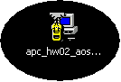

Double clicking this icon will begin the installation process and display the following:

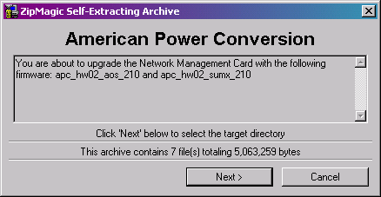

Press, “Cancel” to abort the installation, or press “Next” to continue the installation process and select a path from the following displayed dialog (.\ is the default path):

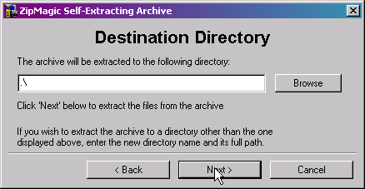
5. Installing the NMC Upgrade Utility (continued)
Type or browse to the selected path, and press “Next” to continue the unpacking of the seven (7) necessary files to continue the upgrade. The following message will appear to indicate a successfully unpacked NMC upgrade utility.

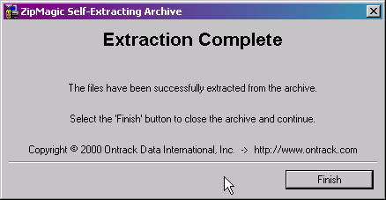

Press, “Finish” to close the archive and continue.

The following (7) files will be unpacked in the destination directory previously specified:

apc_hw02_aos_201.bin
apc_hw02_aos_210.bin
apc_hw02_product_210.bin (Where product is the type of APC product in use)
firmwaredownload.exe
go.bat
winftp32.dll
config.txt

Executing the NMC Upgrade Utility
The NMC upgrade utility will start automatically once the installation is completed successfully. Use the following instructions for first time uses of the NMC upgrade utility. Subsequent usages and multiple NMC firmware upgrades will be detailed later in this section.

First Time Use:

Once the NMC upgrade utility is installed, the following Windows Command Line Interfaces (DOS prompt) will appear on your terminal:

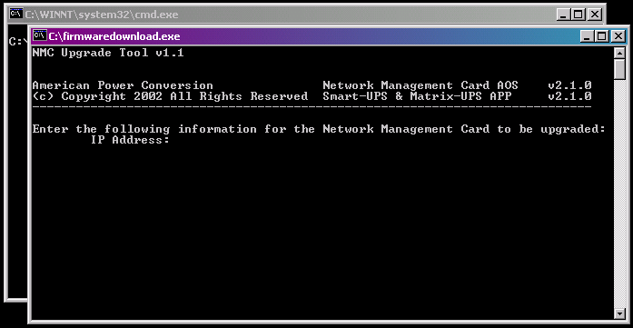

Take note that the correct application is being upgraded onto your NMC based on the APC product in use. The application is noted on the above screen shot, beneath the text “Network Management Card AOS” on the right side of the terminal session. This application is for “Smart-UPS & Matrix-UPS” applications.

If this is the correct application for your product, enter a valid, previously configured, IP address of a single NMC to be upgraded and press “Enter”

You will then be prompted for a user name and password. These correspond to the administrator user name and password of the NMC at the IP address just provided.
6. Executing the NMC Upgrade Utility (continued)
When complete, the screen should look similar to the following:

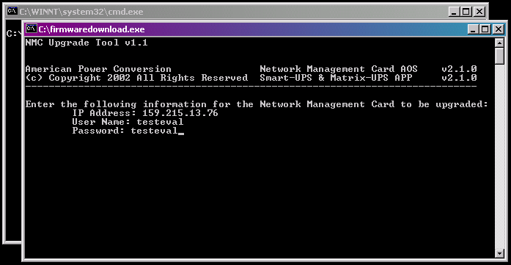

At this point, if all of the previously provided information is correct, the upgrade process will begin, and when complete, the following screen will appear:

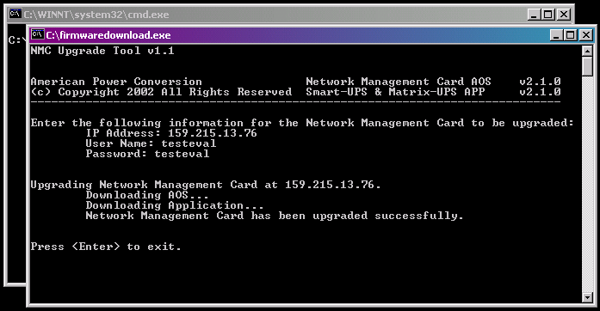

Press “Enter” to exit the upgrade utility.
6. Executing the NMC Upgrade Utility (continued)
If you need to upgrade another card, or multiple cards, please read the section in titled “Subsequent Use of the NMC Upgrade Utility”.

If however, information about the NMC was not correct, or the computer running the NMC upgrade was not able to reach the specified IP address, the following screen will result:

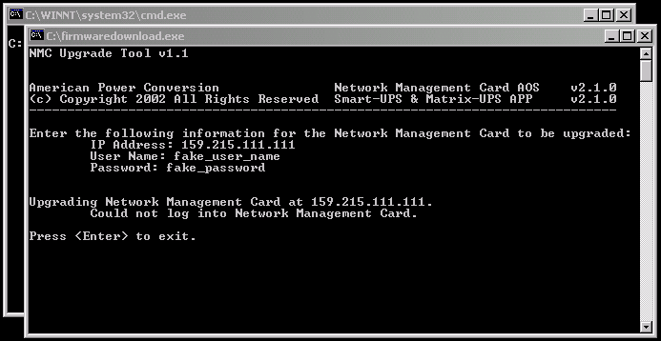

To upgrade this card, another card, or multiple cards, please read the section titled “Subsequent Use of the NMC Upgrade Utility”.

Subsequent Use of the NMC Upgrade Utility:
After the first execution of the NMC Upgrade Utility, two additional files are created in the directory where the utility was unpacked and executed from. These files are, “result.txt” and “iplist.txt”.

“result.txt” is a text file that stores the results of the last attempted execution of the upgrade to a NMC or group of NMCs. In addition to viewing the screen after the execution of the NMC Upgrade Utility, it is recommended the result.txt file should also be viewed to review and verify any upgrade activity.

“iplist.txt” is a text file that stores the IP, user name and password combinations of the NMC or group of NMC’s that are to be upgraded. If this file exists in the directory where the NMC Upgrade Utility resides, this file will provide the NMC IP, user name and password combinations that were previously required during first use, thereby circumventing any user input for those NMC configuration variables.
6. Executing the NMC Upgrade Utility (continued)
To upgrade a NMC and ensure the correct NMC is being upgraded during subsequent use of the NMC Upgrade Utility, perform the following:

- Go to the directory that contains the NMC Upgrade Utility.
- Locate the file named iplist.txt and open the file using any available text editor.
- Edit the text file to contain the IP address, administrator user name and administrator password of the NMC to upgrade.
- Save this text file. It should look similar to the following (This example shows a single NMC at 159.215.13.74 to be upgraded):

[SystemManager]

SystemIP=159.215.13.74
SystemUserName=admin_user_name
SystemPassword=admin_passowrd

- From the same directory, run the go.bat file to execute the utility.
- Verify via the screen that the detailed NMC at the specified IP is upgraded.
- Verify via the result.txt that the detailed NMC at the specified IP is upgraded.

Subsequent Use of the NMC Upgrade Utility to Upgrade Multiple NMC’s:
Similar to the above procedure, only one additional step is necessary to use the NMC Upgrade Utility to upgrade NMC’s at multiple IP addresses.

To upgrade multiple NMC’s and ensure the correct NMC’s are being upgraded during subsequent use of the NMC Upgrade Utility, perform the following:

- Go to the directory that contains the NMC Upgrade Utility.
- Locate the file named iplist.txt and open the file using any available text editor.
- Edit the text file to contain the IP addresses, administrator user names and administrator passwords of all the NMC to be upgraded.
- Save this text file. It should look similar to the following (This example shows three NMCs to be upgraded at 159.215.13.74, .75 and .76):
6. Executing the NMC Upgrade Utility (continued)

[SystemManager]

SystemIP=159.215.13.74
SystemUserName=admin_user_name1
SystemPassword=admin_password1

SystemIP=159.215.13.75
SystemUserName=admin_user_name2
SystemPassword=admin_password2

SystemIP=159.215.13.76
SystemUserName=admin_user_name3
SystemPassword=admin_password3

Etc for the number of NMC’s to be programmed.

- From the same directory, run the go.bat file to execute the utility.
- Verify via the screen the detailed NMC at the specified IP is upgraded.
- Verify via the result.txt the detailed NMC at the specified IP is upgraded.

Warning: If the NMC Upgrade Utility is started after the iplist.txt file is created, but before this file is properly edited for the desired NMC configurations, the result will be the reprogramming of the NMC listed in the iplist.txt file.

Cleaning Up After the NMC Upgrade Utility
The NMC Upgrade Utility does not register itself with the Windows operating system. Therefore once the upgrade of the desired NMC’s are complete, the entire directory can be deleted if so desired without result to the previously upgraded NMC’s.

Manual Upgrade of the Network Management Card
As an alternate to using the automatic upgrade utility previously detailed, the NMC can be upgraded manually using File Transfer Protocol (FTP). If manually upgrading the NMC it is expected the user to have an understanding of the topics in section 4 of this document as well as FTP and related topics.

All firmware files to upgrade the NMC from 1.x.x version firmware to 2.1.0 version firmware are contained in the NMC Upgrade Utility self-extracting executable file. Refer to sections 3, 4 and 5 to identify the correct executable file based on APC product type and extract these necessary files.
8. Manual Upgrade of the Network Management Card (continued)
Once the complete package is extracted, the following files will be used to upgrade the NMC manually. The files can be found in the directory the upgrade tool was extracted into, and are:

- apc_hw02_aos_201.bin
(APC Operating System and incremental system patches)

- apc_hw02_aos_210.bin
(APC Operating System)

- apc_hw02_product_210.bin
(APC Application, where product is the APC product type)

To successfully upgrade a NMC to version 2.1.0 firmware, all (3) files detailed above must be FTP’d to the NMC in the order stated above. Failure to load all (3) files in the order stated will cause errors and not properly upgrade the firmware to the NMC, potentially rendering the NMC unusable until correctly upgraded.

To help guide the process, APC has published a document describing the required steps for upgrading a NMC manually via FTP. Use the following link for details:

APC Details for FTP to a NMC

Conclusion
The NMC Upgrade Utility self-extracting file provides all the necessary files to upgrade from version 1.x.x to 2.1.0. The Network Management Card can be upgraded by automated or manual means as described in this document by an end user. During the upgrade process from 1.x.x to 2.1.0, patches within the apc_hw02_aos_201.bin must be installed onto the NMC, prior to installing the full 2.1.0 version firmware.

